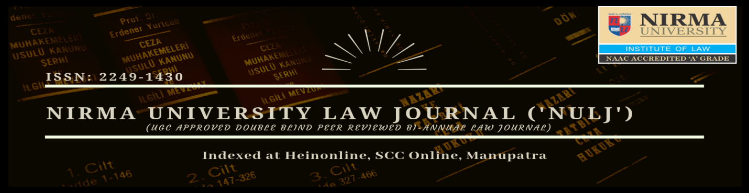
Nirma University Law Journal (‘NULJ’) - ISSN Number 2249-1430
The NULJ is now accepting submissions for its next edition to be published in July 2020. Submissions for scholarly, original and unpublished written works from people across the legal profession – students, academicians and practitioners – are invited, to be published in the Journal.

About the journal
The Journal Committee of Institute of Law, Nirma University hereby invites articles/ research papers, case studies, and book reviews on law and allied areas for publication in the Nirma University Law Journal (July 2020 Issue) bearing ISSN Number 2249-1430. The journal is a bi-annual, peer-reviewed publication from Institute of Law, Nirma University. It showcases contemporary issues and challenges specific to law, with an interdisciplinary approach towards assimilating knowledge. It is an endeavor of the Institute to become the beacon of legal education by encouraging synthesis of knowledge and best practices cutting across the academia and research fraternity. The Journal is indexed in Manupatra, SCC Online, Indian Citation Index and Hien Online and is erstwhile recognized by University Grants Commission (UGC) vide journal no. 49209 and post CARE listing, the journal is in the process of obtaining the enlistment.
Topics
The journal invites submission on any broad area of “Legal Education and Pedagogy in Contemporary Era”. Preference shall be given to original manuscripts highlighting contemporary legal issues with national and international significance on the proposed broad theme.
The authors are free to write on any topic that they wish to contextualize on the theme.

Submission guidelines
- Word Limit: Submissions should not exceed:
- Research papers (4,000- 6,000 words),
- Short notes (2000-3000 words),
- Book reviews (1000-2000 words), and
- Case studies/commentaries (1000-3000 words).
- Eligibility: Entries from students pursuing Bachelors or Masters in Law and allied discipline of Social Science; Professionals, People from legal Academia would be accepted.
- Authorship: Maximum of two authors per entry.
- Citation Style: The Bluebook Uniform System of Citation (20th edition) shall be strictly adhered to. The main text should be in Times New Roman, size 12 with a 1.5 line spacing and the footnotes shall be in size 10 with 1.0 line spacing. This shall be a strict compliance for papers to be accepted for review process.
- The journal is guided by a well defined ‘Ethical policy’ which gives no scope for plagiarized submission. Thus, authors are strictly requested to follow the plagiarism policy for academic submissions published by UGC, or visit our website for further details @ www.nulj.in

Publication policy
- The submissions must be original and should not be under consideration in any other journal. Articles with plagiarism and copyright issues are liable to be rejected immediately. Nirma University Law Journal is not to subject to any liability which may arise in this regard.
- Submission of work must be made to Nirma University Law Journal, is indicative of the fact that the authors grant exclusive permission to NULJ to publish and reproduce their work in all streams of media. Such right is subject to the doctrine of fair use as followed under the law relating to Intellectual Property Rights and subject to the entitlements of the author.
- The editors reserve the right to delete or edit any article or part thereof whose content is found to be offensive, defamatory, out rightly unethical, or if it is suggestive of racism, sexual or religious discrimination, illegal or terror activities etc. The article is subjected to rejection if its content is likely to offend the religious or political sentiments of the reader.
- A process of peer-review shall be used to scrutinize all the submissions. Following this the authors of selected papers will be notified of the results.

TIMELINE

Call for papers: 25th April 2020

Submission of Abstract: 30th May 2020

Submission of full paper: 30th June 2020

Completion & Intimation of Reviewed papers: 15th July 2020

Publication of Journal: 01th August 2020

Contact details
For any further queries, kindly contact us on the following number or email id:
- Shubham Vijay- Mob: 95718 78165 - E-mail: nulawjournal@nirmauni.ac.in

