

IFIM LAW SCHOOL, BENGALURU
Proudly announces

A SPECIAL LECTURE BY DEVINDER SHARMA ON “CRISIS IN INDIAN ECONOMY: CAN AGRICULTURE HELP OVERCOME IT?”

30th September, 2019 (Monday)

2.30 pm to 4.30 pm

About the Lecture

Agriculture is central to the Indian economy. As per 2018, agriculture employed 50% of the Indian work force and contributed 17-18% to country's GDP. When half the population of India has been pulled into the agriculture sector for employment, it becomes pertinent for the country to provide an atmosphere conducive to our farmers. However, Indian farmers must contend with a number of risks such as adverse climate, low incomes to mention a few. The low incomes of the farmers are blamed for the low crop productivity which continues to be the reason behind the continuing agrarian distress. The cost of the raw materials required to produce a single product including the seeds, fertilizers, cost of diesel to run the tractors and many other requirements have increased over the decades, however the farmers are denied their due return by expecting them to provide us with cheaper food year after year. Moreover, there is a huge parity between farm incomes and incomes of other sections of the society. Isn’t it a grave human rights violation with our Indian farmers? Is this the reason why farmers take their lives? If so, what could be the other alternative for the farmers for their survival. By use of more pesticides to increase the productivity and play with the health of the individuals? IF Today we fail to discuss and deliberate about this issue, we will be left in a position where adulterated products will be the only option for us!!!! As the growth of the Indian economy has slowed down Dr. Devinder Sharma through this special session will guide us how agriculture, which is one of the major employment pockets can help overcome the crisis in the Indian economy.

Speaker’s Profile

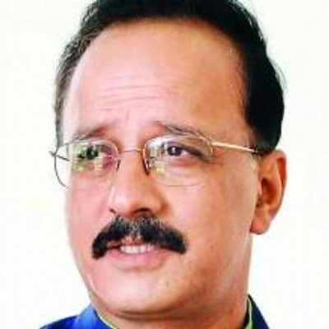
Devinder Sharma is a distinguished food and trade policy analyst. An award-winning Indian journalist, writer, thinker, and researcher well-known and respected for his views on food and trade policy. Sharma holds a Master’s in Plant Breeding & Genetics. He has been recently awarded with the honorary degree of Professor at Large by the CSK Himachal Pradesh Agricultural University, Palampur (India), from where he had graduated, and also has formerly been a Visiting Fellow to the International Rice Research Institute, in the Philippines; Visiting Fellow at the School of Development Studies at the University of East Anglia, Norwich (UK); and a Visiting Fellow at the University of Cambridge (UK). Mr. Sharma is associated with numerous national and international organizations, civil society groups and farmers organizations. He also on the board of half a dozen national and international organizations and is also a member of the CGIAR’s Central Advisory Service on Intellectual Property Rights.

Applicant Eligibility
The session is open to all Academicians, Professionals, Research Scholars and Students of any stream.

No Registration Fee
There is no registration fee charged for the session. Interested participants can fill the registration form and email it to shivani.dutta@ifim.edu.in and cc to divyashree.r@ifim.edu.in on or before 28th September, 2019 with the subject ‘Registration for Special Lecture’.
Certificate of participation will be awarded.

For further details you can email to:

shivani.dutta@ifim.edu.in (Shivani Dutta, Faculty In-charge)
divyashree.r@ifim.edu.in (Divyashree, Academic Co-ordinator)



A SPECIAL LECTURE BY DEVINDER SHARMA ON “CRISIS IN INDIAN ECONOMY: CAN AGRICULTURE HELP OVERCOME IT?”

30th September, 2019

REGISTRATION FORM

Full Name [In Cap]
Dr./Mr./Ms/Mrs
Qualification
Company/Organization/School/College
Email:
Contact No: Mobile

