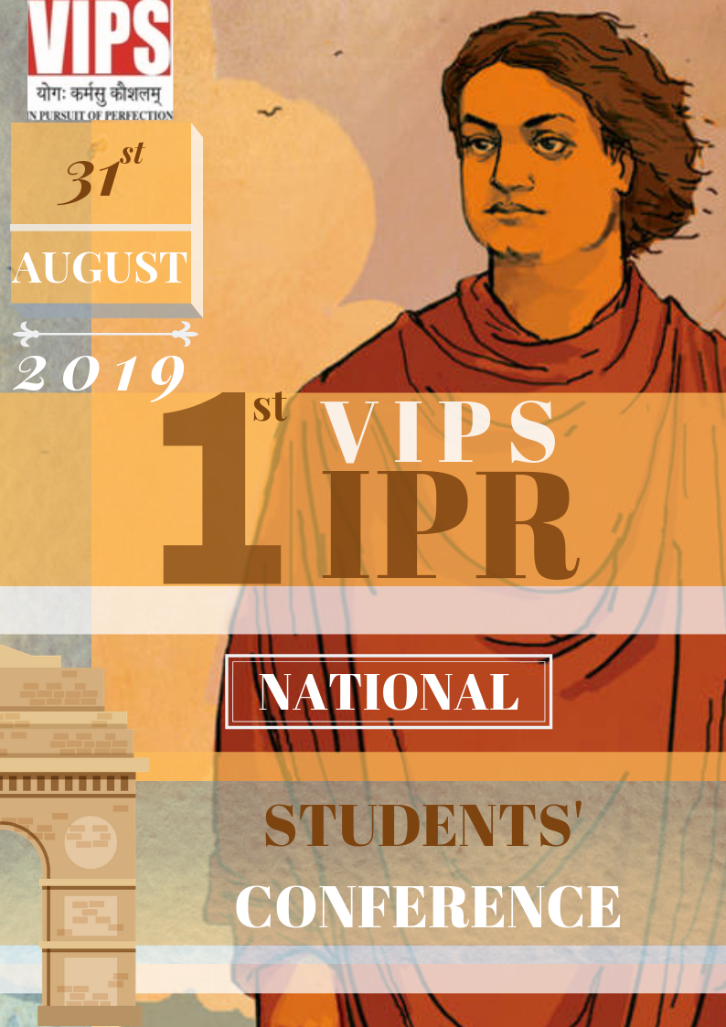


Vivekananda Institute of Professional Studies
(Affiliated to GGSIP University & Approved by BCI & AICTE)
NAAC Accredited ‘A’ Grade
ISO 9001:2008 Certified Institution

1st VIPS-IPR NATIONAL STUDENTS’ CONFERENCE
31st August 2019
In fourteenth century, the Inns of Court started simulation exercise to train the students of law in the rigours of pleading and advocacy. These exercises were slowly and gradually adopted by all the Universities of law. It not only helped in improving academic performance of the students but also enhanced their critical faculty. It enhanced their research, analytical skills as well as their ability to learn the law. Nowadays, various means of research have been evolved in contemporary areas of law. Conference is one of the best ways where students put forth their own research, get acquitted with the research by others and then discuss it together. Intellectual Property Rights (IPR) is witnessing evolving new areas of research. IPR holds significance in not only legal field but affects other disciplines also. Research in IPR is the need of the hour. It connects us with individuals, society, state and international community. IPR has many perspectives of human rights, economic rights and many more. The Conference focuses only on one of the area of IPR, with the belief that the potential delegates would put forward the best of their knowledge and research.
1st VIPS IPR National Conference in Intellectual Property Right in Information Age: Global Response, is a one day national conference for the delegates to make presentation in the forthcoming areas of IPR. Some areas like, human rights, GMO’s, virtual world, etc. needs specific reflection by the young minds. The delegates may take up IPR and related areas for making an effective contribution in the Conference.
The institution would be humbled by your benevolent presence in our campus. We look forward to your positive response.

VIVEKANANDA INSTITUTE OF PROFESSIONAL STUDIES
INVITATION LETTER

To,
The Vice Chancellor/ Dean/Registrar/ Head of the Department
Subject- Invitation for the 1st VIPS-IPR National Students’ Conference 2019
Vivekananda School of Law and Legal Studies (VSLLS), proudly announces the 1st VIPS-IPR National Students’ Conference, 31st August, 2019, Saturday.
Advocates’ Legion Moot Court Society of Vivekananda School of Law and Legal Studies, has been organizing various events of national and international significance, to provide a platform to the students to imbibe the pragmatic aspects of law and this moot court is one of such attempt to create a simulated atmosphere for the law students to accustom them with the intricacies and expediencies of law.
The conference focuses on the leading issues of IPR in India which helps the students to gain an understanding about the various practices of Patents, Trademarks and Copyrights legal fora in India.
We take pride in inviting your esteemed University/Institute/College to participate in the conference. We would be glad to receive positive response about your participation to the Email-vipsipr@gmail.com, so that together we can give our students a platform to hone their mooting skills. A copy of detailed rules and regulations is attached herewith. The last date for registration is 20th August 2019
We look forward to grace your presence for the competition.
Thanking You
Warm regards,
Prof. (Dr.) Rashmi Salpekar,
Dean,
VSLLS,
Vivekananda Institute of Professional Studies
Dr. Deepti Kohli,
Associate Professor,
Faculty Convenor
E-mail- vipsipr@gmail.com /deepti.kohli@vips.edu
Yash Aggarwal
Student Convener
Contact- +91-99116-43408
Advocates’Legion
Vivekananda School of Law and Legal Studies,
Vivekananda Institute of Professional Studies.

1st VIPS NATIONAL STUDENTS’ CONFERENCE ON INTELLECTUAL PROPERTY RIGHT IN INFORMATION AGE: GLOBAL RESPONSE
RULES AND GUIDELINES
1. THEMES FOR CONFERENCE PAPER SUBMISSION

The delegates have to submit their Conference Paper on any one of the theme or sub-themes given below:
Intellectual Property Right in Information Age: Global Response
  - IPR Jurisprudence: A way forward
  - IPR, Trade and Human Rights
  - Upcoming challenges and it’s response in IPR
  - GMO’s v. Traditional knowledge
  - IPR legislations and Implementation tools
  - Prospect of IPR in virtual world
  - Any other related area
2. GUIDELINES FOR RESEARCH PAPER SUBMISSION

2.1 Submissions should be in Times New Roman, 12 font size with 1.5 line spacing, Justified Text and 1 inch margins on all sides of an A4 sheet besides the centre aligned page number at the bottom of each page.
2.2 Footnotes should be in Times New Roman, font size 10 along with single line spacing.
2.3 Graphics, Charts, Tables, and Diagrams should be numbered consecutively and included in the body of the work. Submission must be compatible with Microsoft Word.
2.4 The Power Point Presentation (PPT) of the research paper is not allowed.
2.5 All the submissions must be emailed at vipsipr@gmail.com along with a cover page with the Title of the Research Paper and Name of the delegate.
2.6 Each submission should be accompanied by an abstract of not more than 300 words.
2.7 The submission must be the original work of the delegate. Any form of plagiarism will lead to immediate disqualification.
2.8 Submitted entries must not have been sent for consideration at any other place for presentation or publication.
2.9 Authorities are to be cited according to the Harvard Blue Book (19th Edition) citation style. Delegates are required to adhere to the same.
2.10 Copyright of all the submissions shall exclusively vest with VSLLS, VIPS.

3. REGISTRATION FOR CONFERENCE PAPER SUBMISSION

3.1 Who can register?
Students of graduation/ post graduation/ M. Phil/Ph.D/ of any recognized university having interest in IPR.
3.2. The registration amount per delegate is Rs. 2000/.
3.3. Each paper will get 10 minutes to present the Conference Paper.
3.4. The soft copy of the Conference Paper shall be submitted latest by 11:59 PM on 20th August 2019, Sunday.
3.5 The Conference Paper should be a minimum of 1200 words to maximum of 1500 words, excluding footnotes.

4. Judging Criteria
The best paper of the conference shall be judged on the basis of following criterion-
- Originality 30
- Critical analysis 30
- Findings/Conclusion/Suggestions 20
- Presentation 20
Total 100

5. AWARD – BEST DELEGATE
The best conference paper presentation shall be awarded with
- Certificate of ‘BEST DELEGATE’
- Cash Prize of Rs. 5000/
- Publication in the VIPS Student Law Review (VSLR) ISSN (Online) – 2582-0303, ISSN (Print) – 2582-0311 or Vivekananda Journal of Research (VJR) ISSN No. 2319-8702, ISSN (Print)- 2319-8702
- Memento

4. EXEMPLARY POWER CLAUSE
In case of any dispute arising out in the interpretation of the rules, or otherwise, the decision of the Faculty Convenor in consultation with the Organizing Committee (OC) would be final and binding. The Faculty Convenor in consultation with the OC will have the exclusive authority to interpret these Rules.

1ST VIPS IPR NATIONAL STUDENTS’ CONFERENCE
31ST AUGUST 2019
REGISTRATION FORM

NAME OF /Institute/College/ University: ________________________________________________________________________________________________________________________________________________

DELEGATE
Name:___________________________________________________________
Course: __________________________________________________
Email: ___________________________________________________________
Contact No.:_______________________________________________________

THE DELEGATES ARE THE BONAFIDE STUDENTS OF THE COLLEGE.

Signature & Seal of the Head of the Institution

