

National Symposium on Law and Development: A Global Perspective
22nd March 2019

About the Symposium:
IFIM Law School, Bangalore with its unique idea of understanding the inter-disciplinary issue of Law and Development is organising a National Symposium on Law and Development: A Global Perspective on 22nd March 2019.
The symposium is aimed at deliberations by prominent speakers from India as well as abroad on the inter relations of law and development. The societal and economic development of a country is dependent on the international and national legal framework, thus is imperative for each one of us to deliberate and share our ideas to frame the legal regulations which do not pose as a roadblock to development. The field of law and development examines the role of law, legal institutions and legal systems, both domestic and international, in the processes of economic and social development, particularly in developing countries, emerging markets, and nations in transition. It seeks to understand how law may both inhibit and foster desired change and the ways in which legal institutions may be organized to achieve national and international policy goals.
Registration Procedure:
Interested participants shall fill in the registration form and the payment details and email it to aisha.sharfi@ifim.edu.in
Registration Fee includes registration kit and refreshments.
Deadline: The last date for registration is 20th March 2019.
Timing:
10:00AM-1:00 PM
Eligibility:
We invite all the Academicians, Professionals, Research Scholars and Students to participate in the Workshop
Registration Fee: Rs 200/-

Speakers

Justice Subhash Bashetti Adi is a former Judge of the High Court of Karnataka and Upa Lokayukta of Karnataka Lokayukta.
Justice Subhash enrolled as an Advocate on 10-11-1978 and practised Writ, Civil, Criminal matters. He was appointed as an additional Judge of the High Court of Karnataka on 06-01-2006 and permanent judge on 01.03.2007. He held the office of UPA Lokayukta from 2013 to 2018.
Justice Subhash Adi has often been hailed as a saviour and protector of environment helping citizens in their efforts towards public welfare and betterment of the city. He has been instrumental in saving Ibblur lake. Citizens living near Ibblur lake had been petitioning for long against encroachments that came up in the lake area. Thanks to the intervention of Justice Adi, the Bengaluru Urban Revenue department officials intervened, notices were issued to the encroachers, the same were heard and disposed in the High Court of Karnataka, which paved the way for the demolition of the unauthorised structures in 2014. That in turn has created a deterrent against other parties trying to annex public land. As a Upalokayukta Justice Subhash Adi was a saviour for citizens and for protecting public assets. He was proactive in preventing potential avenues for corruption.

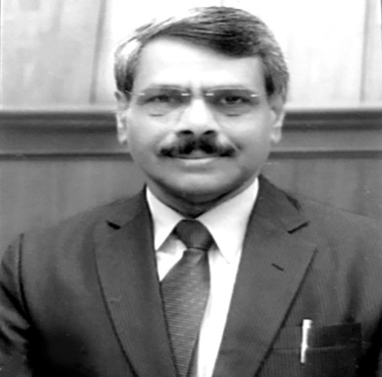

Dr. Arnaud Raynouard is a full-time Professor of Law and Vice-President of University Paris-Dauphine, Paris, France. He is in charge of international affairs of the University. His research is majorly focus on the European Union Law, Globalization and Law & Law & Development/ Economics.
He is associated as Visiting Professor with Zurich University of Applied Sciences, Switzerland, Tulane University (LA, USA), Case Western Reserve University (Ohio, USA), Law Academy of the Department of Justice of the Russian Federation (Russia), Universidad de Valladolid (Spain), Louisiana State University (USA), IFIM Law School, Bangalore, India.



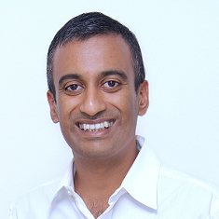
Dr. Sudhir Krishnaswamy is a co-founder of Centre for law and Policy Research and a partner at Ashira Law. He is currently a faculty member at the Azim Premji University. He was also the Dr. B.R. Ambedkar Visiting Professor of Indian Constitutional Law at Columbia Law School.
He graduated from the National Law School of India University (NLSIU), Bangalore (B.A. LL. B). He read the BCL and obtained a D.Phil. from Oxford University. He has been a Teaching Fellow in Law at the Pembroke College at Oxford University, an Assistant Professor at NLSIU and a Professor at the West Bengal National University of Juridical Sciences, Kolkata.
He has authored a book titled ‘Democracy and Constitutionalism in India’ which was published by the Oxford University Press in 2009.
His main areas of interest are constitutional law, legal education, legal theory, intellectual property law and administrative law.

Prof. Dr. T.S. Somashekar is a Professor of Economics at NLSIU, Bangalore. He completed his Ph.D. in Economics from The Institute for Social and Economic Change in 2010. He started his teaching career at St. Joseph’s College, Bangalore, in 1998 and was a visiting faculty in NLSIU between October 2001 and January 2002. He joined NLSIU as a regular faculty in March 2002 and was promoted as Associate Professor in 2012. His areas of interest and research include Law and Economics, Industrial Organisation, Competition Laws and Economics Business Strategy, Public Policy Analysis and the World Trade Organisation.
He was an Erasmus Mundus Fellow in the Institute for Law and Economics at the University of Hamburg, Germany in 2006. In 2008 he was an advisor to the Ministry of Commerce and Industries, Government of Karnataka, to help formulate the industrial policy organisation.
He is a Member of the Advisory Board for the European Doctorate in Law and Economics (EDLE).
In 2009 and 2010 he was selected for the US International Visitors Leadership Program (IVLP) to study US Trade Policy. He has been a visiting professor at the Dedman School of Law, Southern Methodist University, Texas, USA from 2011-2014.



