CALL FOR PAPERS

TWO DAYS NATIONAL SEMINAR

ON

ELECTORAL SYSTEM IN INDIA:

PRESENT SCENARIO & PROSPECTS

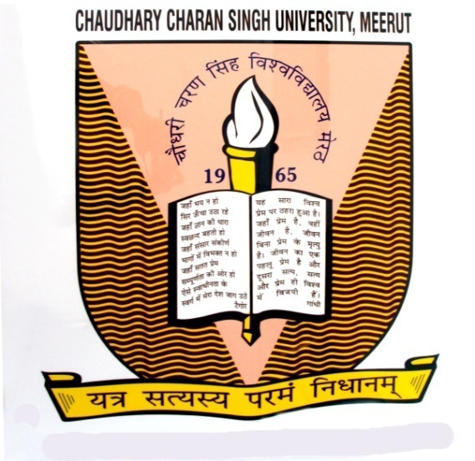

October 06-07, 2018

Venue-
Brahaspati Bhawan, C.C.S. University, Meerut

Jointly Organized by:

Institute Of Legal Studies
&
Manyawar Kanshi Ram Shodh Peeth
Chaudhary Charan Singh University, Meerut (U.P.) India

Dear Sir/Madam,
We are glad to inform that the Institute of Legal Studies and Ma.Kanshi Ram Shodh Peeth, Ch.Charan Singh University, Meerut jointly organizing a two days National Seminar on “Electoral System in India: Present Scenario & Prospects” on October 06-07, 2018. You are cordially invited to contribute.
About The University-
Ch.Charan Singh University (formerly, Meerut University) was established in 1965, to cater to the needs of higher education in western region of Uttar Pradesh. The University has celebrated its golden Jubilee in 2015. Under the leadership of the Hon’ble Vice-Chancellor, a renowned innovative technologist and an established committed academic administrator, the university is offering a large number of new and innovative post graduate, under-graduate, diploma, advanced diploma and postgraduate diploma courses under regular & self-financed scheme in areas of Agricultural Sciences, Humanities, Social Sciences, Journalism, Mass Communication and Multimedia Techniques, Earth Sciences, Teacher and Physical Education, Fine Arts, Legal Studies, Applied Sciences, Home Sciences, Business Studies, Geographical Information System (GIS) and Remote Censoring.
About the Institute of Legal Studies, Chaudhary Charan Singh University , Meerut-
Institute of Legal Studies was established in 2003 by the university with the objectives of imparting legal education. Presently, Institute is running LL.D. (Doctor of Laws) LL.M. and B.A., LL.B. courses. Institute has a glorious track record of producing Judges, Professors, Law Officers, Legal Advisors and other capacity holder in the field of Law.
About the Manyawar Kanshi Ram Shodh Peeth, Chaudhary Charan Singh University , Meerut-
Ma.Kanshi Ram Shodh Peeth was started as a state government funded scheme to enhance the research related activities among the students of social sciences especially those belonging to marginalized sections of the society. The peeth is regularly engaged on this job thorough 30 short term research projects funded by the peeth. The peeth is also publishing a biannual and bilingual national research journal ‘Journal of Socio-Economic Review’ since 2013. The peeth is regularly organizing the seminars/conferences on the various issues related to marginalized sections of the society.
About the Seminar-
Present age is the age of Democracy. India as a state contributed to the world politics as being a largest democratic state in the world. Indian Democracy envisages the Parliamentary System of Government. As being a Democratic State Elections are at the Centre of the Indian Politics. There is a strong commitment to hold free, fair &regular elections by which members of Parliament and Legislative Assemblies are elected. Constitution of India provides for the establishment of Independent body that is Election Commission of India for conducting the Elections.
Election Commission of India has been entrusted with various functions like supervision of nomination of candidates, monitors the election campaign and candidates funding. It also performs other functions like preparing polling booths, holding smooth election, supervising counting of votes, declaration of results and also hears the cases concerning election disputes.
The major law which regulates the election process in India is Representation of Peoples Act 1951. It deals in detail almost all the aspects of conducting elections and post election disputes. If the Act is silent, the election commission has residuary powers under the Constitution to act in an appropriate manner.
In a healthy democracy free and fair elections are the basic premise over which whole system relies, this is the reason why elections are called as festival in democratic countries but with the passage of time, many demerits and vices have crept in the system which seriously undermines the sanctity of modern democratic governments.
Multiplicity of political parties, shortcoming in Anti defection Laws, distribution of incentives to the voters, booth capturing, criminalization of Politics, communal violence and lukewarm response of voters have combinely posed a severe challenge before the healthy democracy of India.
From the very beginning, attempts have been made for electoral reforms e.g., deploying CRPF in polling booths, delimiting the expense of candidates, bar on huge processing and videography of political rallies, use of Electronic Voting Machines. Besides these attempts, some innovative Ideas may be considered. E.g. ban on contesting elections proem two constituencies, linking voter list Aadhar cards, ban on exit polls and paid news , rights to call back the elected representatives, provision of nota .and one nation one election etc.
This is the time to ponder over these issues and initiate sincere attempts in meeting them. This national seminar aims to discuss in depth all these issues in order to arrive at some concrete solution.
The outcome of the seminar will be helpful to policymakers, Government servants, academicians and research scholars. The findings of the seminar will be intimated to the concerned department of Government of India which will be helpful in formulating further policies at later stage.
OBJECTIVES-
- To analyze the role of Election Commission in conducting elections in India.
- To study and analyze the impact of One nation One election policy in India.
- To critically examine the role of Anti Defection Law of India.
- To ponder over the various challenges against free and fair election in modern India.
- To analyze the impact of new techniques and proposed techniques adopted in election procedure in India.
SUB THEMES-
Sub themes identified from discussion are as follows-:
1-Constitution and functions of Election Commission of India.
2-One Nation One Election.
3-Efficacy and Efficiency of anti defection Laws.
4-Challenges against free and fair elections.
5- Relevance of the Representation of the People Act 1951.
6- Communalism, Casteism, Capitalism, Regionalism and Electoral System
7- Evolving techniques of voting, EVM, E- voting etc.
8- NOTA, Right to Reject and Recalling of Representatives.
9- Application of Information Technologies in Electoral Reform Process.

Note-The above sub-themes are illustrative and good papers on somewhat allied issues may also be considered in accordance with the overall theme of the seminar.
Abstract and Paper Submission-
Abstract should be of 400 words including key words. The details of the authors should be submitted latest by September 04, 2018. All the abstracts would be reviewed by expert team, the decision of which will be notified by email on September 05, 2018. Full papers in the range of 3000 to 5000 words to be submitted till September 07, 2018. Abstracts/Papers submitted to the Seminar must be original. The authors are requested to submit the abstract and full papers through e-mail attachment in MS word format to seminarilsccsu@gmail.com
Important Dates
Last date of Abstract submission | 27-09-2018
Abstract acceptance to be notified by email | Within 03 days after submission
Last date of full paper submission | 03-10-2018

Publication-
We will be publishing the quality reviewed papers as a part of the book.

Registration Fee (Rs.)
Teacher/ Academician / Advocate | 700
Research Scholar & Student | 400

(Registration fee includes modest local hospitality including seminar kit, tea, lunch etc. during the seminar. Accommodation may be provided at moderate level on first come first serve basis. However, we may guide the delegates for hotels as per their requirements in Meerut on self payment basis.

Inaugural Session | 06-10-2018 at 10.00 A.M. (Saturday)
Valedictory Session | 07-10-2018 at 03.00 P.M. (Sunday)

(Dr.Yogendra Kumar) (Prof. Dinesh Kumar)
Organizing Secretary Seminar Convener
Assistant Professor, Institute of Legal Studies Director,
Email: juristyogi@gmail.com Ma. Kanshi Ram Shodh Peeth
(Mobile No- 9058995499 / 8279761998) (Mobile No- 9412745595)

