MALAD KANDIVALI EDUCATION SOCIETY’S
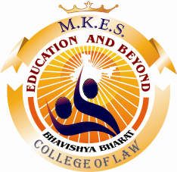M.K.E.S. COLLEGE OF LAW PRESENTS


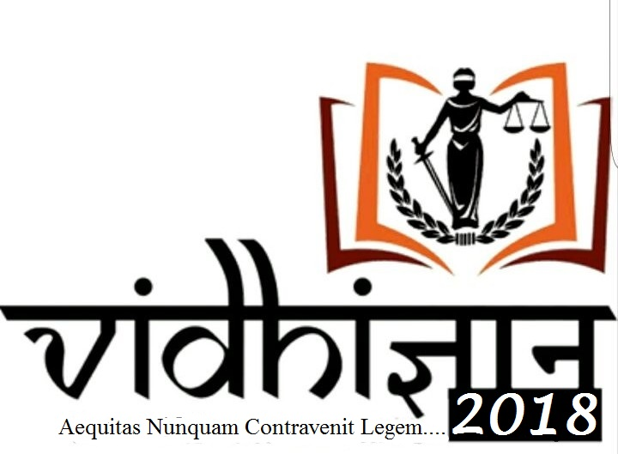
INDEX

- ABOUT THE COLLEGE 3
- ABOUT VIDHIGYAAN 4
- INTRODUCTION 5
- MOOT PROBLEM 6
- RULES AND REGULATIONS 7
- TEAM COMPOSITIONS 9
- REGISTRATION 10
- ROUNDS 1 1
- MEMORIALS 13
- SCORING CRITERIA FOR PRILIMINARY ROUND 14
- SCORING CRITERIA FOR FINAL ROUND 15
- AWARDS 16
- DATES TO REMEMBER 16
- QUERIES AND CLARIFICATIONS 17

ABOUT OUR COLLEGE

Our philosophy on education is driven by our mission of providing integral and transformational education to our students. We firmly believe that education must not be limited purely to academic learning. At M.K.E.S, our focus is to develop all faculties of an individual to ensure holistic development. Mental Education to develop high levels of concentration, Vital Education for the development of one's character, Physical Education for team building and collaboration, and Spiritual Education for the growth of consciousness and the development of values.

Our Vision Bhavishya Bharat
Education for the youth
Education for all
Education for the future of our country

Quality Policy
‘We at M.K.E.S. College of Law are committed to impart quality education to youth, enabling them to develop right attitude, professional competence and inculcating right ethical values.

ABOUT VIDHIGYAAN

‘VIDHIGYAAN’ is law fest festival organized by the students of M.K.E.S College of Law. ‘VIDHIGYAAN’ provides an ideal platform for the students of various colleges to showcase their talents.

It provides an opportunity for students to come together, interact, to get motivated with the experience gained through Participation & Competition. It endeavours to bring together the creativity, intellect and wackiness of youth.

We strongly believe that there is a bit of Art in every heart &‘VIDHIGYAAN’ helps to unleash it. We will strive to make this year’s ‘VIDHIGYAAN’ a big success & attract great participation. ‘VIDHIGYAAN’ shall create history with great success and blossom not only qualitatively but also quantitatively.

VIDHIGYAAN, will not only have legal events such as the moot court competition but also cultural events so as to enhance the participant’s competitive spirit in a multifarious aspect. This year we at VIDHIGYAAN will be covering National Moot Court competition. As we believe to break the boundaries of a cliché law fest. Our participants are the reason VIDHIGYAAN exists.

INTRODUCTION

Mooting being an important part of a student’s life in law school, to hone the talent and skills of young mooters who have only started with their journey in law, M.K.E.S has endeavoured to provide them a suitable platform with this moot court competition.

We at M.K.E.S, believe in the strength of the non-conventional methods for imparting legal knowledge and mooting being an integral part of this method, offers to the law students the art of persuasion and application of the laws to real facts, without having to gain such experience at the risk of inadvertently damaging a real client’s interest.
After the success of our 1st and 2nd Nation Moot Court Competition our Team Vidhigyaan is organizing the 3rd National Level Moot Competition this year which is an attempt to offer students with fair opportunities of learning as it serves as a concurrence of their academic appraisal with pragmatic sensibility.
MOOT PROBLEM

Jitender Sharma was a young boy of 18 years of age. He fell in love with Poonam Srivastav who was a girl of 16 years of age. One day they eloped from their respective homes and finally got married as per Hindu rites and ceremonies. Poonam’s family members were against this marriage. Even her Grandfather and paternal uncle were not ready to accept this marriage at any cost. They threatened Poonam of her life and safety.
Thereafter Poonam’s Father lodged First Information Report (FIR) against Jitender at Gandhi Nagar Police Station, Delhi under Section 363 and Section 376 of Indian Penal Code.
On 05.05.2010, a typed letter signed by Poonam was received at the Gandhi Nagar Police Station stating that ,she had married Jitender with her own will and requested not to file any criminal case against Jitender.
Thereafter on 07.05.2010, Jitender and Poonam were apprehended from Bilaspur in Uttar Pradesh and produced before respective court. Poonam refuse to undergo any medical examination. She did not state anything against Jitender in her statement before the Magistrate under Section 164 of Code of Criminal Procedure, 1973. Thereafter Jitender was sent to Juvenile Home.
Subsequently, Poonam gave in writing that she had left her parents’ home by her own will and went along with Jitender. The court sent Poonam to Nari Niketan for some time. Then on 17.05.2010, Poonam’s custody was handed over to her parents.
Thereafter, on 15.06.2010, Jitender was released. Subsequently, he demanded custody of her wife by filing writ petition in Delhi High Court.
Now argue for the both side and also the law and procedure in the aforesaid matter. Some of the issues are listed below and are not limited to the below mentioned issues. These issues are as follows:
1-Whether Jitender is liable for the kidnapping of Poonam from her legal guardian?
2-Whether the marriage is voidable under the Hindu Marriage Act, 1955?
3-Whether Jitender is liable under Section 376 of Indian Penal Code, 1960?
4-Whether Poonam must be sent with Jitender under Guardian and Wards Act, 1890?

Note: Participants are permitted to raise issues they deem necessary.

RULES AND REGULATIONS

DATE OF COMPETITION

MKES College of Law Inter-Collegiate Moot-court Competition shall be held on 3rd March 2018 at MKES College of Law, Bhavishya Bharat Campus, S.V. Road, Malad (w), Mumbai-400 064.

VENUE OF COMPETITION

Jagmohandas Gokaldas Memorial hall Bhavishya Bharat Campus Malad (w), College Premise.

LANGUAGE

The Competition shall be held in English only.

ELIGIBILITY

Competition is restricted to bonafide regular students of Law school/College/University. All participants must be students of 3 years /5 years law course in the academic year 2017-18
TEAM COMPOSITION

- Each college shall send only one team which shall comprise of Minimum Two and Maximum Three members. This number cannot be modified under any circumstances.
- Each team which consists of three members, shall comprise of Two Mooters and One Researcher. Each team should identify such speakers and researcher during registration. The researcher won’t be allowed to speak except under special cases and only with express permission of the organizers/Judges. If a team consists of Two Members then both of them shall be mooters only.
- Each team will be given a unique team code which will thereafter be the identity of the team and its members.
- During the course of the competition, the identity of the college must not be disclosed to the judges or to any other person. Any such discloser shall lead to disqualification. The decision for the same shall be at the discretion of the organizers.
- The teams of respective institutions shall have to bear travelling expenses although accommodation will only be provided to outstation teams and prior intimation of the same is required.
- The charges for accommodation will be for the whole team for 2 days i.e. 3rd and 4th of March, 2018.

REGISTRATION

Teams must register themselves latest by 1ST MARCH, 2018.

Registration form duly signed by participants and the principal

of the concerned college should be sent to Principal, MKES

College of Law,Bhavishya Bharat Campus , Gate No. 4, S.V.Road , Malad (west), Mumbai – 400064.

REGISTRATION FEES

Rs.3000 /- per team payable by Demand Draft or Cheque in the name of “MKES COLLEGE OF LAW”, at the time of registration.

REGISTRATION FEES FOR ACCOMODATION (OUSTATION PARTICIPANTS ONLY)

Rs.3500/- per team payable by Demand Draft or Cheque in the name of “MKES COLLEGE OF LAW”, at the time of registration.

ROUNDS

1) The Moot court Competition shall comprise of following two rounds.
I) Preliminary Round. II) Semi-final (at the discretion of the college) III) Final round.

2) After inaugural ceremony, the Preliminary Round will commence at allotted classrooms. There will be draw of lots and

The team of each college as per draw may have to argue either for Petitioner or for Respondent.

- Preliminary round is knocking-out round.

- Top two teams of preliminary/ Semi-Final (at the discretion of the college) round shall qualify for the final round and will then argue the same case in the final round on that particular day.

- Participants shall submit Memorials to the host college by
Hand or post latest by 1st March 2018. Late submission of memorials will result in loss of marks for memorials i.e. 30 marks.
- The Memorials shall be typed on A4 size on one side paper with margin 1.5 inches from left side and (1) one inch from the other sides.

- Arguments must not exceed 20(twenty) pages.
- Font: - Times new roman.
- Font size:-14 and for footnotes 10.
- Line spacing:-1.5

7) The memorials shall be submitted neatly and spiral bound in

4(four) copies i.e. 2(two) copies from petitioner’s side and

2(two) copies from respondents side.

- The memorial submitted will not be returned.

- Page numbering should be at bottom middle of each page.

- Covers must be placed on briefs as follows: Petitioner: - Blue colour.

Respondent: - Red colour.

- Identity of the institution shall not be revealed anywhere in the memorial. Instead code numbers allotted to the students should be mentioned. Violation of these provisions shall result in penalties including disqualification. The decision of organizer shall be final in this regard.

- The written memorial shall be in accordance with the High Court rules.

MEMORIALS

The Memorial shall consist of following:-

I) Cover page

II) Table of contents

III) Index of authorities

IV) Statements of jurisdiction

V) Statement of facts

VI) Statement of issues

VII) Summary of pleadings

VIII) Argument advanced

IX) The prayer.

DRESS CODE

The dress code for participants shall be as prescribed by the Bar

Council of India. (Gowns and bands prohibited)

PRELIMINARY ROUND

- Each team will have a maximum of 15 (12+3) minutes to present its oral submissions.

- All the participating teams are expected to carry with themselves case laws and authorities which they intend to refer along with their own copies of memorials.

- The participants during the course of oral submissions will not be permitted to make any audio/visual representation nor will they be allowed to use personal computers, laptops and any other technical or mechanical device.

SCORING CRITERIA FOR PRELIMINARY ROUND

The Marks shall be given as per following criteria for preliminary round

Written memorials- 30 Marks Oral arguments - 50 Marks Time adherence- 10 Marks Overall performance- 10 Marks

Total - 100 Marks

The decision of the judges as to assessment of oral submission shall be final.

FINAL ROUND

In the final round each team will get 30 minutes to present the side allotted to them.

SCORING CRITERIA FOR FINAL ROUND

For final round the marks shall be given as per following criteria:-

Application of law relevant to the case- 20 Marks Advocacy and presentation- 15 Marks

Court etiquettes- 10 Marks

Answers to court questions- 15 Marks Interpretation of and use of facts- 10 Marks Research relevant to the case- 10 Marks Time adherence- 10 Marks

Overall performance- 10 Marks

Total 100 Marks

RESULT

The results will be announced within thirty minutes after the preliminary round. The final results and the winners will be announced during valedictory ceremony. The decision of the judges on the performance of the participants shall be final and binding on all the participants.

AWARDS

- Winner’s trophy +cash prize+ certificate of participation ₹35,000/-

- Runner up’s trophy + cash prize +certificate of participation ₹20,000/-

- Best speaker trophy + cash price+ certificate of participation ₹5000/-.

Certificate of Participation will be given to all participants.

DATES TO REMEMBER

- Date of competition – 3rd March 2018.

- Last date for registration– 28th February 2018.
3) Submission of memorials- 1st March 2018.

FOR ANY QUERIES PARTICIPANTS ARE WELCOME

TO CALL OR EMAIL.

- Vice Chair Person:- Priyal Gogri: +919869586939 vidhigyaanmkes@gmail.com

- Administration Head: Samiksha Rajput: +919820559602

Chair Person:- Sneha Soni: +919833324164 snehasoni96@gmail.com

Moot Court Convener :- Prof. Namrata Shetty: +919769874475

