  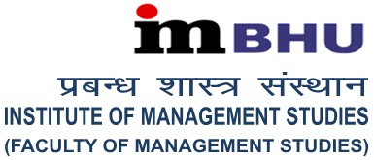 |  | 
Celebrating 50 golden Years of Nurturing managerial minds…

Registration Form No.

(for office use only)

Two-day National Seminar on Mastering Your Mind for Success at Work & at Home
DCI level Three (16-17 February 2018)
Registration Form |  |  |  |  |  |  |  |  |  |  | (space for latest passport size photograph)
  Students / Research Scholar |  | Faculty Members
  Corporate |  | CEO / Secretary
Name
Father’s Name
Date of Birth | (DD/MM/YEAR)
Education / Qualification
Area of Specialization
Designation (for other than students & research scholars)
Name & address of the
Institute / University / Company
Mailing Address:
Ph. No. (Off.) |  |  | Mb.:
Email:

(Signature of the participant)

(Photocopy of the registration form may also be used)
Important Notes:

- There is no registration fee. The registration will be confirmed on first come first serve basis.
- The duly filled in registration form and research papers (if presenting paper) should reach the Office of the Seminar Coordinator latest by 10th February 2018 (either through direct submission or through registered / speed post / courier)
- Entry to the Seminar venue is strictly on production of copy of the confirmation of participation mail from the seminar mail id : nsmms@fmsbhu.ac.in.

