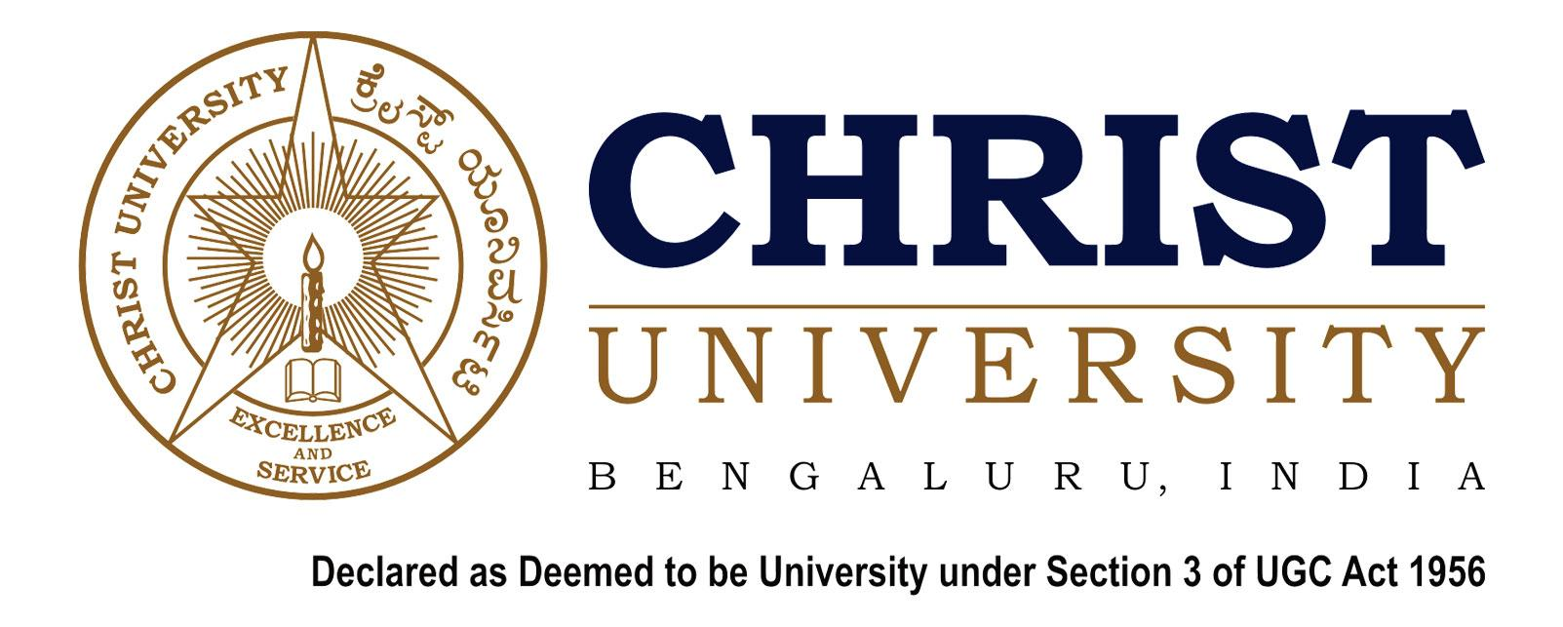

SCHOOL OF LAW

SEMINAR ON THE NEW WORLD ORDER: How major Leaders Are Impacting International Relations
2017

13th and 14th September, 2017

CONCEPT NOTE

CHRIST UNIVERSITY, BANGALORE

Christ University was formerly known as Christ College (Autonomous) and was affiliated to Bangalore University. Established in July 1969, Christ College became the most preferred educational institution in the city of Bangalore within the first three decades. From 1990 onwards it scaled greater heights. With the introduction of innovative and modern curriculum, insistence on academic discipline, imparting of Holistic Education and with the help of creative and dedicated staff, Christ College has been continually rated among the top 10 educational institutions of the country. It has the rare distinction of being the first institution in Karnataka to be accredited by National Assessment and Accreditation Council (NAAC) UGC for quality education. In 2005, it became the first college in South India to be reaccredited with grade A+ by NAAC. In 2006, the UGC had also identified it as an institution with potential for excellence.

SCHOOL OF LAW, CHRIST UNIVERSITY

Located in a beautiful expansive campus of Christ University, Bangalore, SLCU is an institute imparting world class legal education not only to students from various parts of the country but also from around the world. SLCU boasts of unmatched infrastructure comprising of well-equipped audio-visual classrooms, resourceful libraries with the latest legal publications and journals, information centre with all-time Internet connectivity, conference hall, mini auditorium and above all, a conducive environment to study and explore numerous possibilities in life.
The Seminar on ‘The New World Order: How Major Leaders Are Impacting International Relations’, a student-led initiative is proposed to be held on the 13th and 14th of September, 2017 as a part of the Decennial celebrations of School of Law Christ University which shall be organised by the International Relations & Foreign Policy Committee.

THE INTERNATIONAL RELATIONS AND FOREIGN POLICY COMMITTEE

Christ University believes in encouraging student-led Committees that aim to create understanding and awareness on academic fronts. In SLCU, these committees aim to give students an insight into every field of law, by organizing various events such as guest lectures, competitions like Moot Courts and Debates. The International Relations & Foreign Policy Committee is one among the many student led committees in SLCU. It believes in imparting an understanding of the complex arena of international relations to the students.

SEMINAR ON THE NEW WORLD ORDER: How Major

Leaders Are Impacting International Relations

OBJECTIVE AND SCOPE:

The International Relations and Foreign Policy Committee will be hosting a Seminar on “The New World Order: How Major Leaders Are Impacting International Relations” on the 13thand 14thof September, 2017. The world of today is changing and developing at a greater pace than ever before. In such a dynamic environment, our world leaders play a key role in shaping global interactions and future developments. In the past few years, the world has experienced a number of global leaders who have majorly influenced the rise of a new world order. Further, powerful and charismatic leaders are at the helm of affairs in developing nations which are gaining notable space on the global stage. These emerging powers are galvanising the rise of multi- polarity. This Seminar intends to create a platform to bring to fore the role of global leaders in influencing the ideological shift. This new world order that we have been ushered into poses challenges and complexities that the world may never have witnessed. Thus dialogue and discussion at this juncture is important to all of us as Global Citizens.

In light of this, the Seminar shall concentrate on six broad topics:

- United States of America under the leadership of Donald Trump –Withdrawal from major International Treaties, involvement in Middle East and Immigration Policy.
- China under the leadership of Xi Jinping –South China Sea dispute, recent developments in Trade, Military and involvement with North Korea.
- Russia under the leadership of Putin –Changes in Foreign Policy in context to recent developments like-Change in U.S.A. Presidency, situation in Syria, etc.
- India under the leadership of Narendra Modi- Strengthening of ties across the world and rebranding India’s image.
- United Kingdom: Comparative study of Foreign Policy under Theresa May and Jeremy Corbyn in the light of Brexit.
- Contemporary Challenges to the world order-
- Terrorism
- Environmental Protection
- Nuclear Deals
- Military Developments

Any other sub-themes related to the theme of the conference will also be reviewed.

ABSTRACT SUBMISSION:

Participants can submit a short abstract of 300-500 words by 24th August, 2017. Selected abstracts will be called upon for an opportunity to publish.
Final submission of papers: by 5th September, 2017.
Word limit for final paper: 5000- 6000 words.
Paper submission is optional for participants.

TIMELINE:

The Seminar shall be held on two days according to the following timeline.

Day 1: 13th September 2017

9:00 – 10:00 – Inaugural ceremony

10:15 – 11:45 – Session 1

11:45 – 13:15 – Session 2

13:15 – 14:15 – Lunch

14:15 – 15:45 – Session 3

15:45 – 17:15 – Session 4

Day 2: 14th September 2017

9:30 – 11:00 – Session 5

11:00 – 12:30 – Session 6

12:30 – 13:00 –Closing Ceremony
REGISTRATION DETAILS:

- Register through the link given below- https://docs.google.com/forms/d/1CHrdTtHcoWsProtvM_bJGtbSVi2SU06QQLN040DfaHs/viewform?edit_requested=true
- On Spot Registration will be accepted (Subject to availability).
- Students- 500 INR(Rupees Five Hundred)
- Academicians, Teachers ,Professionals- 1000 INR( Rupees One Thousand)
- Accommodation will be provided to the first 100 applicants.

We look forward to your participation in this Seminar. If there are any further clarifications or queries please do contact us.

Warm Regards,

Joshua Moses (Convenor)
(joshua.moses@law.christuniversity.in)
+91-9740897134

Kunal Naik (Convenor)
(kunal.naik@law.christuniversity.in)
+91-9823721712

