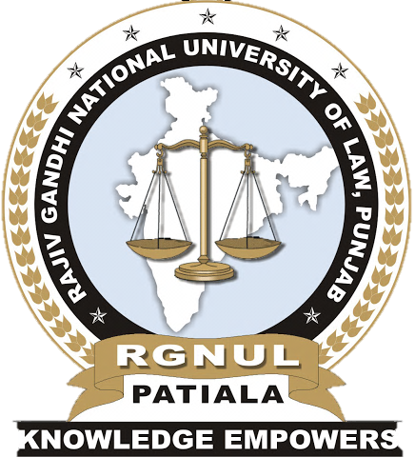
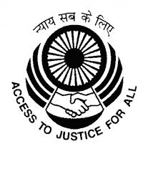

NATIONAL SEMINAR

ON

Access to Justice: Right to Legal Aid and Legal Services in India

ORGANIZED BY

CENTRE FOR ADVANCED STUDIES IN CRIMINAL LAW (CASCL)

IN ASSOCIATION WITH

PUNJAB LEGAL SERVICES AUTHORITY, CHANDIGARH

RAJIV GANDHI NATIONAL UNIVERSITY OF LAW

PUNJAB

ON

AUGUST 5, 2017
Access to Justice: Right to Legal Aid and Legal Services in India
(Theme)

The main objective behind organizing this seminar is to provide a common platform for Academicians, Scholars, Advocates and Administrators dealing with Legal Aid and Social Justice. The Seminar intends to focus on the challenges, strategies and reforms in providing access to Legal Aid to those in dire need of it. The Seminar will also focus on providing Legal Aid to the poor, prostitutes, victims of trafficking, casual workers etc. and any other class of persons in order to ensure access to justice and a life of dignity for them. The Seminar aims to provide a forum to speakers to come up with innovative and practical Legal Aid models, discuss challenges, latest developments and reformative solutions which can contribute further in the area of research and also suggest improvements in functioning of Legal Aid authorities.

Sub Themes:

- Legal Representation And Legal Aid For Undertrials
- Access To Justice Through Legal Aid: Constitutional And Legal Framework
- Legal Services To Women And Juvenile Offenders
- Effective Utilization Of Technology To Advance Legal Aid Services
- Legal Aid For Workers In The Unorganized Sector
- Impact Assessment Of Lok Adalats
- Legal Services To Victims Of Drug Abuse
- Access To Justice For Victims Of Trafficking And Prostitution
- Incorporating Legal Aid Into Law School Curriculum
- Legal Aid For Refugees
- Legal Services To Mentally Ill And Mentally Disabled Persons
- Protection And Enforcement Of Tribal Rights
- Legal Literacy And Financial Literacy
- Developing Networking And Alliance Initiatives For Social Justice
- Legal Aid In Civil Cases
- Any Other Relevant Sub Theme

Call for Papers
Papers are invited from the academicians, practitioners, researchers, scholars and students on the issues related to the above themes. Papers selected by the Committee will be published in the form of an edited book with ISBN No. Only one co-author shall be allowed.

Guidelines for the Papers
An abstract of 300 – 350 words accompanied by a brief profile of the author containing his/her email ID, contact number and official address should be sent. The Paper should not be of more than 6000 words. It must be typed in Times New Roman Font Size 12 on A4 size paper with 1” margin on all sides with 1.5line spacing using MS Word. A uniform system of citation must be strictly adhered to while submitting the abstracts and full paper. All the abstracts and full length papers shall be sent to: casclseminar2017@gmail.com.
Papers may be presented through Video Conferencing with the prior approval of the Organizing Committee, after furnishing satisfactory reasons for failure of physical participation.

Accommodation
Accommodation will be provided as per availability on payment basis at a charge of Rs. 500/- per day.

Registration Details
Registration fees must be sent via demand draft in the name of Registrar, RGNUL, Punjab, payable at Patiala.

Postal Address
Registrar
Rajiv Gandhi National University of Law,
Bhadson Road, Sidhuwal, Patiala, Punjab-147001

Registration Fees
Students - Rs. 500/-
Research Scholars - Rs. 700/-
Professors / Teachers - Rs. 1000/-

Important Dates
Last Date for Submission | July 7, 2017
of Abstract
Date of Intimation in | July 10, 2017
case of Selection of Abstract
Last Date for Submission | July 20, 2017
of Full Paper with
Registration Fees

Organizing Committee

Professor (Dr.) Paramjit Singh Jaswal
Vice Chancellor, Rajiv Gandhi National University of Law

Professor (Dr.) G.I.S Sandhu
Registrar, Rajiv Gandhi National University of Law

Ms. Ivneet Walia
Seminar Convener, Rajiv Gandhi National University of Law
#09646590015
ikwalia@gmail.com

Dr. Renuka Soni
Seminar Co-Convenor, Rajiv Gandhi National University of Law
#08283837176
renuka.salathia@gmail.com

Mr. Raghav Mendiratta
Student Convenor
#09871091717
raghav.mendiratta@hotmail.com

Ms. Shreya Tewari
Student Convenor
#09872465804
tewarishreya@hotmail.com

