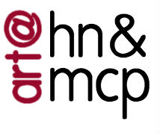
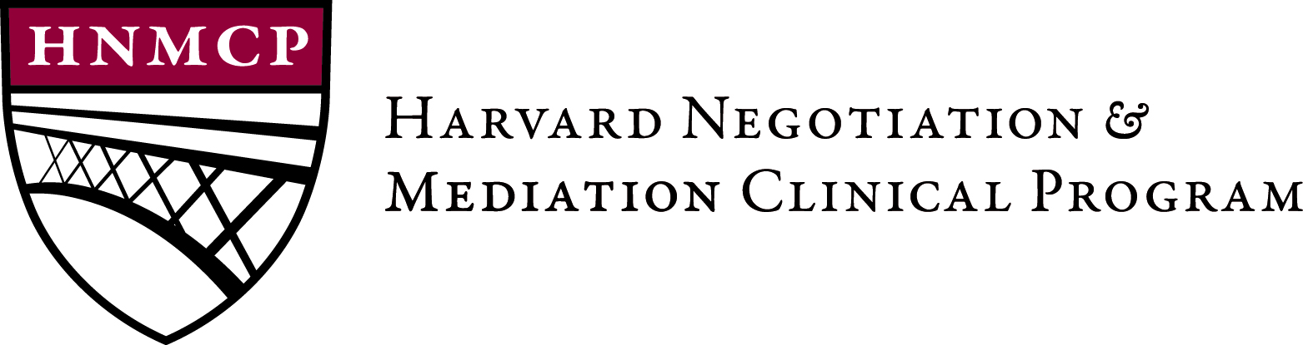

2017 HNMCP Art Competition

ABOUT:
Creative expressions of conflict resolution—whether in photography, on canvas, or through sculpture—promote and advance conflict resolution itself. The Harvard Negotiation and Mediation Clinical Program (HNMCP) builds community around conflict resolution skills and practice, and we want our space to reflect our values. HNMCP seeks to feature creative representations of conflict resolution and peacemaking throughout our space. Artwork will be displayed in our suite on the Harvard Law School campus for a minimum one year, beginning in Spring 2017.

GUIDELINES
- The artwork must be the artist’s original creation
- The use of any medium is acceptable (photography, sculpture, painting, drawing, etc.)
- Applicants may submit as many entries as they wish
- The artwork must be no larger than 4’ x 5’

JUDGING
- The artwork will be evaluated on how well it reflects themes of conflict resolution and/or peacemaking, as well as artistry and creativity
- Winning entries will be selected by a panel of judges, including:
- Robert Bordone, Director of the Harvard Negotiation and Mediation Clinical Program
- Martha Minow, Dean of Harvard Law School
- Lisa Dealy, Assistant Dean for Clinical and Pro Bono Programs

PRIZES
All participants will be notified of a decision in early April. Winning entries will be framed and displayed at the HNMCP office at Harvard Law School for a minimum of one year, with the possibility of extension. Each winner will receive $200 in prize money. All artwork will be returned to its original owners at the end of the display period.

Thank you for your interest in the 3rd Annual HNMCP Art Contest! Please complete this form by Friday, March 17, 2017 and submit it to hnmcpartcontest@gmail.com, along with a high-resolution digital image of your artwork and a completed release form. All participants will be informed of a decision by mid-May. Winners will receive $200 in prize money, and will have their artwork on display in HNMCP’s offices at Harvard Law School for a minimum of one year.

BASIC INFORMATION

NAME:

E-MAIL:

PHONE NUMBER:

AGE:

SCHOOL AFFILIATION (if any):

ARTIST’S BIO (50-75 words):

INFORMATION ABOUT ARTWORK

TITLE OF ARTWORK:

MEDIUM:

DIMENSIONS:

ARTIST’S STATEMENT or DESCRIPTION OF WORK (50 – 250 words):

2017 HNMCP Art Competition Release Form

ARTIST NAME:

SCHOOL AFFILIATION (if any):

TITLE OF ENTRY:

ORIGINALITY CERTIFICATION
I, the undersigned, hereby certify that, to the best of my knowledge, the art entry described above is an original work of my personal creation and that it is neither copied from nor includes any other person’s copyrighted work.

ARTIST SIGNATURE: ____________________________________________

ARTWORK RELEASE
I, the undersigned, represent that the art entry described above is an original work of authorship to which I am entitled copyright protection. In consideration for the acceptance of the art entry by the Harvard Negotiation and Mediation Clinical Program (HNMCP) in the 2017 HNMCP Art Competition, and intending to be legally bound hereby, the undersigned grants HNMCP the right to publicly display the art entry, if it is selected for display, through May 30, 2018 (unless an extension has been given, in which case the final date of the display period will be determined by HNMCP) and in accordance with the rules of the Art Competition.

The undersigned also grants HNMCP the right to reproduce the art entry for any noncommercial purpose, including, but not limited to publishing digital images of the artwork on the HNMCP website. The undersigned hereby releases HNMCP from any and all liability for damage, loss, or misappropriation of the art entry during and subsequent to the Art Competition. The undersigned further agrees to indemnify, hold harmless and defend HNMCP from any and all claims of any nature whatsoever, including, but not limited to, claims of copyright infringement, by any party whatsoever, arising out of or in any way related to the submission of the art entry in the Art Competition.

ARTIST SIGNATURE:___________________________________________________

