

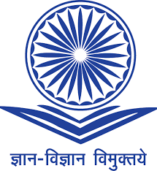
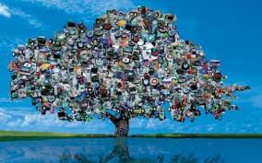
Environmental Law Centre
NATIONAL LAW SCHOOL OF INDIA UNIVERSITY
Bengaluru

UNIVERSITY GRANTS COMMISSION – MRP PROJECT

One Day National Workshop
Law and Management of Electronic Waste in India
Issues & Challenges

27th January, 2017 at International Training Centre, NLSIU

Aim and Purpose of the Workshop:
To Draft a comprehensive Law manual for stakeholders, administrators and Policymakers dealing with e-waste
Concept Note:

Waste Management, especially e-waste is now seen as part of the comprehensive global concern for sustainability. Waste management is also seen as an issue of good governance, which is supposed to be comprised of transparency, effectiveness, openness, responsiveness and accountability. The MoEF has notified the new E-waste Rules of 2016 with an attempt for stricter enforcement and imposing penalty. Yet, the challenges of management and handling of e-waste continues.

The workshop attempts to:

1. Acquaint with the current development of law and emerging trends in the field of e-waste.
2. to study, scrutinize and critique the existing systems of law and governance at domestic
level
3. to identify gaps in the translation and legal application of prevention, precaution, recycle
and reuse.
4. to make policy intervention to strengthen legal and enforcement capacities of law makers
and enforcers, to enable and facilitate compliance with regulation
5. to contribute to the jurisprudence of the subject.

Environmental Law Centre
NATIONAL LAW SCHOOL OF INDIA UNIVERSITY
Bengaluru

UNIVERSITY GRANTS COMMISSION – MRP PROJECT

One Day National Workshop
“Law and Management of Electronic Waste in India: Issues & Challenges”

27th January, 2017 at International Training Centre, NLSIU

TENTATIVE PROGRAMME SCHEDULE

9.00 A M : REGISTRATION

9.30 a m to 10.00 a m : Welcome and About the Workshop

Prof. (Dr.) R Venkata Rao, Vice Chancellor, NLSIU
Prof. M K Ramesh, Professor of Law, NLSIU
Adv. Shyam Divan, Sr. Advocate, Supreme Court of India
Prof. Sairam Bhat, Associate Professor, NLSIU

10.00 a m to 11.15 a m : E-waste law 2016

Chair: Prof.(Dr.) M K Ramesh
Resource Persons
An Overview of the E-waste Law : Ms. Bineesha
Presenting of Draft Report on E-Waste
Mr. Manjeri Subin Sunder Raj, Assistant Professor, NLSIU

11.15 a m to 11.45 a m : TEA BREAK AND PHOTO SESSION

11.45 a m to 01.00 p m : Review of E-Waste Law in India : Issues & Challenges

Chair: Prof. Sairam Bhat
Resource Persons
Mr. Parthasarathy, Founder & M D : EParisara, Bengaluru
Ms. Bineesha, Executive Director, (IIWM)

01.00 p m to 02.00 p m : LUNCH

02.00 p m to 3.30 p m : Way Forward: Suggestions & Critical Analysis

Chair: Prof. M K Ramesh, Professor of Law, NLSIU

3.30 p m to 04.00 p m : Concluding Session

