 SVKM’S PRAVIN GANDHI COLLEGE OF LAW 

Presents

“CONFICIENDIS LEGISLATIVA”
6th NATIONAL LEGISLATIVE DRAFTING COMPETITION, 2017
DRAFT A BILL ON “CROWD FUNDING”

RULES AND REGULATIONS
- Eligibility for participation.
Participation is restricted to students currently studying in the Law colleges only. Law schools/ colleges recognised by the Bar Council of India are eligible to participate in the Sixth National Legislative Drafting Competition, 2017.

- Team Composition.
The team may comprise of a maximum number of 2 members. A maximum of 3 entries are permitted from each institution.

- Registration.
The Students interested are required to send the duly completed registration form to mcs.svkm@gmail.com along with a scanned copy of a Demand Draft in favour of “PRAVIN GANDHI COLLEGE OF LAW”, payable at Mumbai of Rs. 2000/- (per entry) (Two Thousand Only) as the registration fee. The hard copy of the same must be sent to SVKM’s Pravin Gandhi College of Law, Mithibai College Campus, 8th Floor, Bhaktivedanta Swami Marg, Vile Parle (W), Mumbai- 400056.’
The Participants have to send the soft copy of the registration form and the demand draft by 31st of January, 2017 by 16:00 hrs. The last date for sending the hard copy of the registration form and the Demand Draft is 3rd February, 2017.
Both the formalities have to be completed in order to confirm the participation.

- Background Note.

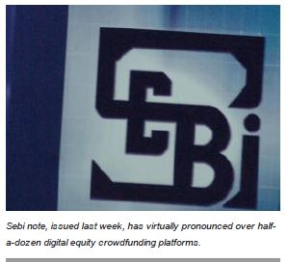
Crowd control: Sebi warning turns off crowdfunding tap for startups
By Shailesh Menon, ET Bureau | Updated: Sep 09, 2016, 05.04 PM IST
MUMBAI: An investor-interest warning notice issued by capital market regulator the Securities and Exchange Board of India (Sebi) has questioned the very legality of equity crowdfunding platforms serving startup companies.
The Sebi note, issued last week, has virtually pronounced over half-a-dozen digital equity crowdfunding platforms (ECP), including prominent ones like Grex, LetsVenture, Termsheet, Equity Crest and Tracxn, as unauthorised, unregulated and illegal. Sebi, more specifically, has also asked Grex Alternative Investments Market (Grex), a two-year old crowd-funding platform, to stop "onboarding" new investors or taking up fund raising mandates from startups, it is reliably learnt.
Such platforms have emerged as a new source of funding for startups. Close to 200 companies have raised Rs. 350-450 crore on these platforms over the past 18 months, according to industry estimates.
"Electronic platforms facilitating fundraising on digital platforms are neither authorised nor recognised under any law governing the securities market," said the Sebi note to investors. "Such platforms, which are open to all investors registered with the platform, amount to a contravention Securities Contract Act and the Companies Act," the regulator has clarified.
According to Sebi, only recognised stock exchanges can provide electronic platforms where equity and other corporate securities could be listed and traded. Incidentally, Sebi diktat comes at a time when ECPs are doing brisk business - enlisting more angel investors and raising "small working capital" (average ticket size: Rs 50 lakh to Rs 6 crore) for startups.
LetsVenture, one of the biggest players, has raised funds for close to 100 companies. "If the Modi government is serious about startups, it should ensure that new businesses raising capital or platforms helping them to raise funds are not harassed," said Vivek Durai, founder of Chennai based Termsheet.
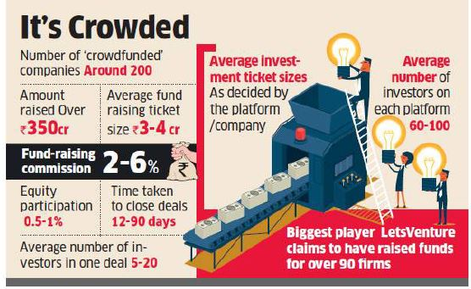
"If funds are raised through private placements on a platform, be it online or offline, it is not for Sebi to decide. Such activities are outside the jurisdiction of capital markets regulator. Sebi cannot stop us from using electronic platforms if we keep fund raising activity in a private domain.”
ECPs help startups to raise funds from multiple investors. These are quite similar to general or social crowdfunding platforms that help charities raise public funds for a specific 'cause.' But there are a few differences.”
ECPs only "parade" their fund raising mandates (startups wanting to raise funds) to a closed group of registered investors. In case of normal crowdfunding, investors do not expect any return from their investments; but in startup crowdfunding, investors expect huge returns.
For their services, crowdfunding platforms charge listing fees, fund raising commission (2-6 per cent of funds raised) and in some cases, 0.5-1 per cent equity participation in companies for whom they’ve raised capital.
“The Sebi advisory leaves a lot of questions like definition of electronic platforms, private placement norms unanswered,” said Abhijeet Bhandari, CEO of Grex. “There’s a need to give easy capital access to startups to thrive. The need of the hour is to have a clear regulatory framework so that platforms can work in India.”
According to sources, Sebi is not comfortable with the structure of ECPs in the country. None of these platforms meet the critical net worth criteria (of Rs 100 crore) required to set up security exchanges. Sebi is also worried about small investors getting sucked into unknown, illiquid companies. Although these platforms cater to a closed set of registered investors, lower investment threshold limits (in many cases, as low as Rs 5 lakh) make them almost "barrier-free."
The regulator, it is learnt, is also unsure about the quality of firms raising funds on these platforms. "Sebi is justified in cautioning investors about such platforms, but it should not limit itself to just that. The regulator should come out with some enabling guidelines which will allow such platforms to co-exist," said Deepak Gupta, co-founder & CEO of Equity Crest.
In developed markets too, ECPs, like AngelList, fall in a regulatory twilight zone. "Some of these platforms have started behaving like stock exchanges," said Sandeep Parekh, former executive director of Sebi and founder of Finsec Law Advisors.

E. Format of the Submission.
- The language for the competition will be strictly English.
- The bill should be typed on A4-sized paper.
- The font used must be Times New Roman, size 12, double line spacing, One-inch margin on each side.
- The font of footnotes must be Times New Roman, Size 10, single line spacing.
- Page numbers must be given at the Top Right hand corner.
- The length of the bill should not exceed 30 pages.
- The cover page of the submission should include the Long Title of the bill along with the name of the Author(s), with the author's designation.
- Format.
The draft of the Legislation should be in the following format:
  - The Long Title
  - The Preamble
  - The Enacting Clause
  - The Short Title
  - Extent and Commencement Clause
  - Definitions
  - The Operative Section
  - Exceptions and Exemptions Clause
  - Procedural Provisions
  - Offences
  - Penalties
  - Provisions regarding Delegated Legislation

- General Rules.
    - The Participants have to send the soft copy of the registration form and the demand draft by 31st of January, 2017 by 16:00 hrs.
    - The Participants have to send the hard copy of the registration form and the demand draft by 3rd of February, 2017 by 16:00 hrs.
    - The Participants have to send the soft copy of the Legislative bill by the 11th February, 2017 by 23:59 hrs.
    - The Participants will have to send 3 Hard Copies of the Bill by 15th February, 2017.
    - Results will be declared on 04th March, 2017.
    - All participants will receive a participation certificate.
    - The organizers shall send the certificates and the prize amount via courier or speed post.
    - Entries sent after the deadline shall be disqualified.
    - Any entry found to be plagiarized will be disqualified.
- Prizes.
    - The Best Team - Cash Prize of Rs. 12,000/- and Certificates.
    - The Runner Up Team - Cash Prize of Rs. 9,000 and Certificates.
    - The Second Runner Up Team - Cash Prize of Rs. 7,000 and Certificates.

For further queries please contact:
Faculty-in-Charge:- Dr. Geeta Kubsad - +91 98202 54446
Student Co-ordinators: - Shrusti Dalal - +91 9619808096
Labdhi Parekh - +91 8655636218

REGISTRATION FORM

(Please fill in block letters)

Name of the Institution: ______________________________________________________
Address: ___________________________________________________________________
Email: ______________________________________ Phone: _______________________
Name of faculty in-charge: ____________________________________________________
Contact details of faculty in-charge: _____________________________________________
 | NAME | PHOTOGRAPH
PARTICIPANT 1
PARTICIPANT2

(Signature of the Head of the Institution)

NOTE: THE PHOTOGRAPH SHOULD BE SELF ATTESTED.

