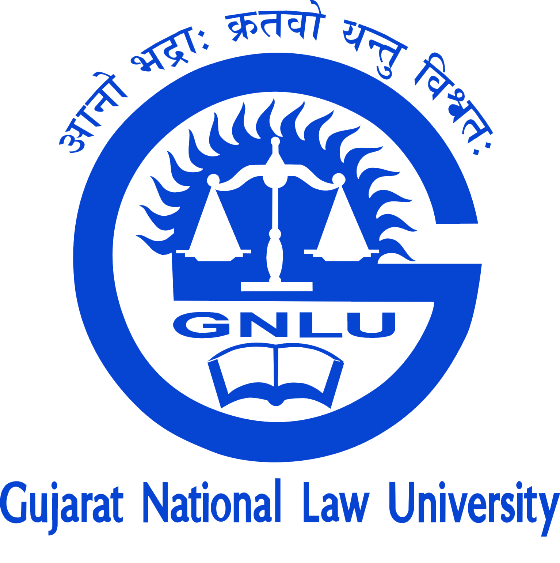 | Gujarat National Law University
------------------------------------------------------------------------------------------------------------------------------------------

IPPO Capsule Course in Patent Drafting
(9th January 2017)
Organised by GNLU Centre for Intellectual Property Rights in collaboration with IPPO.

Details
  About the Course:
  The Capsule Course will explore the practical approach of Patent Drafting and different stages of the same. The Course will be taken by Mr. Gregory L. Maurer, Partner, Klarquist, USA.
  It will be a unique opportunity for dynamic stakeholders like entrepreneurs, IP Professionals, academicians and students to interact with the experienced professionals of the field and by that to learn the practical aspects of dealing with different forms of IP.
Date: 09/01/2017
Reporting Time: 1:30 PM
Session Duration: Two Hours (2:30 PM to 4:30 PM)
Fees: There shall be No Fee for this Course.
Who can apply:
Industry Professionals; Consultants; Practitioners; Academicians; Research Scholars; PG and UG Students.
Certificates shall be issued to participants.
How to Apply: Registrations can be made by sending E-Mail on gnluipr@gnlu.ac.in on or before January 5, 2017. Applicant shall send the mentioned details while registering for the course: Name, Institute, and Mobile Number.
Last date of Application: 5th January 2017.

About the Centre for Intellectual Property Rights:
GNLU Centre for Intellectual Property Rights was established in January 2016 with an aim to promote research, extension and training in the field of intellectual property rights of India. With the aim and vision to incentivize innovative and cutting-edge academic research in the field of IPR Laws, and conducting various training and extension activities for creating more awareness in the field of IPR laws, GNLU has established Centre for Intellectual Property Rights. Centre activities are undertaken under the able guidance of Dr. Nidhi Buch, Assistant Professor of Law; Mr. Hardik Parikh, Assistant Professor of Law; and Mr. Shrut Brahmbhatt, Research Associate along with a group of 3rd, 4th and 5th year undergraduate law students.
About the Intellectual Property Protection Organisation Pvt. Ltd (IPPO):
IPPO provides a central platform to entrepreneurs for various IP related activities that boost networking and implementation, as well as increase awareness through seminars and online guidance sessions. The Micro, Small & Medium Enterprise sector needs to focus on commercialization of technology, promotion of innovative products through IPR Protection, implementation, awareness and training. IPPO, a professional training arm, with an aim to harness and nurture the knowledge of IP amongst the young talented individuals, in-house corporates and those who wish to develop their career in the burgeoning field of Intellectual Property with professional, certified courses.

Address your Queries to:
Mr. Shrut Brahmbhatt,
Research Associate (GNLU-GUJCOST Chair)
E-Mail: gnluipr@gnlu.ac.in
Mo.: 8128650870

