BRIEF DESCRIPTION OF THE RESOURCE PERSONS FOR THE 10th REMEMBERING S.P. SATHE NATIONAL SYMPOSIUM ON CURRENT TRENDS IN INDIAN CRIMINAL JUSTICE SYSTEM
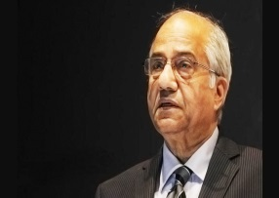
Mr. Justice B. N. Srikrishna
Justice B. N. Srikrishna is a former judge of the Supreme Court of India. He is currently the chairman of Financial Sector Legislative Reforms Commission (FSLRC). He has headed various commissions such as the 'Commission of Inquiry' set up to investigate into the Bombay riots of 1992-93, which became known to all as the Srikrishna Commission. He then headed a one man commission to inquire about the Madras High Court riots of 2009. In 2010, he was appointed as the Chairman of a five member committee called the Srikrishna committee that was constituted to look into the demand for separate statehood for Telangana.

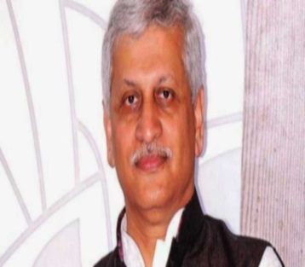
Hon’ble Mr. Justice U U Lalit
Hon’ble Mr. Justice U U Lalit was designated as a Senior Advocate of the Supreme Court. He has been the Special Public Prosecutor in the 2G Scam. He has represented the BJP President, Mr. Amit Shah in the encounter killing of Sohrabuddin Sheikh and Tulsiram Prajapati in Gujarat, former Punjab CM Amarinder Singh in a corruption case, Navjot Singh Sidhu in a culpable homicide and Salman Khan in the Black Buck poaching case. He was elevated to be a judge at the Supreme Court in 2014.
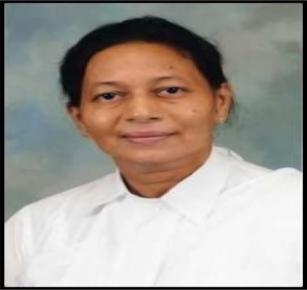
Hon’ble Ms. Justice Mridula Bhatkar
Justice Mridula Bhatkar, an alumnus of ILS Law College, Pune enrolled as an Advocate on February 10, 1982 and has practiced in Pune District in the Civil, Criminal and Family Courts. She was appointed as an Additional Judge of the Bombay High Court on February 10, 2009. She has heard the sensational 7/11 Bombay train blast case in her tenure.
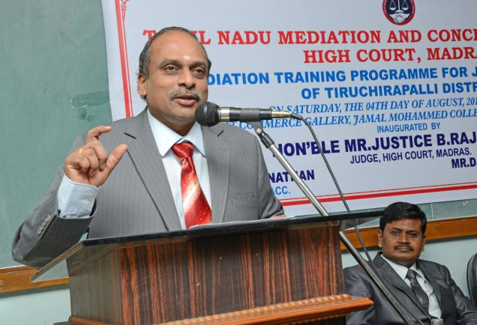
Mr. Justice B. Rajendran
Justice Rajendran commenced active practice on the civil and criminal sides in the District Courts at Tiruchirapalli. Within five years of his practice, in 1983, he was made a member of the Indian Council for Arbitration. Moving on to constitutional courts, he shifted his focus to the High Court of Judicature at Madras in 1994. His expertise ranges from the traditional civil and criminal litigation to the more intense and specialized fields of Constitutional, Taxation, Labor, Company & Service laws. During his years as a practitioner, Justice Rajendran was appointed as an Additional Public Prosecutor for the Tiruchirapalli District. He was later appointed as an Additional Government Pleader (Writs) for the Principal Seat of the High Court at Madras. He was elevated to the Bench of the Madras High Court as an Additional Judge on 30.03.2009, and was sworn in as a Permanent Judge of the High Court on 29.03.2011. Justice Rajendran has rendered several landmark decisions including the transnational taxation judgment in Nokia v. State of Tamil Nadu.

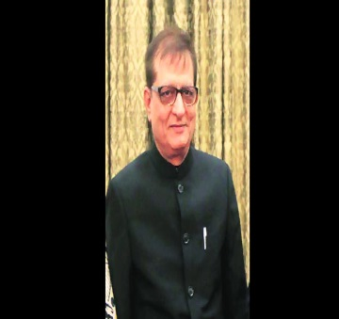
Mr. Justice M. L. Tahaliyani
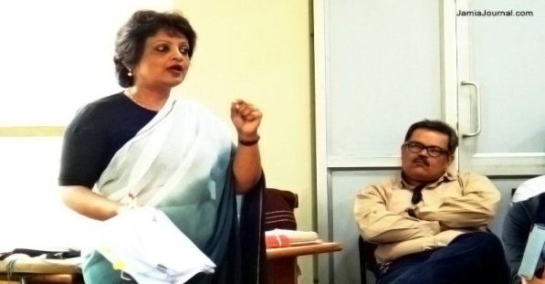
Justice M. L. Tahaliyani is known as a tough and fair judge in the corridors of power. He shot into the limelight after he convicted Ajmal Kasab, the lone surviving terrorist of the 26/11 terror attack on Mumbai in 2008. Tahaliyani pronounced his landmark order on August 29, 2014. He was elevated as a judge of the Bombay City Civil Court later that year and then rose onto become the Principal Judge of the same court in 2010, and in 2011, became a judge of the Bombay High Court. Justice Tahaliyani has presided over several high-profile trials, including the Gulshan Kumar murder case and the money laundering case involving businessman Hasan Ali.
Senior Adv. Ms. Rebecca John
Ms. Rebecca John acquired Membership to the Bar in 1988. She is the first lady lawyer in the field of criminal law to be officially designated as a Senior Advocate by the Delhi High Court. She has argued the famous Harshad Mehta’s case. Her clientele consists of Coca Cola, Reckitt Benckiser, SAIL, and Ispat among others. She has also defended Kobad Gandhy, top CPI (M) leader and was also the counsel for murdered Noida teenager, Arushi's parents, Rajesh and Nupur Talwar. She has also been involved in the other high profile matters such as the 2G scam.

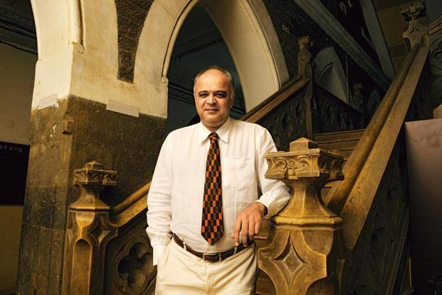
Mr. Yug Mohit Choudhary
Mr. Yug Mohit Choudhary is an erudite scholar who spearheads the death penalty abolishment movement in India. He represents inmates who are on the death row. He was regularly consulted by lawyers appearing for Ajmal Kasab. Some of the other cases he is actively involved in are - the Rajiv Gandhi assassination case (Murugan, Santhan and Perarivalan), Mahindra Nath Das case, Saibanna case in the Karnataka High Court and the 7/11 train blast case for the accused in the Bombay High Court.

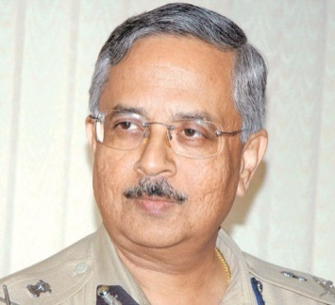
Mr. Jayant Umranikar
A man of intelligence and a master of languages, that in short is Pune’s former Police Commissioner, Mr. Jayant Umranikar. He joined the police as Joint Commissioner of Police in Nagpur and then as Addl. DG (ANO). Subsequently, he became the Commissioner of Nagpur and then went to Pune where he headed the CID before becoming the Pune Police Commissioner. He has also worked in various countries in Africa, Asia and Europe and knows a number of languages. He is known for using his linguistic skills for better communication with people. He is known for his expertise in international communication, terrorism, Islamic fundamentalism and nuclear issues.


Mr. Sandeep Sachdeva
Mr. Sandeep Sachdeva has a rich experience in consultancy and in litigation. He has guided various MN clients and Indian business houses on indirect tax matters. Over the years, he has worked on entire gamut of indirect taxes, gaining significant expertise. He has successfully argued matters relating to Service Tax, Central Excise and Customs before the CESTAT and other departmental authorities and assisted the senior Attorneys before the higher courts. He regularly delivers talks on various topics relating to indirect taxes.

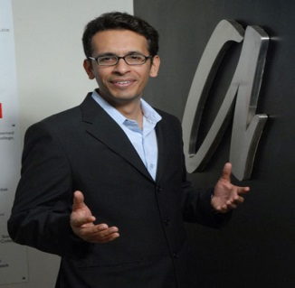
Mr. Rohas Nagpal
Mr. Rohas Nagpal is the founder President of the Asian School of Cyber Laws. He advises Governments and corporates around the world in cyber-crime investigation and cyber law related issues. He has also assisted the Government of India in drafting rules and regulations under the Information Technology Act, 2000. Apart from being the president of the Asian School of Cyber Law he is also the Senior Partner, TechJuris Law Consultants, Chief Consultant at Cyber Shield Information System Assurances Pvt., visiting faculty in Technology Law with various law colleges and Universities. He has also authored several books, papers and articles on cyber law, cyber terrorism, cyber-crime investigation and financial law.

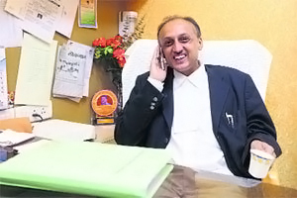
Adv. Mr. Harshad Nimbalkar
Senior criminal lawyer Harshad Vasantrao Nimbalkar is a name to reckon with in the legal fraternity. He has fought over 2,000 cases in various Sessions Courts in Pune, Baramati, Ahmednagar, Aurangabad and Solapur. He was the Public Prosecutor in the sensational Nayana Pujari case and the Govind Pansare murder trial. He is currently the Chairman of the High Court Bench Action Committee, a panel set up to pursue the demand of establishing a separate bench of the Bombay High Court in the Pune region.

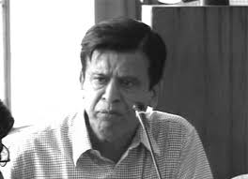
Senior Adv. Dhairyasheel Patil
Dhairyasheel Patil is a Senior Advocate from Maharashtra and former chairperson of the Bar Council of India. He has a wide range of experience in various criminal matters. In one such instance, he wrote about how the criminal justice system was gradually becoming extraordinarily harsh to poor. He has also stressed on the need for a reform in the Criminal justice system. A system which is marred by the fact that persons accused of crimes are let go at the drop of a hat without any regard to the victims of the crimes committed by them. He has also added to the woeful state of affairs wherein the under trials are kept in prison for an unduly long time. He adds that all of this needs a shakedown and a reform.

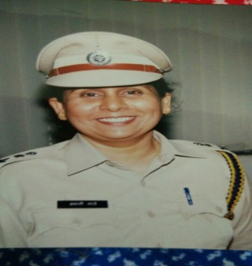
Ms. Swati Sathe
Mrs. Swati Sathe was formerly in-charge of the Arthur Road Jail who reformed the system of administration by squashing the corrupt practices rampant among the inmates. She holds a Masters in criminology and correctional administration from Nagpur University in 1990. She has the distinction of being the first woman jail superintendent in India. She is known as the iron lady who is currently the DIG Prisons, Western Region, Maharashtra.

