
CENTRE FOR PUBLIC LAW, ILS LAW COLLEGE, PUNE PRESENTS
1STCONSTITUTIONAL LAW OLYMPIAD
22nd JANUARY 2016
DO YOU FIND THE INDIAN CONSTITUTION FASCINATING???
DO YOU QUOTE FUNDAMENTAL RIGHTS AT EVERY CHANCE???
DO YOU WISH TO EXPLORE THE VARIED FACETS OF OUR CONSTITUTION???
IF YES, THEN READ ON…
Commemorating the 125th Birth Anniversary of Dr. B.R Ambedkar, Centre for Public Law, ILS Law College is proud to announce its 1stConstitutional Olympiad – A novel initiative to promote Constitutional studies and evolve multi-dimensional perspectives in students. With the rapidly changing socio-economic landscape and the rise of a ‘glocal’ world, Constitutional philosophy is acquiring a new significance. With this in mind, the 1st Constitutional Law Olympiad encourages students to:
- Engage with Constitutional Law earnestly.
- Distil its major aspects and apply them creatively to address contemporary socio-legal issues.
ELIGIBILITY: Students from any discipline interested in Constitutional Law.
VENUE: ILS LAW COLLEGE, PUNE TIME: 3:00 pm – 4:30 pm
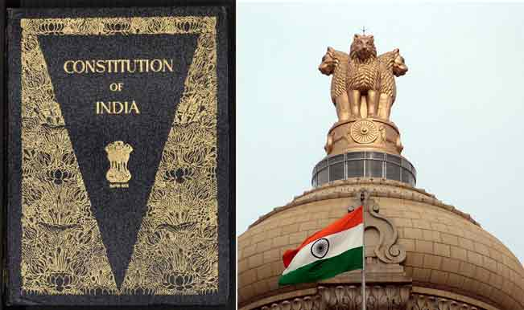
PRIZES:
1st Prize: Rs. 5000 + Citation
2nd Prize: Rs. 3000 + Citation
3rd Prize: Rs. 2000 + Citation
(All contestants shall receive a Participation Certificate)
RULES:
- 100 Marks Multiple Choice Question Test: 100 questions to be answered in 90 minutes.
- There will be negative marking. 1/3rd marks shall be deducted for every wrong answer.
- Syllabus: Up to date text of the Indian Constitution as it stands on 1st January 2016 + Current newspaper articles and leading case laws + National Working Committee Report on the Reviewing of the Constitution.
- Registrations: 9th December 2015 – 18th January 2016. Registration Fee: Rs.351/-
- Mode of Payment: Preferably Electronic Transfer. Details: INDIAN BANK DECCAN BRANCH A/c No: 490076558, IFSC CODE IDIB000D007. Beneficiaries Name: ILS Law College. Kindly mention in the remarks that this money is for participation in the Constitutional Olympiad. Contestants making online payment are requested to mail their details (Name, College, Class, Mobile No and Transaction Id to centreforpubliclaw@gmail.com.
- Students can also register in person in the office of Dr. Sanjay Jain, ILS Law College from 11.00 am – 3.00 pm, excluding holidays.
- The list of the contestants with seat numbers and halls shall be displayed on the blog and notice board of the Centre for Public Law, ILS Law College on 18th January 2016. Kindly refer to the college website (www.ilslaw.edu) and blog website (https://ilscentreforpubliclaw.wordpress.com/) for updates.
- The College reserves the right to make any changes regarding the competition as may be deemed necessary.
- For any clarifications email to centreforpubliclaw@gmail.com. You may also contact student co-ordinators of this competition for any clarifications. [Ankit Miglani – 7276358720, Jelsyna – 7276750442,Akrity – 9561780236 , Gnanusha - 7768060959]

