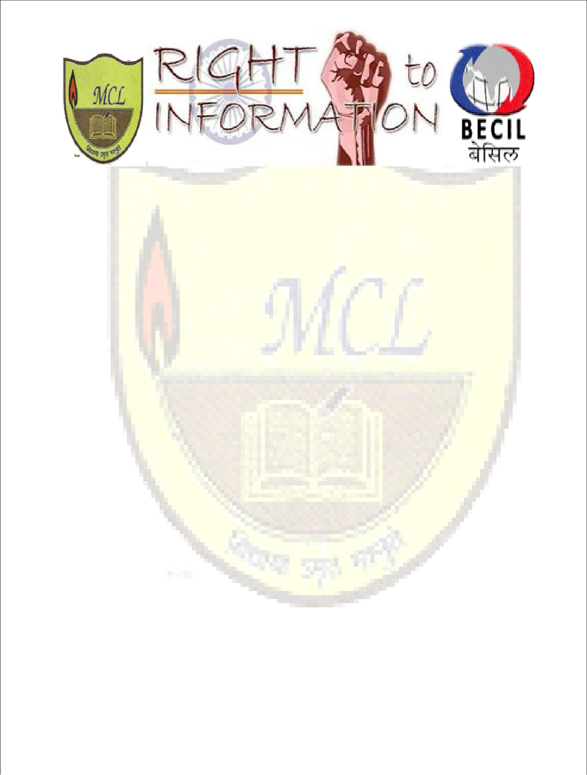

Modern College of Law organizing

National Conference

ON the occasion of Constitution Day

(November 26, 2015)

In collaboration of Broadcast Engineering Consultants India Ltd.( BECIL)

On

“An Audit of the 10 Years of Right to Information Act 2005: Issues and Challenges”

Modern College of Law

Affiliated to C.C.S University
Anand Industrial Estate, Mohan Nagar, Ghaziabad

Ph: 0120-4900197

About the College

MCL set up under the aegis of Ganesh Shiksha Samiti, a registered non-profit body, the Modern College of Law, has dedicated itself to search out the young men of substance and shape in their abilities to take on the challenge ahead of them, at a global level. The alacrity of the professionals passing out the gates of institute must catch up the speed of super computers measuring in nanosecond. And their grey cells must store up information pools in volumes that gigabyte is but a small unit to keep track on them. But, above all, the experts from all walks of life acting as the friends, philosophers and guide of these vastly talented pools in the institute ingrains the humane approach that is so highly essential for success in any discipline.

With strong emphasis on justice and personality development our students are trained to be not only efficient and smart but also technically sound.

The college is located in a sprawling campus at Mohan Nagar, Ghaziabad at a compatible distance of 10 Km from Delhi. It is very well connected by road and Train. Railway station of Sahibabad and Ghaziabad are equidistantly located and it takes hardly 10 mins. To reach college by public transport this is abundantly available.

About the Knowledge Partner

Broadcast Engineering Consultants India Limited (BECIL) an ISO 9001:2008 certified, Mini Ratna public sector enterprise of Government of India was established on 24 March 1995 and provides project consultancy services and turnkey solutions encompassing the entire gamut of radio and television broadcast engineering, viz, content production facilities, terrestrial satellite and cable broadcasting in India and abroad. It provides associated services like building design and construction, human resource related activities like training, providing manpower etc. It also undertakes supply of specialized communication, monitoring, security and surveillance systems to defense, police department and various Para-military forces. The operations of BECIL were headquartered in New Delhi and the company now has its Corporate Office in Noida and Regional Office in Bangalore.

About the Conference

The Right to Information Act, 2005 was enacted with the avowed objective of providing an effective framework for effectuating the Right of Information recognized under Article 19 of the Constitution of India and to provide for setting the practical regime of RTI for citizens to secure
access to information under the control of public authorities in order to promote transparency and accountability in the working of every public authority.
With the expansion of economy, people's quest for right to information has increased and so has the demand for the inspection of record held by the Government departments and various public authorities. Perhaps, because of the apprehensions that the masses may not get alienated, the Government thought it imperative to initiate steps to bridge the gap with the people through the Right to Information Act and ultimately diminish the aura of mystery around the decision-making and functioning of the Government.
12 October 2005 marked the beginning of an era of empowerment of a special kind in India. It was the day on which the Right to Information Act 2005 came into force in India that empowered every citizen of India to question the acts and omissions of public servants and government bodies and take legal course if they are not convinced with the explanations given. In fact, way back in 1975, the Supreme Court of India recognized the right to information to be a fundamental right of every citizen of India under Article 19 of the Constitution of India. This was followed by a series of progressive decisions by the Supreme Court elaborating this right. Yet, realistically, citizens could not really enjoy this right. An archaic colonial law known as the Official Secrets Act 1923, reinforced by a bureaucratic mindset which had been conditioned over decades that it was accountable to no one, ensured that the right to information remained an illusory concept for the people of India. It was as a result of years of campaigning at the national and regional level that the right to information gradually started taking a real form – first through legislation passed by certain states and then by the Centre through the Right to Information Act 2005 (RTI Act).

Since its inception, the RTI has been used by several citizens, workers and activists to the advantage of millions of common masses of India. However, there still exits a huge gap at its implementation stage between government officials and common masses. At one hand, government officials tend to maintain secrecy of information and try their level best not to disclose the right information to general public as they risk losing their faces on account of inefficiency at work, corruption and overspending of tax payers money and many officials have learnt the fine art of how to confuse the applicant, provide misleading information or claim that the requisite information is exempt from the RTI. On the other hand, common citizens awakened by their rights and under the influence of internet, mobile phone and social media boom continue

to empower themselves through increased connectivity among themselves, and continuous use of RTI, the tool that helps in maintaining check on the government officials.

Papers are invited on the following Sub-Themes

- Indian Constitutional visa-a-vis Right to Know

- Pros and Cons of RTI
- RTI and Judiciary
- Right to Information and role of media
- RTI as a tool of maintain transparent good governance
- RTI in service sector
- Protection for ‘whistleblowers’
These subthemes are not the constrains, the related issues can also be explored.

Call for paper

Research papers are invited from the academicians, practitioners, researchers, scholars and students on the issues related to above themes. It is also proposed that the selected papers by the Committee will be published in a special volume of the Conference in the form of an edited book with ISBN No. Author of selected abstracts would be given an opportunity to present their paper as per requirement of the theme during sessions on the day of the Conference.

Guidelines for Submission of research paper

An abstract should contain 300 – 350 words accompanied by a brief profile of the author indicating his email ID, contact number and official address. Paper should not be of more than 5000 words. It must be typed in Times New Roman Font Size 12 on A4 size paper with 1” margin on all sides with 1.5 line spacing using MS Word. A Uniform Formatting Style must be strictly adhered to while submitting the abstracts and full paper. Those who want to contribute

their paper in Hindi submit their paper and abstract according to universal norms. Please adhere the guidelines of copyright while submitting the papers. The papers will be submitted according to the date mentions in schedule at the address mcl.conference2015@gmail.com. In case of any quarry please contact at 09711149736.

Registration details

Registration fees by demand draft in the name of Modern College of Law payable at Ghaziabad must reach on or before 20 November 2015 on the address mentioned below along with the single side printed hard copy of the paper or bring one hard copy of your research paper at the time of presentation. Registration at the spot is also available.

Modern College
Anand Industrial Estate, Mohan Nagar, Ghaziabad
Ph: 0120-4900197

Registration fee
  Students & Research Scholars | 300
Teachers & other persons | 500

Co-author* : Rs. 600 (For students & Research Scholar) & Rs. 1000(For Teachers& other person)- *Only two authors per paper permitted

*The fee will include kit, food and local hospitality. T.A and accommodation are not provided by the college so it is requested to make their own arrangements.

Important dates

Last Date of Submission of Abstract | ₃₁st | Oct.
Notification of Abstract Paper | 4th November
Full Paper Submission (Soft Copy) | ₁₆th | November
Full Paper Submission (Hard Copy) & Registration Fees via | 20th November
Registered Post only.
Patron- In-Chief |  | Patron
Mr. Vineet Goel |  | Dr. Nisha Singh
(Secretary, MCL) |  | (Principal, Modern College)
Conference Convener
Dr. Pooja Singh
(HOD Law)

Conference Coordinators
- Ms. Shalini Tyagi (Assist. Prof.)

- Mr. Pradip Kashyap (Assist. Prof.)

- Ms. Pooja Chaudhary (Assist. Prof.)

- Mr. Arjun Dabas (Assist. Prof.)

- Mr. Pradeep Singh (Assist. Prof.)

Student Coordinators

- V.P Singh (3rd Year) 08750050078

- Purnima (3rd Sem) 09818689439

- Ravi Kumar (1st Sem) 9810268481

- Praveen (1st Sem) 9910902805

- Leelawati (1st Sem) 9868254995

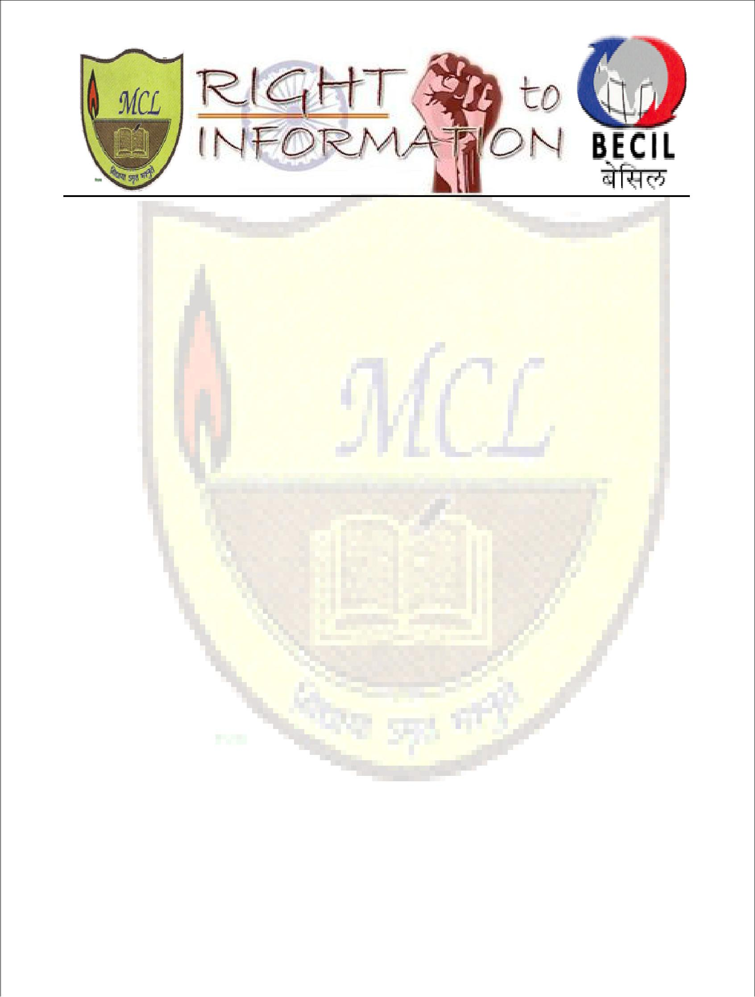

Registration Form National Conference on

The occasion of Constitution Day (November 26, 2015)

Organized by Modern college of Law

In collaboration of Broadcast Engineering Consultants India Ltd.( BECIL)

“An Audit of the 10 Years of Right to Information Act 2005: Issues and Challenges”

Name: _______________________________________________________

Designation: __________________________________________________

Institution _____________________________________________________

Postal Address: ________________________________________________

_____________________________________________________________

Phone No. (Cell) ______________________ (Office) ____________________

E-mail Id: ___________________________

Are you presenting a Paper? Yes ⁮ No ⁮ Title of the paper: ____________

Details of the Bank Draft: Draft No. ____________________________

Date: __________________

Place: ______________________________

Issuing Bank ______________________

Signature of the Delegate ______________________

Please mail the completed registration form to: mcl.conference2015@gmail.com Photocopies of Registration Form may be accepted

