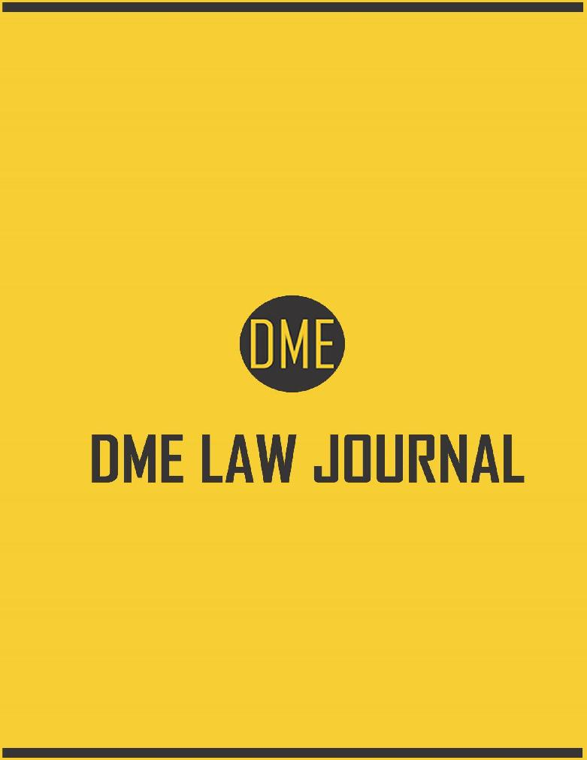
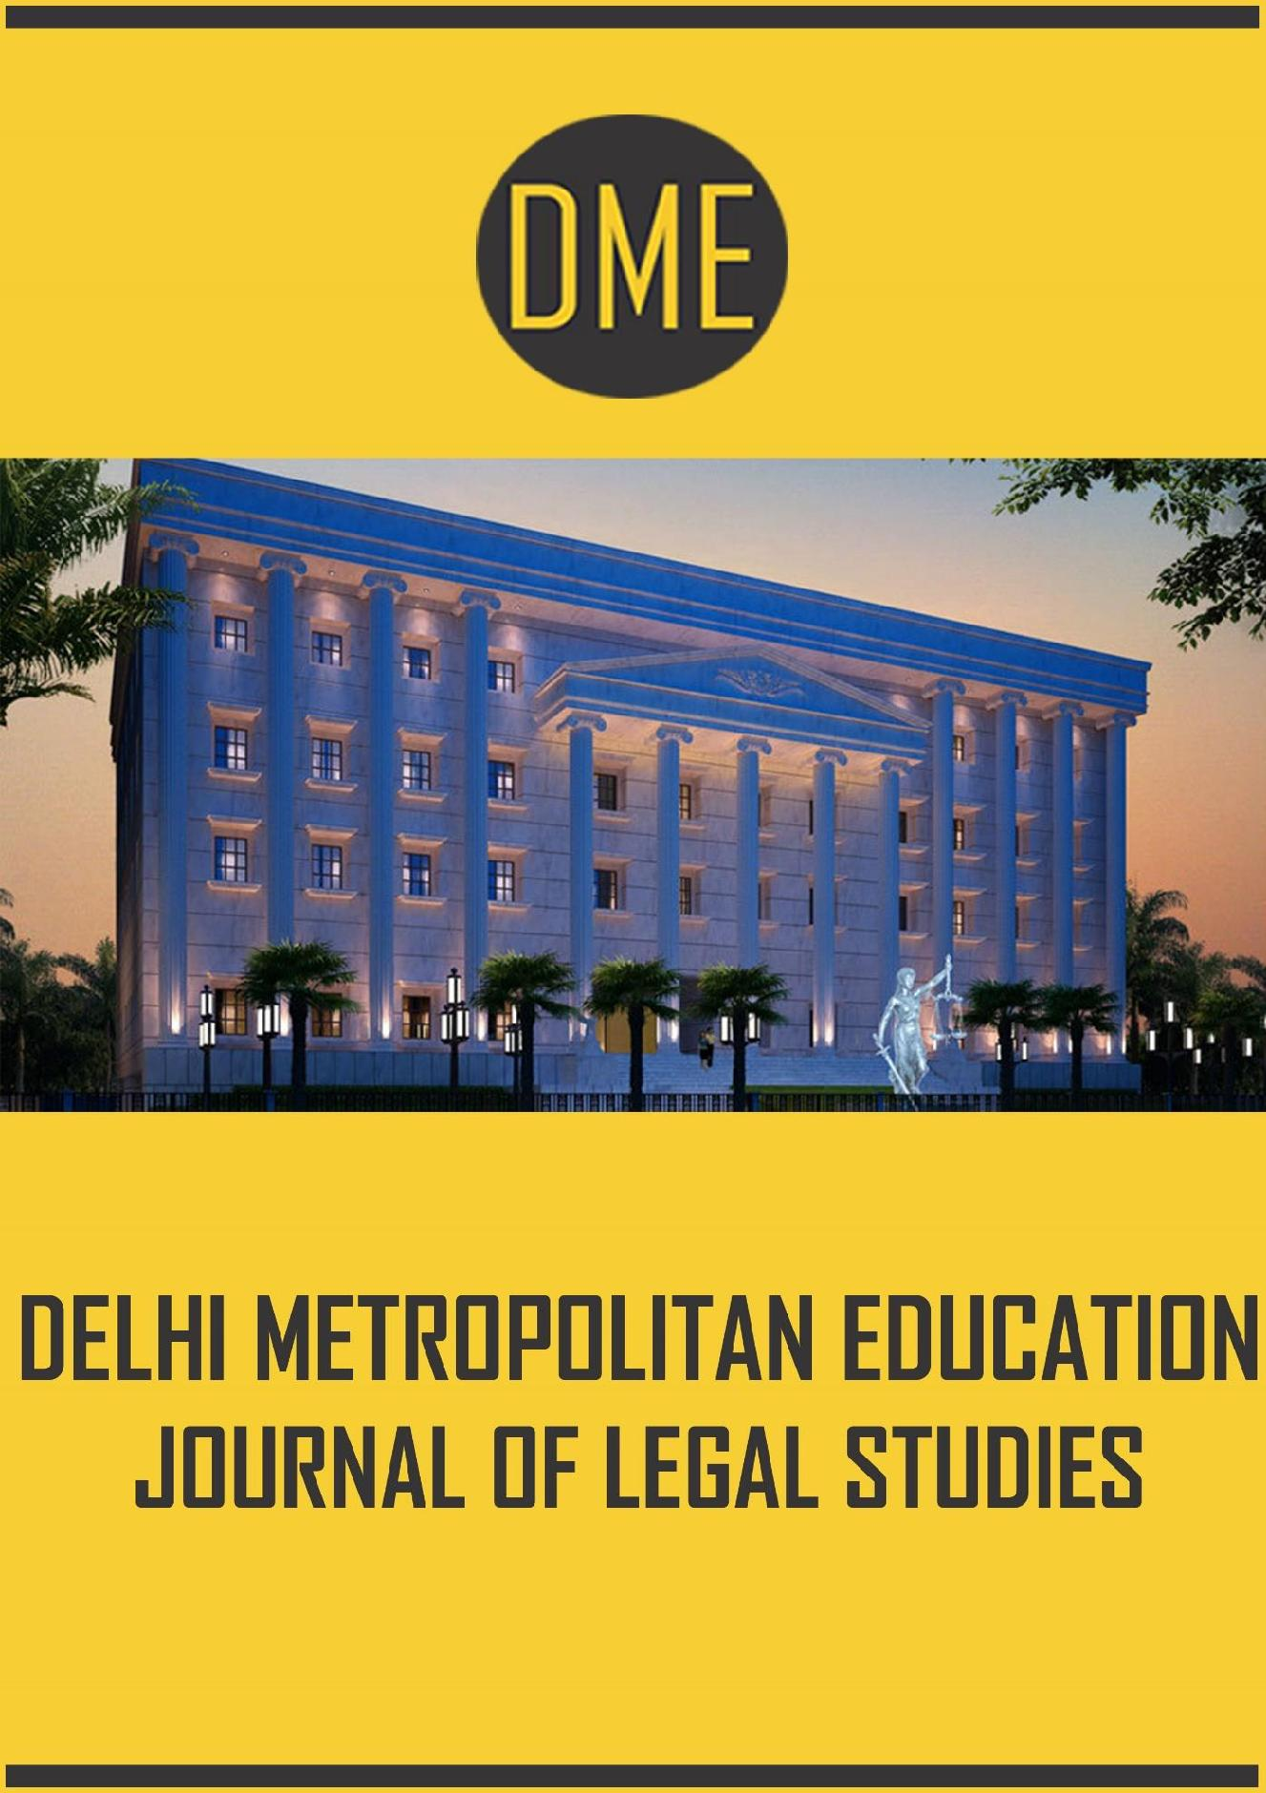
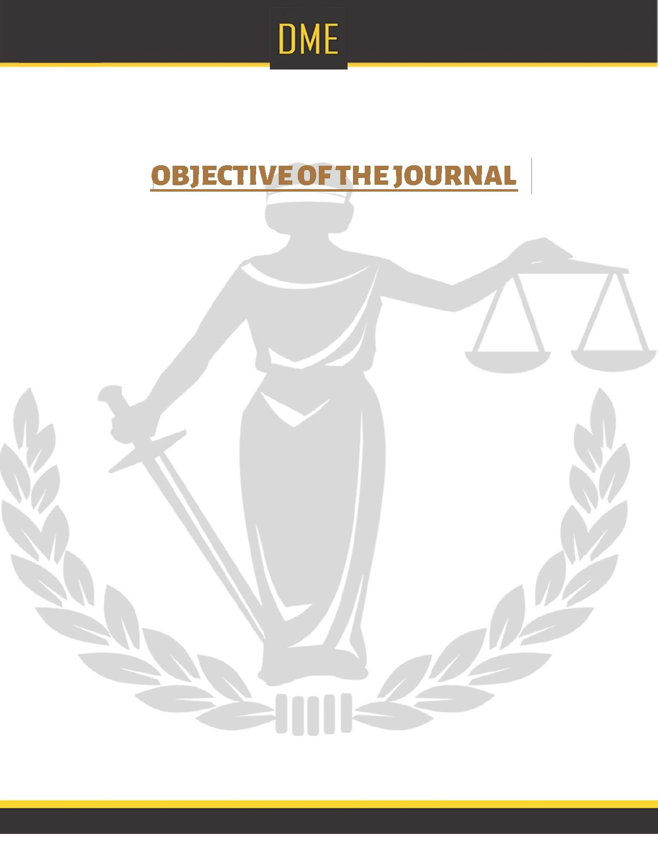

To promote and encourage, especially Law Scholars and Professionals, to take active part in research and get acquainted with the latest developments in the field of Law. To promote cooperation in the pursuit of knowledge in general and exchange ideas in the field of Indian and International Law in particular.

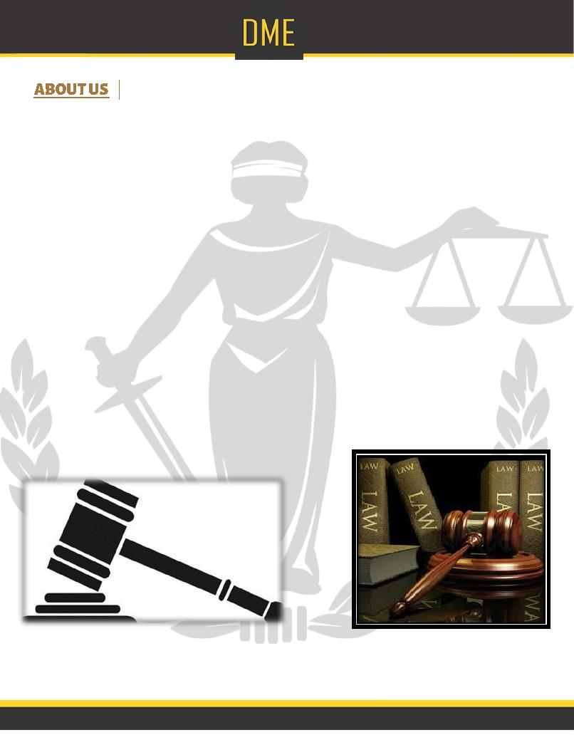

Welcome to Delhi Metropolitan Education, a premier educational institute affiliated to Guru Gobind Singh Indraprastha University, New Delhi and approved by Bar Council of India. At DME, we extend first rate infrastructure with strong academic facilities to provide a dynamic and clinical grounding for success.

The courses being taught here are:

- BA.LLB & BBA.LLB

- BBA

- BJMC

Our society has been involved in education over the last 12 years. We are running the esteemed Mayoor School, Noida in collaboration with Mayo College, Ajmer. The school campus is spread over ten acres and the school has over 3000 students enrolled currently.

Our sister college is Delhi Technical Campus at Greater Noida which provides the most sought after programmes affiliated to Guru Gobind Singh Indraprastha University and is approved by All India Council for Technical Education (AICTE) . The institute imparts technical education in the fields of engineering, architecture and MBA.

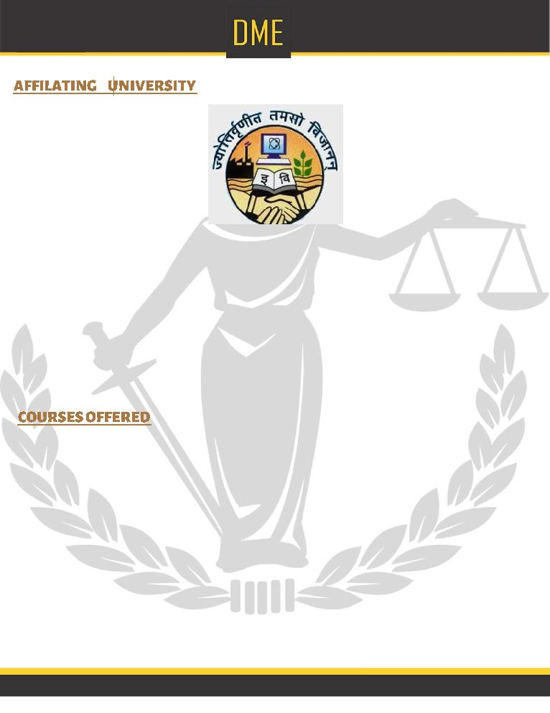

Guru Gobind Singh Indraprastha University is a public, professional state university located in Delhi, India. Founded in 1998 by Govt. of NCT Delhi as a state University, it is a teaching-cum-affiliating university which has been graded ‘A’ by NAAC .The University has received the Platinum Technology Award for quality and excellence in the field of education, in Geneva, Switzerland. Guru Gobind Singh Indraprastha University is a member of the Association of Commonwealth Universities, Association of Indian Universities, and Medical Council of India.

B.A.LL.B/ BBA.LLB is a professional degree course that equips the students with knowledge and skill of every branch of law and making them articulate, accurate and meticulous in plaint-drafting and sharp in court-arguments. The five-year Integrated Honours Courses of Law are fine-tuned to provide in-depth knowledge and analytical power to the students. The courses have been selected and structured to meet their aspirations of practising in the courts as well as in the corporate houses of the MNCs. Moreover, our courses have been designed in such a fashion that the students get imbibed with the social and moral values, to be a good citizen first and a law-practitioner afterwards.

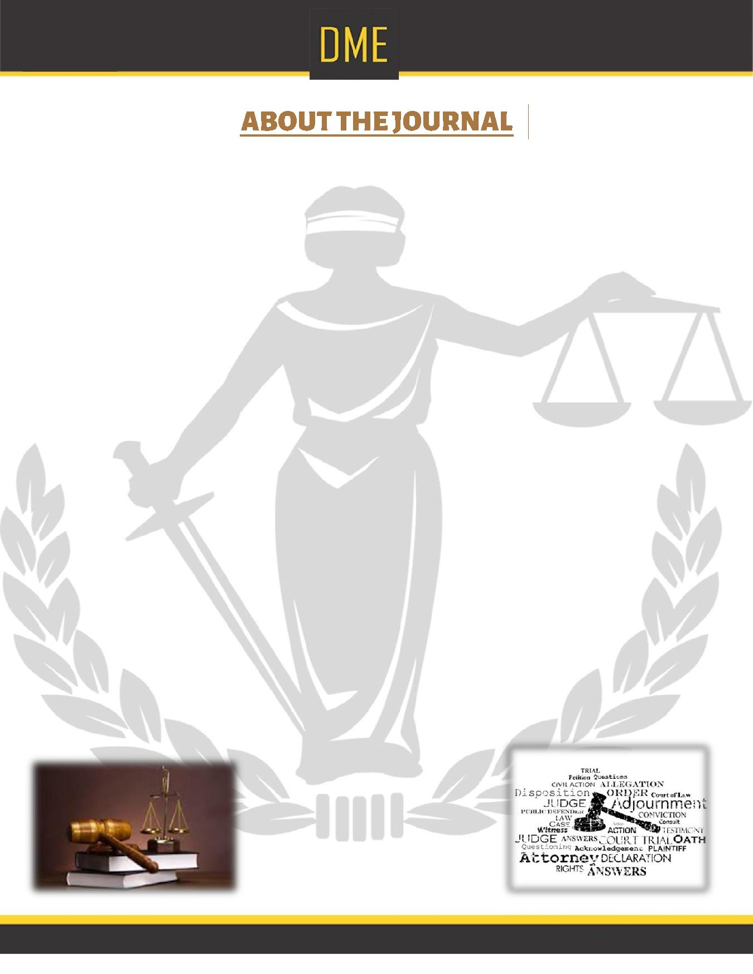

The Delhi Metropolitan Education Journal of Legal Studies (DMEJLS) is a peer-reviewed and interdisciplinary academic annual law journal focusing on various law issues in world as analysed by lawyers, economists, political scientists and others drawn from throughout the continent and the world. The journal, which is initiated by the DME School of Legal Studies aims to serve as the leading forum for the thoughtful and scholarly engagement of a broad range of complex issues at the intersection of law, public policy and social change in world.

DMEJLS places emphasis on presenting a diversity of perspectives on fundamental, long-term, systemic problems of human rights and governance, as well as emerging issues, and possible solutions to them. Towards this end, DMEJLS encourages critical reflections that are based on empirical observations and experience as well as theoretical and multi-disciplinary approaches.

It is hoped that articles appearing in the journal will influence public policy in India by providing original, useful and timely critiques of legislation, judicial decisions, law reform and other domestic and foreign policy measures that impact on the daily lives of ordinary India. In addition to articles, the journal welcomes reports on recent conferences, workshops and seminars as well as books for review and lists of recent publications.

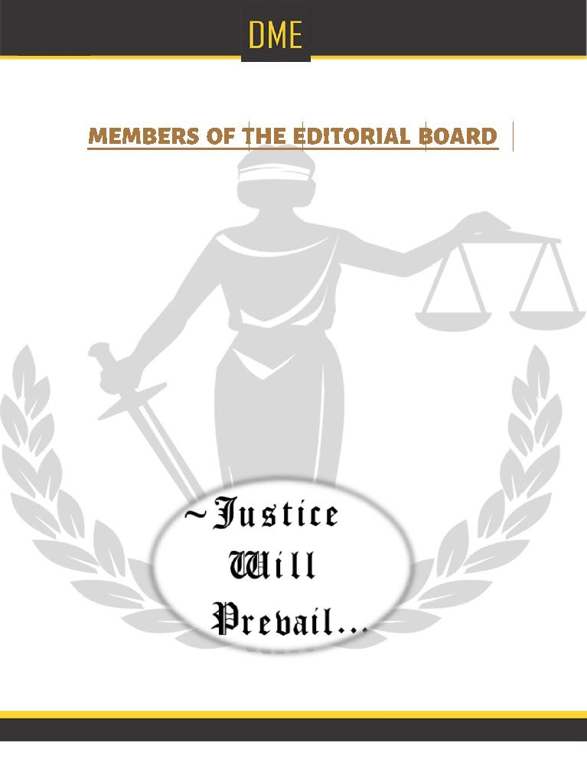

- Patron-in-Chief: Mr. Vipin Sahani, Chairman, Delhi Metropolitan Education.
- Chief Advisor: Justice Bhanwar Singh, Director Genereal, Delhi Metropolitan Education.
- Advisor: Mr. Dr. Prof. Vikram Dutt, Principal Academics, Delhi Metropolitan Education.
- Editor In Chief – Dr. Prof. Rama Sharma, Head of the Department of Law, Delhi Metropolitan Education.

- Associate Editor – Mr. Rupendra Singh, Assistant Professor, Department of Law, Delhi Metropolitan Education.

- Assistant Editors –

  - Mr. Gautam Gupta, Assistant Professor, Department of Law, Delhi Metropolitan Education.
  - Ms. Maitrayee Bordoloi, Assistant Professor, Department of Law, Delhi Metropolitan Education.
  - Ms. Richa Krishan, Assistant Professor, Department of Law, Delhi Metropolitan Education.

  - Ms. Neha Pandey, Assistant Professor, Department of Law, Delhi
- STUDENT EDITORS-
  - DAMINI BIST B.A.LL.B III Year
  - HARSHIT DAVE B.A.LL.B III Year
  - KIRTI SHARMA B.A.LL.B III Year
  - ACHINTYA PRATAP B.A.LL.B III Year
  - TRUPTI B.A.LL.B II Year
  - SYED ALVI B.A.LL.B II Year
  - SHREYA B.A.LL.B II Year
  - HARSHIT BHATIA B.A.LL.B I Year
  - SHRUTI PANDEY B.A.LL.B I Year
  - KABEER MEHRA B.A.LL.B I Year
  - MEGHA GARCHA B.A.LL.B I Year

THEME
The theme selected but not confined for the present issue of DMEJLS is Law and Social Justice.

SUB THEMES:
- Social Justice and Allocation of Natural Resources
- Environment & Social Justice
- Health care and Social Justice
- Technology and Social Justice
- Education and Social Justice
- International Trade Regime and Social Justice
- Transparency and Social Justice
- Judicial Construction of Social Justice.

SUBMISSION GUIDELINES:
1. TOPIC: The field of Law and Social Justice is such that is closely associated with Human and Social Welfare; hence the law dealing with this branch too needs to be updated constantly. The articles should be a study of the intricate relationship of law and Social Justice. The main focus shall be at the latest trends in the field of Law and Social Justice that are often creating problems in law.
2. WORD LIMIT:
Articles: 4000-5000 words
Case Comments: 2000-3000 words
Book Review: 1500- 2500 words
3. ABSTRACT: The Article should also include an abstract of about 100- 150 words, which has to precede the article.
4. AUTHORSHIP:
Academician, Practitioners, Researchers, Students and Other stakeholders working and interested in the field of Social justice are eligible to send in entries. Entries can be co-authored. However, a maximum of two authors per entry is allowed.
5. CITATION STYLE: Standard Indian Legal Citation should be adhered to.
6. FORMAT OF MAIN TEXT & THE FOOTNOTES: The Times New Roman font, in font size 12 is prescribed for all entries. Further, the footnotes shall be in font size 10 and in the Times New Roman font. A line spacing of 1.5 for the main text and 1.0 for footnotes should be followed. All submissions should be in doc or docx format, submissions in pdf shall not be accepted.
7. DECLARATION: All articles being submitted are to be sent along with a duly filled Declaration, the format for which is being attached with this mail. The duly filed Declaration has to be scanned and sent on the email address mentioned below.
8. IMPORTANT DATES:
Last date for submission of articles: January 15, 2016
Last date for intimation of acceptance of articles: January 26, 2016.
9. All entries are to be mailed to lawjournal@dme.ac.in latest by January 15, 2016 (11:59pm, IST)

10. Kindly mail all queries for any requisite information to lawjournal@dme.ac.in.

