Guidelines for Abstract Submission  Original contributions are invited from legal researchers working on any area of law or focusing on contemporary legal issues and developments. The maximum word limit for abstract submission is 500 words. The abstract must include the description of research problem, methods used to address the research problem and the justification of the Methodology. Some points to remember:   The main text should be in Times New Roman with font size 12 and line spacing of 1.5.   All submissions should be sent in MS-Word.   A brief description about the participants (name, current designation, research experience, and institutional affiliation) should be attached separately.   Submission of abstract shall be made to convenor@rgsoipl.iitkgp.ernet.in  Participants  Ph.D. and LL.M students (final year) registered in Law Schools/Colleges/Universities. The intake of participants is limited to thirty-five, only.  Registration  Registration process will start only after the selection of abstract. Legal Researchers who intend only to participate are required to send only duly filled in registration form with fees.  Important Dates  Last date for submission of Abstract: 26th October, 2015  Communication of Acceptance: 28th October, 2015  Registration Deadline: 10th November, 2015  Registration fee details:  Registration fee includes two days of accommodation & lunch, both. Participants shall bear their own expense in case of extending their stay in the campus.  Registration fee for Paper Presenter: INR 1500/-  Registration fee for Participation without Presentation: INR 1800/-  Payment Mode  Direct transfer, through Electronic transfer, or Demand Draft in favour of “CEP- STC IIT Kharagpur” payable at “Kharagpur”.  Bank Account Details  Name of the Account: CEP-STC  Account No: 95562200002955  Bank: Syndicate Bank  Branch: SRIC, IIT Kharagpur, 721302  MICR Code: 721025103  IFSC Code: SYNB0009556  About The Indian Institute of Technology Kharagpur  The Indian Institute of Technology Kharagpur (IIT KGP) is the first engineering institution established by the Government of India in 1951 and the third oldest technical institute in the State of West Bengal. The motto of IIT KGP is "Yoga Karmashu Kaushalam" which literally means, "Excellence in action is Yoga". This quote in its wider context of Gita urges man to acquire equanimity, which essentially implies that doing your work well is (true) yoga. Standing up to the motto, the IIT KGP has over the years excelled in education and research producing global leaders.  About The Rajiv Gandhi School of Intellectual Property Law  The Rajiv Gandhi School of Intellectual Property Law (RGSOIPL) established in 2006 is the first law school in the entire IIT system in India. The School is pioneer in techno-legal education and attempts to meet emerging challenges posed by technology-driven society. Its enviable infrastructure and academic ambience bonded with friendly atmosphere foster the students’ desire to excel. The RGSOIPL and its faculty constantly strive to cultivate and nurture the Spirit of excellence among the students. The educational curriculum of the School includes a three-year Bachelor’s Degree in Law (LL.B Hons. in IP), a two-year Master Degree in Law (LL.M) and a Doctorate Programme (Ph.D.). In less than a decade of it’s existence, the RGSOIPL has manifested the promotion of legal education and created synergy among science, technology and law.  National Colloquium on Legal Research  Realizing the ever widening application of ‘law’ and to neutralize the ongoing intrigue and bickering challenges taking place all through , it has been inevitable to revisit ‘the structural and operational facets’ of law and to draw inference for innovative research. In this regard, the RGSOIPL is organizing a two-day National Colloquium on Legal Research on 28th November & 29th November 2015. The colloquium will provide an outstanding forum for doctoral and LL.M students (final year) enrolled in various Universities & Law Schools, who are interested to pursue their career in academics and research. This colloquium will provide a unique platform for intensive deliberations on various aspects of research and methodology with leading academicians. The prime objective of the colloquium is to enable the participants to relook at their research problem and approach it with better scientific temper. The colloquium intends to acquaint participants with different facets, dynamics, and emerging trends in legal research and methodology from the stage of formulation of a research problem to report writing and to equip them with the requisite skills to (re)shape their research problem (if necessary), pursue it in a systematic and effective manner and present it in an impressive manner.  Themes & Sub-themes (Tentative)  - Legal Research and Methodology: Some Reflections on Methodology & Approaches  - Historical and Comparative Legal Research  - Advancements in and Challenges to Socio-Legal Research  - Developments in Case study Methods  - Opportunities and Challenges in Interdisciplinary / Multidisciplinary Legal Research  - Research Design  - Developing Research Proposal  - Writing and structuring of Thesis  - Empirical Legal Research  - Tools of Data Collection  - Analysis and Interpretation of Data  - Effective Use of Information Technology Tools  - Software Applications in Legal Research (Use of SPSS, AMOS, SAS, STATA, Excel Stat and other contemporary software. Including, the access to Data files, Data editor, Data transformation, files handling, demonstration and practice of statistical techniques to facilitate researchers in handling multiple sets of data in Legal Research).  - Technological advancements in Footnoting, Bibliographic & Referential style for Research Writing.  - Methodologies for accessing distinct information sources.  - Research Ethics and Structuring of Manuscript  - Copyright and Authorship related Issues  - Plagiarism Testing  - Report Writing  - Publication of Final work  - How to publish a research paper? (Publication of Literature Review, Research Proposal, Thesis, Articles and Book Review)  Contact details:  General Enquiry : Bishwanath Gupta (+91-8902659955) Abstract Submission: Shova Devi (+91-9555484623) Accommodation : Utpal Raha,(+91-8902392361).  Queries can also be communicated to convenor@rgsoipl.iitkgp.ernet.in |  | Rajiv Gandhi School of Intellectual Property Law,  Indian Institute of Technology Kharagpur  Organizes  2nd National Colloquium on Legal Research, 2015  On  (28th November & 29th November 2015)  REGISTRATION FORM  Name: Mr./Ms. ….................................................................................................................  Department/Institute/University: ...........................................................................................  Broad Area of Research: ……….…………………………………….……………………..  Proposed Topic for Abstract submission: ..............................................................................  Mailing Address: …………………………………………………………………………...  E-mail……………………………………………… Mobile: .............................................  Year of Enrollment as a Ph.D. Candidate/LL.M student: .....................................................  Registration Details:  Bank of Remittance: ……………………………….………. Branch: …………………..  Transaction No/DD No…………………………………. Amount paid: ….…………….  Date of Payment: …………. Accommodation Required Yes/No…………………………  Date and Time of Arrival: ……………….… Date and Time of Leaving: ….……………  Signature of the candidate with date  A soft copy (Scan) of the Registration form shall be submitted to convenor@rgsoipl.iitkgp.ernet.in (no hardcopy shall be accepted)
  Organizes
  Indian Institute of Technology Kharagpur
  Rajiv Gandhi School of Intellectual Property Law
  2nd National Colloquium on Legal Research
  On
  (28th November & 29th November 2015)
  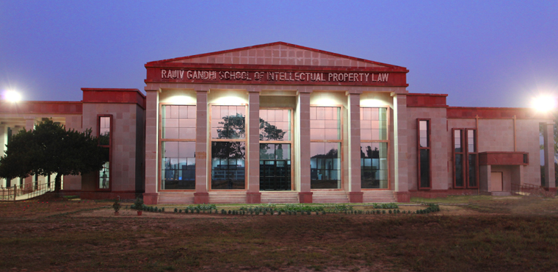
IIT Kharagpur
Indian Institute of Technology Kharagpur,
West Bengal
India - 721302
+91-3222-255221
FAX : +91-3222-255303

Rajiv Gandhi School of Intellectual Property Law,
Indian Institute of Technology Kharagpur
Organizes
2nd National Colloquium on Legal Research, 2015
From
(31st October – 1st November 2015)

REGISTRATION FORM

Name: Mr./Ms. …...............................................................................................................
Department/Institute/University: ..........................................................................................
Broad Area of Research: ……….…………………………………….……………………..
Proposed Topic for Abstract submission: ..............................................................................
Mailing Address: ………………………………………………………………………….
E-mail……………………………………………… Mobile: .............................................
Year of Enrollment as a Ph.D. Candidate/LL.M student: ...................................................
Research Fellowship (If any): ....………………………………………………………….
Publication Details (If any): …............................................................................................

Registration Details:
Bank of Remittance: ……………………………….………. Branch: …………………
Transaction No/DD No…………………………………. Amount paid: ….……………
Date of Payment: …………. Accommodation Required Yes/No………………………..
Date and Time of Arrival: ……………….… Date and Time of Leaving: ….……………

Signature of the candidate with date
A soft copy (Scan) of the Registration form shall be submitted to convenor@rgsoipl.iitkgp.ernet.in (no hardcopy shall be accepted)

