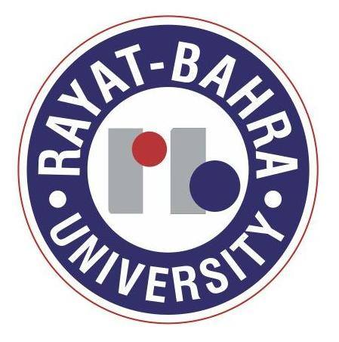
Rayat Bahra University School of Law
Mohali, Punjab
Ph: 0160-5009675,5009665, 5009672, Mob. 9915004285, 9888510943 (Fax)5009680
Website: www.rayatbahra.com
Email Address:nationalmoot.rbcl@gmail.com

RBUSL 1st National Moot Court Competition 2015
28th-29th March, 2015

Ref No. RBCL/DIR/___ Date:
To
The Vice Chancellor/ Director/Principal/HOD
---------------------------------------------
---------------------------------------------
Subject: Invitation to Participate in “RBUSL 1st National Moot Court Competition, 2015 on 28th -29th March, 2015.”
Dear Sir/Madam;
We are immensely pleased to inform you that Rayat-Bahra University School of Law is hosting 1st National Moot Court Competition on 28th -29th March 2015 with a view to provide law students an exposure to contemporary socio-legal issues in the dispensation of justice. We cordially invite the law students of five year integrated course of your institution to participate in the competition. Copies of the Registration form, Travel plan, Rules and Regulations and the Moot Proposition are appended herewith.
The winner team shall be awarded a trophy. In addition to the trophy, there shall be cash prizes:
First Prize (Winner Team) | Rs 10,000/- | Best Memorial | Rs 3,000/-
Second Prize (Runner up Team) | Rs 5,000/- | Best Mooter | Rs 2,000/-

The RBUSL will provide free boarding and lodging for out stationed participants. We would appreciate if you kindly confirm the participation of your institution latest by 23rd Feb. 2015 by sending us the duly filled in registration form along with registration fee of Rs 3,000 in the form of a demand draft drawn in the favour of “Rayat Bahra College of Law payable at Sahauran, Mohali”.

For any other clarification/information, you may contact the following (between 9:30 A.M- 3:00 P.M):

Dr. Jaspreet Kaur | 9814015920 | Ms. Radhika Dev Varma | 9779343399 | Ms. Jasdeep Kaur | 9872446212

We are looking forward to the meaningful participation of your institution.
Warm regards,

Prof. (Dr.) M.S Bains
Director Principal

