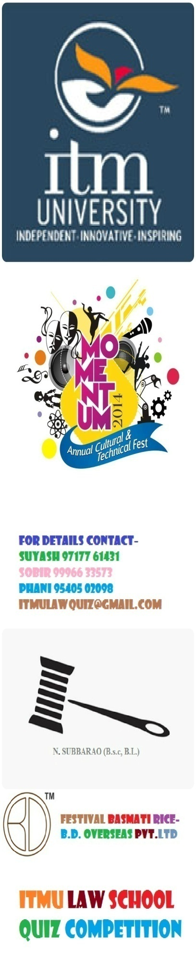
OVERVIEW
This is ITMU Law School’s 2nd Edition Quiz Competition. Previous year the quiz was based on Women’s Right with special reference to Pre-Natal Sex Determination. It was organized in collaboration with CSR (Centre for Social Research). This year the quiz emphasizes on-
- Current Affairs
- General Legal Knowledge
- National & International Politics
- National(Recent) Law Amendments
- International Convention & Treaties
- Bare Act
RULES
Preliminary Round- All the teams will be given with a same set of objective question paper. Top 8 teams will qualify for the Quarter-Finals.
Quarter-Finals- Teams will go through series of questioning & top 4 teams will go to the Finals.
Finals- The top 4 teams will battle for the Championship.
Rules related to each round will be explained on the spot.
Organizing Team

Core Committee – Suyash Srivastava
Organizing Committee-
Sobir Garg
Phani Chowdary
Sherlyn Dudeja
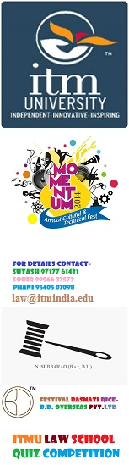
ABOUT SPONSORS
B.D. Overseas Pvt. Ltd-
B.D. Overseas established in the year 1948, have embarked upon the journey in the business of Basmati Rice with a vision
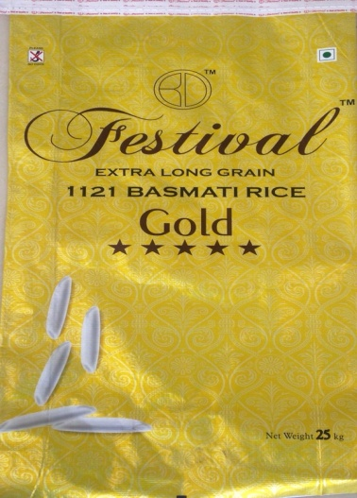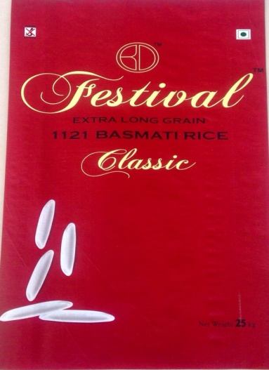
to consolidate the fragmented Rice Industry. We conduct regular research activities in understanding the present demand of the market, helping us in making a significant corporate presence in domestic as well as international markets like Saudi Arabia, Dubai & Australia.
N. Subbarao Chowdary (Senior Advocate A.P. High Court)
Established himself as Civil advocate at Bapatla Civil Session Court in Andhra Pradesh and and Legal Advisor of Shriram Chits Pvt. Ltd and Margadarsi. He has his specialization in Divorce and property matters.

