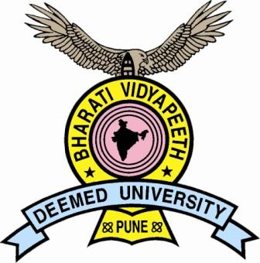
BHARATI VIDYAPEETH DEEMED UNIVERSITY
NEW LAW COLLEGE
RE-ACCREDITED WITH ‘A’ GRADE BY NAAC
Erandwane, Pune – 411 038. Ph: - +91-20-25444616. EMAIL: newlawcollege@yahoo.co.in


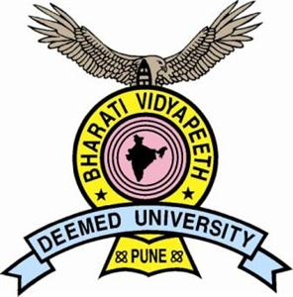
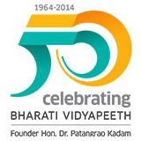

Date: 30/06/2014
To
The Vice Chancellor/ Dean/ Principal,
……………………………………………
……………………………………………
……………………………………………

Subject: Surana & Surana National Trial Advocacy Moot Court Competition (India Western-Rounds) & National Judgment Writing Competition on Criminal Law August 22 -24, 2014

Respected Sir/Madam,
It gives me an immense pleasure to inform you that our College is hosting the first ever Western Rounds of Surana & Surana National Trial Advocacy Moot Court Competition & Judgment Writing Competition on Criminal Law to be held during 22nd to 24th August, 2014 at our campus in Pune. I would be delighted to have your institution participate in the said competition.

ABOUT BHARATI VIDYAPEETH UNIVERSITY NEW LAW COLLEGE, PUNE:
Bharati Vidyapeeth which has grown from mere a sapling to an ark marks the completion of its 50 glorious years of existence and academic excellence in the arena of education. Recently, we have celebrated the Golden Jubilee Year and commemorated the journey of our institute by rejoicing the illustrious path of academic and intellectual triumph.

Bharati Vidyapeeth Deemed University New Law College, Pune is one of the premier institutes consistently ranked amongst the top law colleges in India. The College has secured 9th rank by Outlook in 2014 and 9th rank by Business Barons Magazine. The College has received 4th (Factual) & 14th (Overall) Rank by India Today Magazine in its special issue of June, 2014. The Week-Hansa Research Survey has also placed our College at 17th Rank.
Bharati Vidyapeeth Deemed University is also ranked among top 5 Best Universities in Western India and 35th Best University in India by India Today, Special Issue, 2013. Recently, the College has also received the ‘Gold Star Award’ from the Bar Council of India.
Besides this, the College is re-accredited with ‘A’ Grade by National Assessment and Accreditation Council (NAAC), an organization that assesses and accredits institutions of higher education in India. The Ministry of Human Resource Development has also conferred ‘A’ Grade to our institution.

ABOUT SURANA & SURANA INTERNATIONAL ATTORNEYS:
Surana & Surana International Attorneys has made remarkable strides on the canvas of Indian Legal education and more particularly in the arena of mooting. It has been a satisfying journey since 1994 when there were just three significant moot competitions in India. Inspired by Hon’ble Mr. Justice V R Krishna Iyer and set in motion by the Found and mentor Shri. P.S. Surana, the firm now administer, organize and host ten moots, three essay competitions and seven judgment writing competitions, with the help, support of knowledge and medial partners as well as with able guidance of its Advisory Board.
Till date, its academic initiatives programme has instituted several endowment lectures, given over 200 awards & gold medals for academic excellence, conducted over 110 moot court competitions, supports over 350 annual education scholarships, built a hostel in Chennai to provide accommodation for about 65 blind orphan girls pursuing higher education among others. Over 36,000 students and academicians have directly participated and benefited from our programmes. Every year, it had the honour of several dignitaries including sitting and Former Chief Justices, Judges, of the Supreme Court, various High Courts of India, distinguished advocates, academicians, bureaucrats and leaders of society participates in its programmes. Many of its participants have gone on to win prestigious competitions and study at international top law schools in the world.

APROPOS THE COMPETITION:
This mega-event is a unique blend of two innovative competitions specially designed to hone and harness the legal debate and judgment writing intelligence of law students across the country. The Competition is intertwined with the objective to train students in the area of trial advocacy and also to cultivate the art of writing a judgment which remains a signature tune of the rule of law and fountainhead of justice.
The teams must register online at www.mootsite.com/ www.moot.in by 1st august, 2014. Due to the unique format of the competition and requirement of special arrangements, registration is restricted to only 20 teams which will be strictly on First come First Served basis. The registration process is explained in the rules and participants are required to take note of the same.
The Moot Court problem, Official Schedule, & the official rules & regulations governing the competition are enclosed here with. Kindly confirm your law school’s participation and let us know the team’s travel plans at the earliest after registering before the due date.
In case of further assistance or queries relating to the competition, you may contact Prof. Aman Mishra (Mo+91 9637109415).
Thus, once again, I invite you to participate in the competition by sending a team from your institute.
Thanking you.

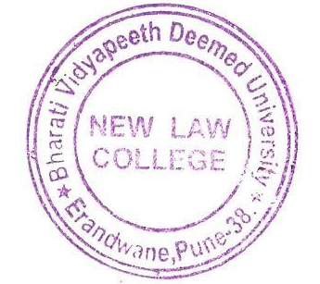

Yours sincerely,

Prof. Dr. Mukund Sarda
Dean & Principal,
Bharati Vidyapeeth Deemed University
New Law College, Pune-038
Maharashtra (INDIA)
Mo: +91 9850898101

