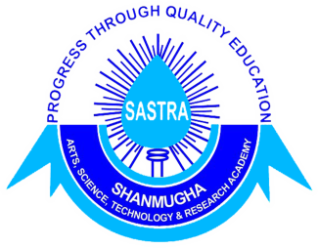
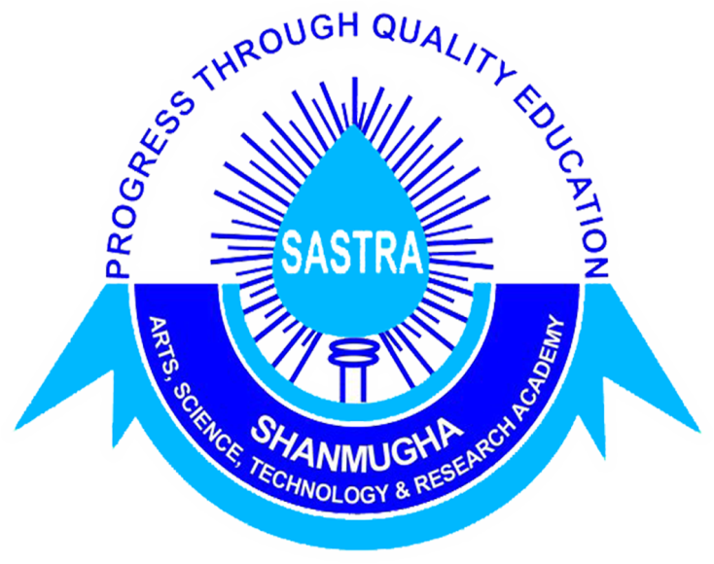
SASTRA UNIVERSITY
SCHOOL OF LAW
THIRUMALAISAMUDRAM, THANJAVUR.
_________________________________________________________
NATIONAL SEMINAR CUM WORKSHOP ON EMERGING TRENDS IN INTELLECTUAL PROPERTY LAWS, 25.10.2013 – 26.10.2013.

Guidelines for Submission
- Co-authorship to a maximum of two authors is permitted, however only one can participate and present the paper.
- Abstract shall not exceed 300 words.
- The paper should not be more than 3000 words (excluding footnotes).
- Footnotes must conform to standard rules of legal citation and must include a description of each authority adequate enough to allow a reasonable reader to identify the authority in a publication.
- The soft copy of the final paper shall be mailed to clec.sol@sastra.ac.in on or before 20.10.2013. The hard copy shall be submitted on the day of registration.
- Plagiarism would result in permanent cancellation of the institution in further events organised in SASTRA UNIVERSITY.
- Soft copy of the duly filled registration form and the scanned copy of the DD shall be submitted to clec.sol@sastra.ac.in on or before 5th October 2013.
- Demand draft shall be drawn in favor of “The Registrar” SASTRA UNIVERSITY payable at Thanjavur.
- Participant shall submit the original Registration form and the original DD at the time of arrival at the venue.
- Registration fee is non refundable.
- Participation is limited to sixteen (16) only.

Other Rules
- Boarding and lodging shall be provided from 3 P.M. on 24.10.2013 to 08 A.M. on 27.10.2013.
- No transport will be provided, participants have to reach the venue on their own however the organisers would guide the participants to reach the venue.
- SASTRA University follows a strict dress code, apart from the event the participants are requested to adhere to that dress code: Men -western formals, women - salvar kameez/ chudidhar.

