
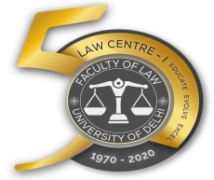

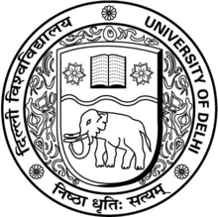
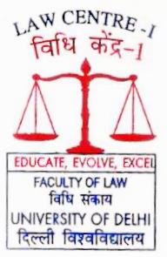
The Law Centre-I is pleased to invite papers from law students, law professors and legal professionals for the ‘Seminar on Social Justice for the Child: Complexities of Protection in Law’ organised as part of the year long Golden Jubilee Celebrations commemorating the fifty years of Centre’s contribution to excellence in legal education since 1970. This Seminar is part of the Seminar Series on Social Justice scheduled to be held from February to March 2020. The Series has been envisioned by Justice Mr. Madan B. Lokur (Retd.), former Judge of Supreme Court; Prof. Dr Ved Kumari, Professor at Law Centre I and former Dean of Faculty of Law; and Prof. Dr Sarbjit Kaur, the Professor-in-Charge of Law Centre I with the objective of advocating and assimilating social justice isues into legal education by comprehensively discussing different themes of social jutice. The Seminar Series is curated by Ms. Shivika Choudhary, Ms. Shachi Singh and Mr. Piyush Kumar.

Seminar on

Social Justice for the

Child: Complexities of Protection in Law

as part of the

Golden Jubilee

Celebrations
Commemorating Fifty Years of
Law Centre I
Organised by

Law Centre I
Faculty of Law
University of Delhi
India has ratified the Convention for the Rights of the Child and has recently made some important changes in the laws relating to education for children, sex-selective conception and abortion, child marriage, children in need of care and protection, children in conflict with law, and child labour. The Seminar aims to examine the real problems and risks that children face and of the remedies that are available in law and policy to change the situation in the best interest of children. The Seminar would be held on Friday, March 20, 2020 at the Moot Court Hall, Umang Bhawan, Law Centre I:
Theme | Social Justice for the Child: Complexities of Protection in Law
Sub-topics  (Suggestive) | • Girl Child – Survival and Development  • Juvenile Justice Boards: Much more to do  • Preliminary assessment and trial of children as adults – Primary Issues  • Care Homes: Effective Protection and Care?  • Rights under the Convention on Rights of Child – Mechanism for Redressal  • Intra and Inter-country Adoption : Safeguards and Challenges  • Child Marriage: Prevention and Prohibition  • Child Labour – Regulation and Prohibition  • Education for Children – Compulsory and Tertiary
Abstract | February 29, 2020
Communication of Selected Abstracts | March 3, 2020
Full Papers | March 14, 2020
The abstract of 500 words indicating the Seminar Theme, Title of the Paper, the key argument and five keywords are to be submitted to seminaronsocialjustice.lc1@gmail.com. Selected papers would be published as a book (with ISBN) by the Law Centre I.
Organising Committee:
1. Dr. Surender Mehra 2. Dr. Suman 3. Ms. Shilpi 4. Dr. Gurpreet Singh 5. Dr. Basuki Nath Dubey 6. Dr. Upendra Nath 7. Dr. Ravindra Kumar 8. Dr. Apeksha Kumari 9. Dr. C.K. Negi Bisht 10. Dr. Krishna Murari Yadav

