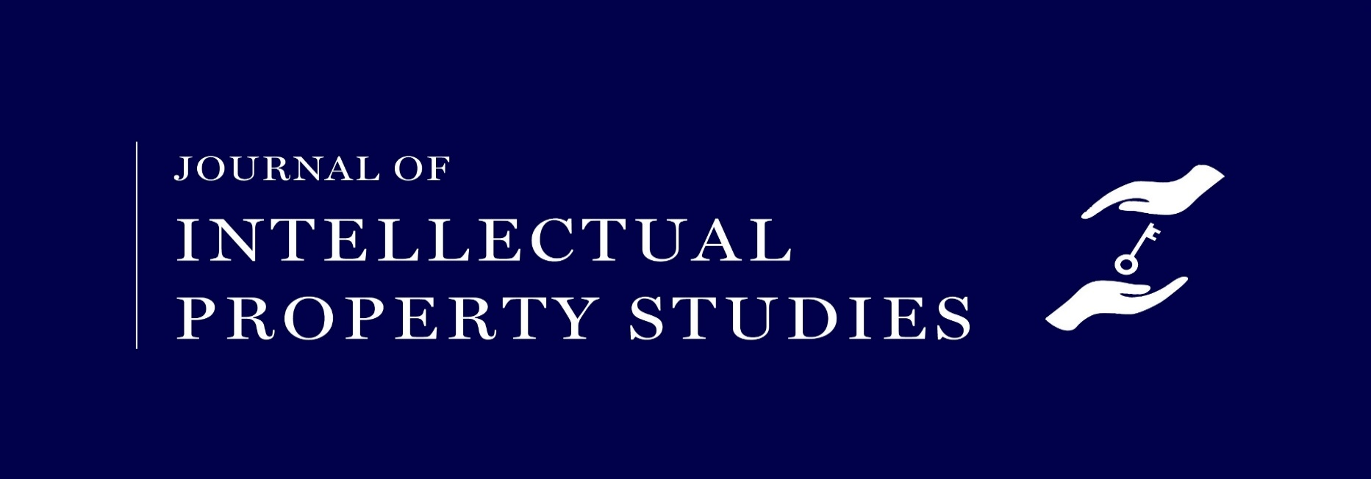
Call for Papers
The Board of Editors of the Journal of Intellectual Property Studies [JIPS], published under the aegis of National Law University, Jodhpur, is pleased to invite original, unpublished manuscripts for publication in the Spring 2020 Issue of the Journal (Volume III, Issue 2) in the form of articles and notes. The manuscripts must pertain to the field of intellectual property law or to related fields such as media and technology law. The deadline for submission for manuscripts is 25th February, 2020.
*
Volume III Issue 1 shall be published shortly in the coming week, and our previous issues are available here. The Journal subjects all articles to a review process by our student editors prior to publication. We also benefit from the guidance of our illustrious board of advisors who help the journal attain its objectives. The Journal stands by the ideals of open access to scholarly works and it will be published online on an open access platform for everyone to read and cite freely.
*
We have a strong preference for papers that display original thinking about contemporary issues. The following broad areas may serve as an indicative guide to the kind of work we are looking to publish:
- Copyright protection of folklore and cultural traditions
- Indian possibilities for a legislation like the CASE Act
- Problems faced by small scale and regional writers: enforcement of copyright regime and reasonable publisher-author agreements
- Copyright exchanges and digital streaming music
- Patenting antibodies
- Full post-trial judgments in patent law in India
- Patenting of Space technology

- Patenting computer programs in India
- Implications of granting trademark to sportspersons’ celebration moves
- Intermediary Liability after notice and grant of stay in proceedings
*
Manuscripts may be submitted via email to the Editors in Chief at jips@nlujodhpur.ac.in. We request all authors to carefully read and follow the submissions guidelines. For further details regarding JIPS, contribution guidelines, and our editorial policy, please visit our website.
*
Last Date for Submissions: 25th February, 2020

