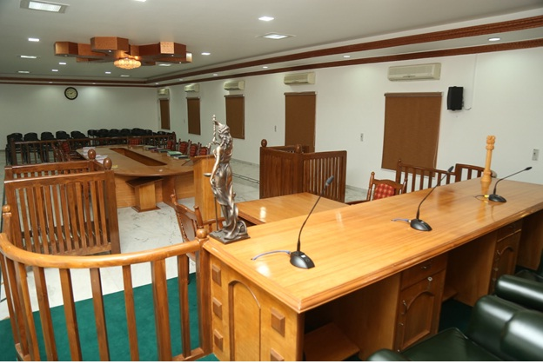
RULES AND REGULATIONS:
- The competition is open to all the students who come under the age group between 18-25, irrespective of their departments.
- Each team should consist only of two members and there is no limitation on the number of teams participating from the same institution.
- The participants are not allowed to use mobile or other electronic instruments during the competition.
- Replacement of any participant(s) of a team is not allowed after registration.
- Surprise round will be conducted in case of tie in the final round.
- The decisions of the Quiz master will be final and will not be subjected to any change.
Structure of the Competition:
- Preliminary round: A common question will be posed to a team. Upon their inability to answer the question, the same will be passed to the next team. A total of five rounds of this round will be conducted.
- Rapid Fire round: Each team will be asked questions one after another in one minute’s time. Marks will be awarded with respect to the number of questions answered by the team.
- Double Trouble round: Prior to the question asked, a team may choose to double the points on offer. If the answer they provide is right, their points will be doubled and if the answer is wrong, negative marks are awarded.
- Finals (Buzzer round): A question will be fired and the team who presses the buzzer first gets to answer first. If the answer provided is wrong, the question may be answered by the other team.

REGISTRATION:
The registration fee is Rs.300/-
Online Registration link: http://www.123formbuilder.com/form-5168481/quiz-competition-form
Payment method: DD drawn in favour of “Sathyabama Institute of Science and Technology” payable at Chennai on or before 25th January 2020. The registration fee includes working lunch, refreshments and certificate of participation. Registration commences by 8.30am. Spot registration is available on prior request. Please note: Accommodation, transport, activities, extras such as tours & dinners are not included in the registration.



NOTE:
There is no limitation on the number of teams participating from the same institution.
For details, contact:
Student coordinators:
Miss K. Aishwarya: +91 9442530609
Miss Anugraha: +91 7358200875
Miss R. Suganya: +91 7397232542
Miss Charumathi: +91 9585695474
EMAIL ID: ssoleventqueries@gmail.com
Important date:
Last date for registration: 25th January 2020

PRIZE AMOUNT:
- WINNER: Rs. 3000/-
- RUNNER-UP: Rs. 2000/-
ABOUT QUIZ:
Quiz competitions are used in schools and universities to aid in language development and in particular subject areas of study. It enables students to think from different angles or simply “to think out of the box“. It helps the students to build soft skills. Quiz can serve as a self assessment tool which gives learners freedom to explore. This allows learners to figure out what they do know, what they don’t, what they need to focus on and how to improve.
OBJECTIVES:
- To assess student’s view regarding quiz competitions as a tool of teaching and learning.
- To enhance academic knowledge among the students regarding the subject matter.
- To enable in-depth analysis that is readily available.
- To foster interaction between students in accordance to the subject matter.
- To provide scope of self improvement and self introspection.
THEMES OF THE COMPETITION:
Participants can expect questions from the following themes:
  - Constitutional law
  - Laws relating to Human Rights
  - Laws relating to Women and Children



Founder Chancellor

Col. Dr. JEPPIAAR M.A, B.L, Ph.D.,

Chief Patrons

Dr. MARIAZEENA JOHNSON B.E.,M.B.A.,Ph.D Chancellor,
Sathyabama Institute of Science and Technology.

Dr. MARIE JOHNSON B.E.,M.B.A.,Ph.D
President,
Sathyabama Institute of Science and Technology.

Patron

Dr. S. SUNDAR MANOHARAN M.E.,Ph.D
Vice Chancellor,
Sathyabama Institute of Science and Technology.

Convenor

Dr.DILSHAD SHAIK, M.L.,M.B.A,Ph.D
Dean, School of Law,
Sathyabama Institute of Science and Technology.

Organizing secretary

Ms.K.SOFIYA
Assistant professor,
School of Law.
Held at A/C auditorium, near Remibai auditorium, Sathyabama Institute of Science and Technology.

ABOUT SATHYABAMA:
Sathyabama Institute of Science and Technology (A Christian Minority Institution) formerly known as Sathyabama Engineering College was established in 1987 by Dr. Jeppiaar. It is a premier institute imparting knowledge in the areas of Engineering, Science, Technology, Law and Education. The institution's progress and contribution to the field of technical education for over two decades resulted in granting Deemed University status on 16th July, 2001. Untiring efforts of staff, students and management and positive academic ambience prevailed in the campus had made University to be ranked as 2nd among Private Universities in Tamilnadu by National Institutional Ranking Framework, Ministry of Human Resource Development, Government of India. The Institution has written a special page in the history of space research on 22nd June 2016 with the launch of “SATHYABAMASAT” in association with ISRO. Our motto is “TOGETHER FOR BETTER TOMORROW” and our mantra of success is “LEARN TODAY AND LEAD TOMORROW”.
ABOUT SCHOOL OF LAW:
Sathyabama School of Law aspires to be an internationally-renowned centre for research and teaching in law. School of Law is dedicated in advancing human dignity, social welfare and justice through knowledge of law. School of Law offers B.A.LL.B (Honours), B.Com.LL.B (Honours), B.B.A.LL.B (Honours) and LL.B Programmes. Our courses are academically rigorous, informed by the latest research. Courses are taught by dedicated, efficient and industrious faculty and a cadre of intellects that includes respected judges and experienced practitioners. One of the unique facets of the School of Law is the opportunity provided for students to take part in both national and international competitions. This allows students to expand on the knowledge obtained through the compulsory moot and internal competitions whilst also affording the opportunity to meet fellow students across numerous institutions. These will enhance the required qualities in the dynamic legal industry. Students will acquire the legal knowledge, skills and values needed to help others and to distinguish themselves by making a true impact upon the world.

