


36
TRAVEL FORM
34
REGISTRATION FORM
33
32
21
16
SCHEDULE
OFFICIAL TIMELINE

RULES & REGULATIONS
ANNEXURES TO MOOT PROPOSITION
6
MOOT PROPOSITION
4
7th MMNMCC- GLIMPSE
2
About 8th MMNMCC 2020
CONTENTS PAGE NO.
ABOUT 8TH MMNMCC 2020

COMPETITION 2020

NATIONAL MOOT COURT


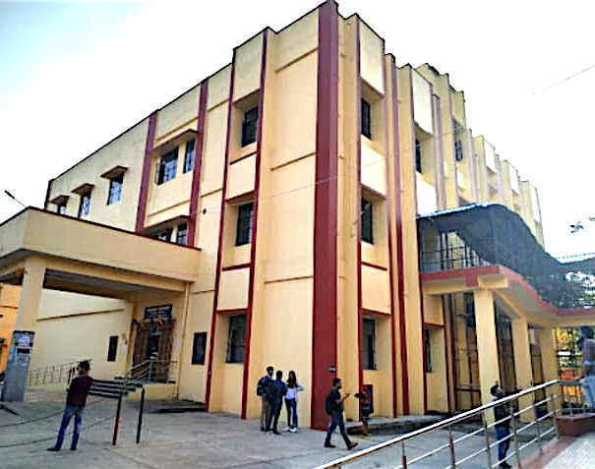
Banaras Hindu University is an internationally reputed temple of learning, situated in the holy city of Varanasi. This creative and innovative university was founded by the great nationalist leader, Pandit Madan Mohan Malviya, in 1916 with the cooperation of great personalities like Dr Annie Besant, who perceived it as the University of India. Banaras Hindu University was created under the Parliamentary Legislation - The B.H.U. Act 1915.

The Law School is one of the earliest faculties established in the Banaras Hindu University. The legal luminaries like Sir Ras Behari Ghosh and Sir Tej Bahadur Sapru, were the earlier Deans. The Law School has developed a holistic approach towards understanding law and justice from a multi-disciplinary perspective through its various courses.

FACULTY OF LAW, BHU
ORGANIZED BY
PATRON
PROF. RAKESH BHATNAGAR
(HON’BLE VICE CHANCELLOR)
ORGANIZING COMMITTEE
- PROF. R. P. RAI- DIRECTOR
(Head & Dean)
- PROF. C. P. UPADHYAY- JOINT DIRECTOR
- PROF. G.P. SAHOO- TREASURER
- DR. RAJNISH KUMAR SINGH- ORGANIZING SECRETARY
- DR. KABINDRA SINGH BRIJWAL- JOINT ORGANIZING SECRETARY
- DR. ANOOP KUMAR- JOINT ORGANIZING SECRETARY

It offers various academic programmes to generate especially skilled global legal professionals.

The Faculty of Law, BHU has a hundred year old history which is incomparable to any traditional institution in this country. This fine law institution has produced great legal luminaries in the past and continues to produce the world's greatest minds to serve in the legal field.
8th MMNMCC 2020 is organized in collaboration with PSL Advocates and Solicitors. PSL is a Top Tier law firm in the field of Dispute Resolution specifically, arbitration, as ranked by The Legal500 amongst others. Headquartered in New Delhi, PSL has an international presence offering expertise in areas of Domestic and International Dispute Resolution, Corporate, Commercial, Regulatory & Policy advisory. The lawyers at PSL have years of hands-on experience in dealing with complex issues relating to Tax, Insolvency & Bankruptcy, Tenders, Intellectual Property, Anti–Trust/ Competition Law, Trade, Media, Land & Property, Economic Offences including white collar crimes, Constitution and Civil Laws.

7TH MMNMCC 2019- GLIMPSE

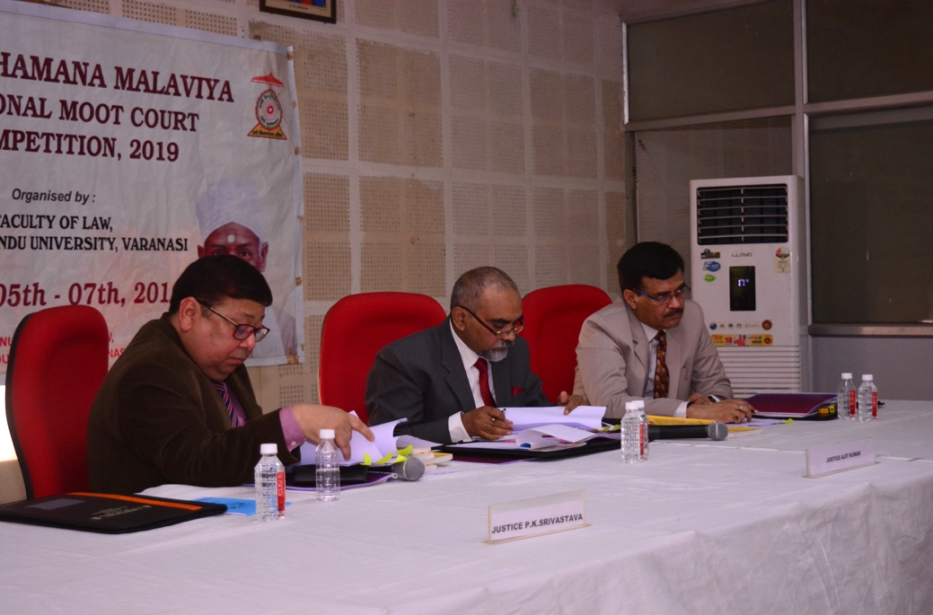
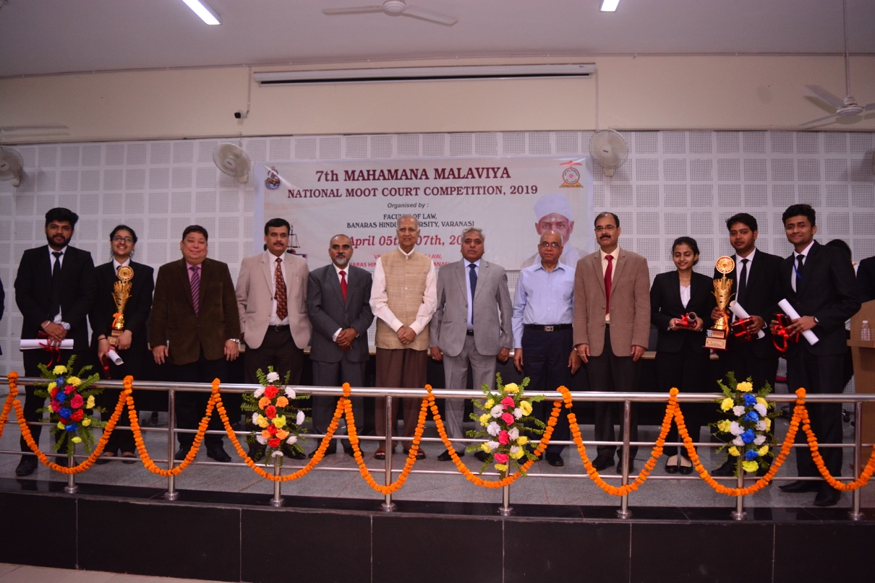
The seventh edition of Mahamana Malaviya National Moot Court Competition 2019 was organized by Faculty of Law, BHU on 5-7 April 2019 wherein 24 teams from across the country argued on the given moot proposition over the course of two days. The moot proposition deal with the provisions of Constitutional Law. The competition was divided into preliminary, quarter final, semi final and final rounds, with each round being judged by eminent professors, lawyers and judges. The final round was judged by Neeraj Tiwari, J. and P. K. Srivastava, J.
LIST OF TEAMS PARTICIPATED

- Symbiosis Law School, Pune
- National University of Advanced Legal Studies, Kochi
- Amity Law School, Gwalior
- Guru Gobind Singh Indraprastha University, Delhi
- Army Institute of Law, Mohali
- Central University of South Bihar, Gaya
- Kalinga Institute of Industrial Technology, Bhubneshwar
- Mody University
- Karnataka State Law University, Karnataka
- Institute of Chartered Financial Analysts of India University, Dehradun
- University Law College, Bangalore
- Amity Law School, Delhi
- Career Point
- Amity Law School, Mumbai
- University Of Petroleum And Energy Studies, Dehradun
- Law Centre- II, Delhi University
- Maharashtra National Law University, Aurangabad
- Damodaram Sanjivayya National Law University, Vizag
- Law Centre- I, Delhi University
- Shastra University
- Maharashtra National Law University, Nagpur
- Lucknow University
- University Institute of Legal Studies
- Lloyd Law College

MOOT PROPOSITION

Dispute Between
AVENGERS PVT. LIMITED and THANOS PVT. LIMITED

- STATEMENT OF FACTS

- Thanos Pvt. Limited, is a private company incorporated under the laws of Republic of Titan (‘Thanos’). Republic of Titan is a country in central Europe (‘Titan’). Thanos is engaged in the business of selling of extremely safe cars with bullet proof mechanism which are made up of highly advanced technology. These cars which are made by Thanos are made by a very complex alloy made from very specific extracts from adamantium and vibranium ores.

- Avengers Pvt. Limited, is a private company incorporated under the laws of Republic of Wakanda (‘Avengers’). Republic of Wakanda is a South-East Asian country (‘Wakanda’). Avengers is engaged in the business of extraction from metal ores of adamantium and vibranium. It is also engaged in development of highly advanced technology for the manufacture of related alloys, conductors and different metallurgic activities. The uses of adamantium and vibranium are manifold, for example, these metals are used in manufacturing of metal body armors, bullet proof vehicles and for large number of defence related goods. The alloy made from adamantium and vibranium is extremely useful, expensive and unique due to its extreme strength, light weight and protection from ultra violet and gamma radiation (‘Cap’ Am’).

- Avengers being the pioneers in technology of making alloys through its equipment and machines, always had the desire to optimize and upgrade the same. Therefore, it has always invested significantly in the research and development of its technology. Due to the same, it has over 150 patents in its name. These patents relate to the various parts and screws which are made and developed by Avengers and are used in the process of making alloys and semi-conducting metals.

- Due to its rich technical know-how as well as great knowledge in manufacture of alloys and semi-conducting metals, Avengers is well known in the metal and alloy industry. Avengers, by way of its patented screws and technical know-how was manufacturing various semi-conducting metals with great accuracy and ion-count.

- Thanos on the other hand, for its car business, was attempting to manufacture the Cap’ Am basis its technology, however, was unable to manufacture the same with any accuracy and the viscosity as well as the ion value were completely out of Thanos’ control, and the Cap’ Am thus, produced could not be exploited commercially. Therefore, Thanos was attempting to develop and streamline the process of manufacturing the Cap’ Am.

- In the year 2013, Avengers was displaying its screw technology and presenting its technical know-how of manufacturing various semi-conducting metals and alloys, in an exhibition at Stark Grounds in Wakanda. Thanos also visited this exhibition in Wakanda. Being lured by the great accuracy and control which Avengers had on this process due to its technology and technical know-how, Thanos approached Avengers to enter into an agreement with it to optimize Thanos process of manufacturing the Cap’ Am using Avengers screw extruder technology.

- On 9 August 2013, after negotiations, Avengers and Thanos entered into a Master Service Agreement in relation to the deployment for conduct and optimization of Thanos’ process of manufacturing the Cap’ Am using Avengers screw extruder technology and technical know-how (‘MSA’). As early 2014, the work by Avengers on the Cap’ Am manufacture process had progressed greatly and by December 2014 the process for manufacturing Cap’ Am was optimized at the small scale. However, this process was completely unviable for manufacturing Cap’ Am at a commercial level.

- In April to October 2015, in order to make the process viable for commercial large-scale production, the representative of from Avengers and Thanos, engaged in detailed discussions on a proposed new agreement which focused on the manufacture of the Cap’ Am at a large commercial scale. At the time of these discussions, Avengers already held patents and held pending applications for various aspects of the machines and extrusion process, including for the individual extruder elements in the extruder, in the Republic of Wakanda and in other jurisdictions around the world. Avenger held a wealth of confidential information on how to arrange extruder elements to achieve the most optimal output in any manufacturing process.

- In a meeting on 17 February 2015, Thanos made a presentation to Avengers about buying USD 71.1 million worth of equipment from Avengers over 10 years upon successful completion of the project at large scale, as the investment in this project would be huge for Avengers. Therefore, some long-term exclusivity was desirable.

- On 29 October 2015, based on the outcome of the MSA and discussions between the parties, Avengers and Thanos entered into a Development Services Agreement (‘DSA’). Under the DSA, Avengers had to “construct, assemble and assist in operating a pilot plant to demonstrate the scale-up of Thanos process of Cap’ Am manufacture using Avengers screw extruder technology” (‘Large Scale Process’). In furtherance of the DSA, Avengers set-up the equipment at the premises of Nebula Private Limited (‘Nebula’) in Wakanda. Thanos is the parent company of Nebula.

- The DSA provided for the milestones to be completed, for the payment to be released to Avengers. The milestones are reproduced below:

- Milestone 1: Equipment for Large Scale Process is delivered and commissioned as per agreed specifications by Avengers;
- Milestone 2: Equipment for Large Scale Process performs as per agreed specifications; and
- Milestone 3: Achievement of finished product specification as set out in the success criteria viz. that the Cap’ Am produced through the Large Scale Process should pass the quality check.

- The DSA also stated that Thanos understands that Avengers is making a major investment in the Large Scale Process, for which returns will come only after the achievement of Milestone 3.

- On 20 July 2016, Thanos confirmed success of Milestone 1 and Avengers received payment for the same.

- On 24 August 2016, Avengers confirmed that Milestone 2 had been completed. However, Thanos claimed vide an email of even date that due to the presence of microscopic cracks in the product produced through for Large Scale Process, Milestone 2 could not be said to be completed.

- On 25 August 2016, Avengers pointed out that it was agreed that payment was only contingent on achievement of specific parameters which had in fact been achieved. It further stated that the presence or absence of microscopic cracks, will not affect the quality and performance of Cap’ Am in any way and also, was never a part of the original understanding or the success criteria mentioned under the DSA. Avengers explained to Thanos on multiple occasions that huge investments have been made by Avengers in this project and that the payment under second Milestone is not affected by the said microscopic cracks found in Cap’ Am. Thanos, however, did not subscribe to this view. Even though the Parties had their difference in relation to the same, in view of the completion of the project, Thanos stated that the payments under Milestone 2 would be made to Avengers, however, the same would subject to issuance of a bank guarantee by Avengers in the name of Thanos. The bank guarantee was issued by Avengers so that the project could be progressed further, and it was issued without prejudice to its claim that the Milestone 2 had in fact been achieved. Further, the bank guarantee was equal to the amount payable under Milestone 2 and could be invoked by Thanos if the success criteria is not met under Milestone 3. Avengers had no problem in accepting this proposition as its was extremely confident about its technical know-how and success of the project.

- The whole of 2017 was consumed in achievement of Milestone 3 by Avengers. On 24 May 2018, Avengers issued a letter to Thanos stating that it has demonstrated a successful scale-up and the product was released for quality check by Thanos. The quality check was taking a long time and Avengers was continuously following up with Thanos for the same, so that final payment could be made to it. Meanwhile, Thanos kept representing that the quality test was being carried on the Cap’ Am produced through the Large Scale Process, and kept raising additional requirements/changes in the form and shape of Cap’ Am which was produced by the Large Scale Process. Avengers accommodated all these requirements and changes of Thanos. However, at the same time, Avengers believed that these changes as well as the delay in the quality test approval were only to defer payments under the Milestone 3.

- Meanwhile, in November 2018, Thanos received an Award from Wakanda Metallurgy Department. This Award was received by Mr. Baron Zemo and Ms. Felicia Hardy, who were Thanos group company employees and were deployed at Nebula for the purpose of the DSA. The said award was received by Thanos for its works and innovation in the field of mass production of Cap’ Am.

- Suddenly, around February 2019, through a newspaper publication, Avengers became aware that Thanos has applied for a patent in a process for manufacturing Cap’ Am at a mass commercial level.

- Avengers was shocked to see that, at one hand Thanos kept delaying the declaration of quality test results, which was the basis of payment of Milestone 3, and on the other hand it was receiving award for the technical know-how and confidential information of Avengers and also mischievously getting Avengers confidential information and technical know-how in the very same Large Scale Process patented under its own name (‘Patent Application’).

- On 4 April 2019, given the urgency and gravity of the situation for Avengers, Avengers, in terms of the arbitration agreement under DSA, filed an application under Section 9 of the Arbitration and Conciliation Act, 1996 (‘Act’) before High Court of New Wakanda City (capital of Wakanda) for injuncting Thanos and Nebula from proceeding with the Patent Application. In the said application, Avengers also sought injunction against Thanos and Nebula from directly or indirectly infringing Avengers rights in its intellectual property or confidential information in the Large-Scale Process as well as the equipment used thereunder. Avengers, by way of the said application also sought to restrain Thanos and Nebula from disposing or transferring the subject-matter under the project to any third-party as well as disclosing Avengers’ technical know-how and the confidential information in the project to any third party. The High Court of New Wakanda City rejected the application under Section 9, stating that there is no urgency in the matter and in any event, the Avengers have the remedy to approach the appropriate authority under the Patents Act, 1970 to oppose the said application. The High Court also recorded that in any event since Nebula is not a party to the arbitration agreement, so the relief against Nebula cannot be sought under Section 9 of the Act.

- Dissatisfied by the High Court’s order under Section 9 of the Act, Avengers filed a Special Leave Petition challenging the order before the Supreme Court of Wakanda.

- Meanwhile, Avengers invoked arbitration in terms of Clause 16 of DSA vide notice dated 23 April 2019 against both Thanos as well as Nebula. The arbitration clause under the DSA is as under:

“ARBITRATION

16.1 Any and all disputes ("Disputes") arising out of or in relation to this Agreement between the Parties hereto or arising out of or relating to or in connection with this Agreement or the performance or non-performance of the rights and obligations set forth herein or the breach, termination, invalidity or interpretation thereof, shall be referred for arbitration in accordance to the provisions of the Arbitration and Conciliation Act, 1996 or any amendments thereof.

16.2 The place of arbitration shall be New Wakanda City and the language used in the arbitral proceedings shall be English. Arbitration shall be conducted by a sole arbitrator to be appointed by Avengers out of panel of three people suggested by Thanos herein.

16.3 In the event of the Arbitrator to whom the matter is referred to, does not accept the appointment, or is unable or unwilling to act or resigns or vacates his/her office for any reasons whatsoever, Thanos aforesaid shall nominate another person to act as the Sole Arbitrator.

16.4 The Award of the Sole Arbitrator shall be final and binding on the parties to the Agreement.”

- In the letter of invocation, Avengers also stated that it disagreed to the appointment mechanism under Clause 16.2 of the DSA and gave its nomination for the sole arbitrator. Avengers invoked the arbitration against Nebula as the subject-matter of the project was within its access and premise.

- On 23 May 2019, Thanos replied to the letter of invocation by stating that the procedure of appointment under the arbitration agreement must be followed for the appointment of the sole arbitrator and thus, provided a panel of three arbitrators to Avengers, so that it could choose one arbitrator from the panel as the sole arbitrator.

- In the months of June and July, 2019, parties had some discussions and negotiations. However, the same were futile.

- On 1 August 2019, Thanos filed a suit for permanent injunction against Avengers before the High Court of New Wakanda City. By way of the said suit, Thanos sought injunction against the Avengers from directly or indirectly infringing Thanos’ rights in its intellectual property or confidential information in the Large Scale Process as well as the equipment used thereunder. Thanos, also sought to restraint Avengers from disposing or transferring the subject-matter under the project to any third-party as well as disclosing Thanos’ technical know-how and the confidential information in the project to any third party. In addition, Thanos also sought an anti-arbitration injunction against Avengers, on the ground that the disputed subject-matter under the DSA(being intellectual property rights and allegations of fraud) is inarbitrable.

- In the said suit, Avengers filed an application under Section 5 read with 8 of the Act, due to existence of arbitration clause under the DSA. It also submitted that the dispute under the DSA is purely contractual and effects only the rights of the parties inter se. The Avengers also informed the Court that an arbitration for the said subject matter has already been invoked. The said application was allowed by the Hon’ble High Court of New Wakanda City vide order dated 15 November 2019 and the suit was consequently dismissed. Against such dismissal, Thanos filed a Special Leave Petition before the Supreme Court of Wakanda.

- On 15 December 2019, given the disagreement between the parties, Avengers also filed an application under Section 11 of the Act before the Supreme Court of Wakanda.

- The Supreme Court of Wakanda has issued notices in both the SLPs emanating out of the proceeding under Section 9, Section 5 and 8 as well as the application under Section 11 of the Act. For the sake of convenience and the subject matter being the same, the Supreme Court has tagged both the appeals as well as the application, for the sake of proper adjudication.

- Hence, the Parties are now before the Supreme Court of Wakanda.

- ISSUES BEFORE THE SUPREME COURT OF WAKANDA

- Whether the application filed under Section 9 of the Act rightly rejected by the High Court of New Wakanda City.
- Whether the suit before the High Court of New Wakanda City rightly dismissed basis the Section 5 and 8 Application filed by Avengers.

- Whether the sole arbitrator is to be appointed in accordance with the procedure mentioned `in the arbitration agreement under the DSA, under the Section 11 application before Supreme Court of Wakanda.

- NOTE TO THE PARTICIPANTS:

- Laws of Wakanda are pari materia with the laws of India.

- The Supreme Court of Wakanda has already tagged the 3 matters and issued notice.

- The parties are requested to abstain from delving deeper into the working of this technology which is mentioned in the present moot proposition. This technology is fictional for the purpose as mentioned above. Therefore, even to establish a case against the other party, parties are requested to stick strictly to the given contract provisions and law.

- Annexure A to the moot proposition are the relevant clauses of the DSA between the parties.

- The moot is governed by the rule of this competition viz. Rules and Regulations, 8th Mahamana Malaviya National Moot Court Competition, 2020.

Prepared By
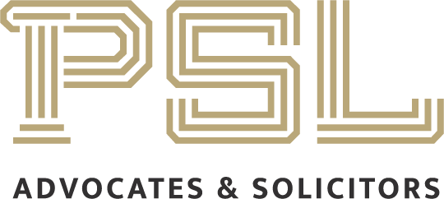

ANNEXURE- A
Relevant Clauses of the DSA

Recital F of the DSA:
“The Parties envisage that upon successful completion of the Project, if Thanos and/or its Affiliates decides to utilize extruder technology for commercial production of Cap Am, the Parties will enter into an exclusive agreement for the supply by Avengers of extruder equipment to Thanos and its Affiliates.”

Recital G of the DSA:
“Thanos understands that Avengers is making a major investment in the project, for which returns will come only after the Quality Test. Therefore, Thanos shall take all reasonable care to try and complete the Quality Test at the quickest possible time.”

Clause 2A of the DSA:
"Upon successful completion of the services as jointly determined by Thanos and Avengers based on the acceptance criteria, if Thanos wishes to utilize the extruder technology for commercial manufacture of products, Thanos and Avengers will enter into a supply agreement for the exclusive supply of equipment based on the prototype, for a period of 5 (five) years from execution of the Supply Agreement for the purpose. Subject to the foregoing, for the avoidance of doubt, nothing in this Agreement shall give rise to an obligation on the part of Thanos or any of its affiliates to enter into any contract for the supply of extruders or any other equipment. "

Clause 2(g) Confidential Information:

“Confidential Information means in relation to either Party any information or data (in whatever media), including data of a personal nature ("Personal Information"), which is made available by that Party or its Affiliates or its or their Agents to the other or its Affiliates or its or their Agents for the purposes of this Agreement or which relates to any Intellectual Property Rights assigned to or of, either Party or its Affiliates under this Agreement.

Clause 2 (k) Intellectual Property:
"Notwithstanding anything to the contrary contained herein, Thanos acknowledges and agrees that all Intellectual Property Rights relating specifically to the hardware, hardware design, and machine technical specification (including those arising from and in the screw designs, machine parts, machine dimensions, and control system) (Avenger Hardware) belong to and vest in the Avenger.”

Clause 2 (m) Know-how:
Know How means all data, technical information, inventions, discoveries, trade secrets, processes, methods, techniques, compositions, materials, formulas or improvements, whether patentable or not.

Clause 2 (o) Project IPR means:
“a) any and all Intellectual Property Rights relating to any Outputs; and/or
b) any and all Intellectual Property Rights arising as a result of the performance of Project and/or the performance of Avengers obligations under this Agreement;

provided that Project IPR will not include Intellectual Property Rights and Existing Material belonging to either of the Parties prior to the Commencement Date.”

Clause 2 (q) Output:
Outputs means the results arising from any work and or projects conducted under the this agreement.

Clause 8 Confidentiality:
“8.1 Each Party shall keep confidential any Confidential Information of the other obtained by it or in its possession under or in connection with this Agreement and shall use the same level of care to prevent any unauthorised use or disclosure of such Confidential Information as it exercises in protecting its own information of a confidential nature.

8.2 Neither Party shall without the prior written consent of the disclosing Party, make use of the Confidential Information of the other for any purpose other than as permitted by the terms of this Agreement, nor disclose the Confidential Information of the other to any third party except to such of its Agents who have been made aware that the information is confidential, who are bound to treat it as such and (in the case of disclosure by Avenegers) to whom disclosure is necessary for the provision of the Services.”

Clause 9 Intellectual Property under the DSA:
9.1 Each Party shall retain ownership of any and all Intellectual Property Rights existing at the Commencement Date or developed independently of this Agreement thereafter. Thanos’ IP shall belong to and vest in Thanos. Avenger’s IP shall belong to and vest in Avengers.

9.2 Avengers shall, during the term of this Agreement, disclose promptly any inventions, improvements, derivative works or alternatives made or conceived by either alone or jointly with others, in the course of or as a result of the performance of the Services, or as a consequence of information supplied for the purposes hereof by Thanos or its Affiliates or Agents.

9.3 Unless otherwise agreed in writing, all Project IPR shall belong to and vest in Thanos, in all cases where Project IPR belongs to and vests in Thanos, Avengers hereby assigns and shall procure that all third parties engaged in the performance of the services shall assign absolutely to Thanos (or any of its nominees which are not competitors of Avengers) all Project IPR free from liens, charges and encumbrances. For the avoidance of doubt, where any Project IPR is created after the Commencement Date the assignment shall take effect as a present assignment of future rights. Nothing herein shall be read as discharging Thanos’ payment obligations herein, to Avengers.

9.4 Notwithstanding anything to the contrary contained herein, Thanos acknowledges and agrees that all Intellectual Property Rights relating specifically to the hardware, hardware design and machine technical specification (including those arising from and in the screw designs, machine parts, machine dimensions and control systems) (Avenger Hardware) belong to and vest in Avengers.

9.5 Avengers undertakes to execute (and procure the execution of) such documents and do (and procure the doing of) such other things as Thanos may from time to time require in order to perfect, confirm, formalise or (as the case may be) achieve the assignment of such Project IPR to Thanos (or such person or persons as Thanos may on a case by case basis nominate in writing). Avengers shall immediately copy such documents as are so executed to Thanos and any person nominated by Thanos as envisaged above, but in respect of such nominated person or persons only in relation to the Project IPR in respect of which he or they have been nominated.

9.6 Avengers shall put into place such procedures as are necessary or desirable to ensure that all persons engaged in bringing Outputs into existence effect such assignments as envisaged by this clause 9.

9.7 All Outputs under this Agreement (excluding Avenger’s IP and Existing Material) shall be owned by Thanos and Avengers hereby transfers all right, title and interest in such Outputs to Thanos (or such person or persons as Thanos may on a case by case basis nominate in writing).

9.8 Avengers may utilise the Thanos’ IP for the purpose of the Project and to facilitate the Services only and only to the extent necessary for the performance of the Services.

Clause 16 Arbitration:
16.1 Any and all disputes ("Disputes") arising out of or in relation to this Agreement between the Parties hereto or arising out of or relating to or in connection with this Agreement or the performance or non-performance of the rights and obligations set forth herein or the breach, termination, invalidity or interpretation thereof, shall be referred for arbitration in accordance to the provisions of the Arbitration and Conciliation Act, 1996 or any amendments thereof.

16.2 The place of arbitration shall be New Wakanda City and the language used in the arbitral proceedings shall be English. Arbitration shall be conducted by a sole arbitrator to be appointed by Avengers out of panel of three people suggested by Thanos herein.

16.3 In the event of the Arbitrator to whom the matter is referred to, does not accept the appointment, or is unable or unwilling to act or resigns or vacates his/her office for any reasons whatsoever, Thanos aforesaid shall nominate another person to act as the Sole Arbitrator.

16.4 The Award of the Sole Arbitrator shall be final and binding on the parties to the Agreement.”

RULES AND REGULATIONS

- GENERAL:

  - Administration: The ‘8th Mahamana Malaviya National Moot Court Competition, 2020’, is to be organized by the Faculty of Law, Banaras Hindu University, Varanasi in collaboration with PSL Advocates and Solicitors and supported by International Chamber of Commerce Young Arbitrators Forum.

  - Date: The Competition shall be held on the 21st of March 2020 and the 22nd of March 2020 at the Law School (Faculty of Law), Banaras Hindu University, Varanasi, Uttar Pradesh - 221005.

  - Language: The official language for the Competition shall be English.

  - Structure Of The Competition: The Competition shall consist of a Researcher’s Test, Two (2) Preliminary Rounds and three (3) Advanced Rounds viz. Quarter-Finals, Semi-Finals, and Finals.

  - Dress Code: All the participants shall adhere to the following dress code for the competition :
Ladies: Black and White Western or Indian Formals
Gentlemen: Black and White Western Formals

- PARTICIPATION AND ELIGIBILITY:

  - Eligibility: Students pursuing either a 3-Year or a 5-Year LL.B. degree in the Academic Year 2019-2020 at any recognized Law School/College/University in India are eligible to participate. Each participating University shall send only one team to the Competition. Team members must be bonafide students of the University they are representing. Once registered (after Final Registrations), a Team will not be permitted to vary their composition in any manner.

  - Team Composition: The participating team shall comprise a minimum of two (2) and a maximum of three (3) members. In a team of two (2) members, both the members shall be designated as ‘Speakers’ and one of the two Speakers shall be considered as ‘Researcher’ (which is to be notified at the time of Final Registration). In a team of three (3) members, two members shall be designated as ‘Speakers’ and the third member of the team shall be designated as a ‘Researcher’. The Organizing Committee reserves the right to bar any team from participating in the Competition.

- REGISTRATION:

  - All the teams willing to participate in the ‘8th Mahamana Malaviya National Moot Court Competition, 2020’ must express their willingness for the same by mailing a duly filled scanned copy of the Registration Form (annexed with this brochure). The mail shall be sent to mcc.lawfacultybhu@gmail.com with the subject "Registration for 8th Mahamana Malaviya National Moot Court Competition, 2020" on or before February 07th , 2020, 11:59 PM IST.

  - The first 24 teams to successfully mail their Registration Forms will be invited to complete their final registration by making a payment of `4,000/- (Four Thousand only). The shortlisting will be done on a ‘First Come First Serve’ basis. The account details for the payment of this fee will be provided at a subsequent stage to the shortlisted teams.

  - The last date for the payment is February 14th ,2020 and any of the shortlisted 24 teams, which fails to make the payment by this date, will automatically forfeit its claim to participate in the competition. In case of forfeiture by one or more teams, the subsequent waitlisted teams will be informed and given an opportunity to complete their registration after the submission of the fee within a stipulated time allocated to them in this regard.

  - The registration will be deemed complete only once the soft copy of payment receipt along with registration and travel form is duly mailed to mcc.lawfacultybhu@gmail.com and the confirmation of the same will be sent to the teams.

  - In case of any dispute, discrepancy, differences, etc., the final discretion shall vest with the Organising Committee of the 8th Mahamana Malaviya National Moot Court Competition-2020 and its decision shall be final and binding. Furthermore, the Organising Committee also reserves the right to cancel the registration of any team at any stage in case of misconduct, incapacity or for any other improper act or likewise.

- MEMORIAL SUBMISSION:

  - Each team participating in the Competition must prepare one Memorial on behalf of Petitioner(s)/Appellant(s)/Applicant(s) and one on behalf of the Respondent(s)/Defendant(s).

  - Each team must send the soft copies of each side of Memorials (One (1) in MS Word .doc/.docx format and One (1) in .pdf format) for evaluation by March 13, 2020 before 11:59 P.M. to mcc.lawfacultybhu@gmail.com with the subject “[Team Code] Memorial for Appellants/Respondents”. The file names of the electronic copies of the Memorials must contain only the Team Code and the side is represented in the following format: e.g., (for Team Code: 10) 10-P or 10-R, ‘P’ being for “Petitioner” Memorial and ‘R’ for “Respondent” Memorial and so forth.

  - Soft copy of Memorials submitted beyond the deadline of 13th March 2020 shall incur a penalty of 02 Marks for each day of delay till 17th March 2020. Any soft copy of the Memorials received after 17th March 2020 will be subject to immediate disqualification thereafter.

  - Further, each team shall submit Six (6) Hard Copies for each side of the Memorial by March 17th , 2020.

  - The method for evaluation of the submitted memorials has been laid down below.

- MEMORIAL FORMAT:

  - All the pages of the Memorial must be of A4 Size with an equal margin of 1-inch on each side. The text font for the ‘Main Body’ must be Times New Roman, Size 12, with 1.5 Line Spacing. The alignment should be justified. The text font for the ‘Footnotes’ must be Times New Roman, Size 10, with 1.0 Line Spacing. Character Spacing should not be condensed in any manner.

  - Footnotes must not be explanatory in nature. An illustrative example of an acceptable footnote: A v. B, AIR 1973 SC 22, 23-24 [hereinafter X]. An illustrative example of an unacceptable footnote: A v. B, AIR 1973 SC 22, 2324 [hereinafter X] (holding that the Right to Information Act was in fact against the express provisions of Art. 14 of the Constitution of India).

  - Teams shall cite authorities in the Memorial using footnotes following the Harvard Bluebook 19th Edition and the footnoting must be uniform throughout the Memorandum.

  - The Memorials shall be ‘Spiral Bound’. The following colour scheme shall be followed for the Cover Page of the Memorial:
Petitioner(s)/Appellant(s)/Applicant(s): Blue
Defendant(s)/Respondent(s): Red

- MEMORIAL CONTENT
A. The Memorials shall necessarily consist of only the following sections:

(a). Cover Page;
(b). Table of Contents;
(c). List of Abbreviations;
(d). Index of Authorities (with Page Number where the authority has been cited);
(e). Statement of Jurisdiction;
(f). Statement of Facts (not exceeding 2 Pages);
(g). Arguments Presented (Statement of Issues);
(h). Summary of Arguments (not exceeding 2 Pages);
(i). Arguments Advanced (not exceeding 20 Pages);
(j). Prayer (not exceeding 1 Page).

B. Each Memorial shall have the following and only the following on its cover page:

(a). The Team Code on the upper right-hand corner of the Cover Page;
(b). The Name and Place of the Forum;
(c). The relevant legal provision under which it is filed;
(d). Name of parties and their status;
(e). Memorial Filed on Behalf of ____.

- EVALUATION
The maximum score for each Memorial shall be 100 Marks. The memorials shall be evaluated on the following criteria:
Knowledge of Law and Facts | 30 Marks
Proper and Articulate Analysis | 30 Marks
Extent and Use of Research | 20 Marks
Clarity and Organization | 10 Marks
Language and Expression | 10 Marks
- PENALTIES
Non observance or violation of the above mentioned rules by any team in respect of the Memorials will lead to the following penalties –
Late Submission | 02 Marks each day
Exceeding Page Limits | 01 Mark per exceeding page
Failure to include the required information on the Cover Page | 01 Mark per violation
Failure to comply Footnote standards, Font Size, Font Style, Line Spacing, Margins | 0.10 Mark per violation
Failure to use correct Colour Coding | - Marks per Memorial

- STRUCTURE OF THE COMPETITION:

- Researcher’s Test:
The Researcher's Test shall be conducted on March 20, 2020 from 05:00 pm to 06:00 pm. Every Team member designated as Researcher has to be present at the time of Researcher’s Test. The test shall contain questions related to the Moot Proposition and the relevant laws applicable.

- Oral Round Procedures:
B.1. General Procedures

The teams have to report at the registration-desk on March 20, 2020 at 3:00 pm. The draw-of-lots and the exchange of memorials shall be done after reporting of the teams at the registration-desk on March 20, 2020.

There shall be two Preliminary Rounds, a Quarter-Final Round, a Semi-Final Round and a Final Round. If the number of teams participating is less than twelve, there shall be no Quarter-Final Round.

Prior to the beginning of the Oral Rounds, each Team shall intimate the Court Officers how it wishes to allocate their time. For instance, during the Preliminary Rounds, the teams need to inform the Court Officers as to how they are going to allocate their 20 minutes among (a) its First Speaker, (b) its Second Speaker, and (c) Rebuttals. Two (2) members, and not more than Two (2) members, from each Team, shall make Oral Pleadings during the Rounds.

B.2. Procedure for Oral Submissions

Each team will get a total of 20 minutes (in Preliminary and Quarter-Final Rounds) and 30 minutes (in Semi-Finals, and Final Rounds), to present their case. This time will include rebuttals subject to the discretion of the Judges.

The Applicants/Petitioners/Appellants shall submit their arguments first, followed by the Respondents.

Thereafter, the Applicant(s)/ Petitioner(s)/Appellant(s) shall have the option of submitting their rebuttals. The Respondent(s)/Defendant(s) may also be permitted for the sur-rebuttal subject to the discretion of the Judges.

The division of time per speaker is left to the discretion of the team, subject to a minimum of 8 minutes and maximum of 12 minutes including rebuttals per speaker (in Preliminary and Quarter-Final Rounds) and minimum of 12 minutes and maximum of 18 minutes including rebuttals per speaker (in Semi-Final and Final Rounds).

Rebuttals can be assigned a time period of a maximum 2 minutes (in Preliminary and Quarter-Final Rounds) and 3 minutes (in Semi-Final and Final Rounds). The oral arguments should be strictly confined to the issues presented in the memorial. The researcher may sit with the speakers during the oral rounds.

Maximum scores for the oral rounds shall be 100 points per speaker per judge.
The speakers can provide the copies of the compendium, only if the same is permitted by the judges in their respective courtrooms.

The oral rounds shall be judged on the following criteria:
Knowledge of Law | 20 Marks
Application of Law to Facts | 20 Marks
Ingenuity and Ability to Answer Questions | 20 Marks
Style, Poise, Courtesy, and Demeanour | 20 Marks
Time Management | 10 Marks
Organization | - Marks

- Preliminary Rounds:
The Preliminary Rounds are scheduled to take place on March 21, 2020.
There shall be two (2) Preliminary Rounds. All the selected Teams will be participating in the Preliminary Rounds.

The Bench constituted for the Preliminary Rounds shall consist of at least two Judges. No Teams shall face the same Bench more than once in the Preliminary Rounds.

The Teams will argue on behalf of each side during the Preliminary Rounds. No two teams shall face each other more than once in the Preliminary Rounds.

Teams with two straight wins in the Preliminary Rounds would advance to the
next round. Teams with less than two wins may also advance to the next round
on the basis of cumulative team scores in both the Preliminary Rounds. The
memorial scores shall be used as tie-breaker should such need arise.

- Quarter Finals
The Quarter-Final Rounds are scheduled to take place on 21st March 2020.
Total of Eight (8) Teams shall proceed to the Quarter-Final Rounds from the Preliminary Rounds, which shall comprise of four (4) fixtures.

In the Quarter-Final Rounds, each Team shall argue from the side decided on the basis of draw of lots. The Quarter-Final Rounds shall be in the nature of knock-outs, i.e., the team with the lesser score shall be eliminated. The Winning Teams in each of the four Quarter-Final matches shall advance to the Semi-Final Rounds.

- Semi-Finals
The Semi-Final Rounds are scheduled to take place on March 22, 2020.

The Winning Teams in each of the Quarter-Finals shall compete according to the draw of lots.

In the event that Quarter-Finals have not been held, top four Teams shall directly proceed to the Semi-Final Rounds. Teams with two straight wins in the Preliminary Rounds would directly advance to the Semi-Finals.

In the event that Quarter-Finals have not been held, top four Teams shall directly proceed to the Semi-Final Rounds. Teams with two straight wins in the
Preliminary Rounds would directly advance to the Semi-Finals. Teams with less
than two wins may also advance to the Semi-Finals on the basis of cumulative
team scores in both the Preliminary Rounds. The memorial scores shall be used
as tie-breaker should such need arise.

The Winning Team from each of the two Semi-Final Rounds shall advance to the Final Round.

- Finals
The Final Round is scheduled to take place on March 22, 2020.
For the Final Round, the Teams shall argue on the side as decided by the draw-of lots. The Winner of the Final Round (i.e., the team obtaining a Higher Score) shall be adjudged as the ‘Winner of the Competition’.
NOTE: Use of any Electronic Gadgets is strictly prohibited during the course of Researcher’s Test and Oral Rounds. Non-Compliance with the Rules shall lead to immediate disqualification.

- Scouting
Teams shall not be allowed to observe the Oral Rounds of another team unless they have been officially knocked-out of the Competition. Scouting is strictly prohibited. Scouting by any team shall entail instant disqualification.

- Adherence To Anonymity
  - During the Oral Rounds, participating teams are supposed not to state their names or the names of the Institution to which they belong and instead must use the Team Code allotted to them.
  - The team shall not disclose their identity anywhere in their written Memorials and instead should use the Code allotted.

  - Failing any of the condition stipulated above shall result in immediate disqualification of the team. The decision of the Organizing Secretary in this regard would be final.

- Awards

a) Winner (50,000 INR)
b) Runners Up (25,000 INR)
c) Best Speaker (15,000 INR)
d) Best Memorial (15,000 INR)
e) Best Researcher (15,000 INR)

- Local Hospitality
Accommodation shall be provided to all teams by the Organisers from the evening of March 20, 2020 to the evening of March 22, 2020. Food and Transportation to and from the venue shall be provided to all the teams for the aforementioned duration and it shall be strictly limited to 03 Members per team.

- Clarifications
Regarding the Rules and Registration for the Competition:
All clarifications regarding the Moot Proposition should only be sent to mcc.lawfacultybhu@gmail.com by February 20th, 2020. A full list of clarifications shall be sent to all the teams. Any other clarifications :-

- Jyotsna Hans, Student Member, Moot Court Committee (Mobile Number- 9454606889)
- Apurv Singh, Student Member, Moot Court Committee (Mobile Number- 8808894509)

8th MAHAMANA MALAVIYA NATIONAL MOOT COURT COMPETITION 2020
OFFICIAL TIMELINE FOR MMNMCC 2020
22nd MAR 2020
SEMI FINALS, FINAL ROUND, VALEDICTORY
21st MAR 2020
20th MAR 2020
13th MAR 2020
20th FEB 2020
17th MAR 2020
21st MAR 2020
20th MAR 2020
14th FEB 2020
07th FEB 2020
24rd JAN 2020
RELEASE OF PROPOSITION
LAST DATE OF REGISTRATION
LAST DATE OF PAYMENT
LAST DATE FOR SEEKING CLARIFICATIONS
SUBMISSION OF SOFT COPY
SUBMISSION OF HARD COPY

FINAL REGISTRATION
DRAW OF LOTS, RESEARCHERS’ TEST
INAUGURAL SESSION
PRELIMS, QUARTER ROUNDS
SCHEDULE FOR MMNMCC 2020
8th MAHAMANA MALAVIYA NATIONAL MOOT COURT COMPETITION 2020
20 MARCH 2020
FL – FACULTY LOUNGE, LT- LECTURE THEATRE,
MC HALL- MOOT COURT HALL

DAY ZERO

DAY ONE

DAY TWO
ROOM 1-3, MC HALL
MC HALL
MC HALL
ROOM 1-4
ROOM 1-6
ROOM 1-6
MC HALL
ROOM 1-6
ROOM 1-6
LT
FL
FL
10:00 AM

09:00 AM

03:00 PM

01:30 PM

04:30 PM

02:30 PM

01:30 PM

10:00 AM

11:00 AM

05:00 PM

05:00 PM

03:00 PM

VALEDICTORY SESSION
FINALS
22 MARCH 2020
SEMI FINALS
PRELIMS 1
21 MARCH 2020
PRELIMS 1
INAUGURATION
QUARTER FINALS
PRELIMS 2
PRELIMS 2
RESEARCHERS’ TEST
DRAW OF LOTS
TEAM REGISTRATION


Name and Address of the Institution : ___________________________________
___________________________________
___________________________________
Contact No : _________________________________________________________
Email Id : ____________________________________________________________

Payment Details:
Amount of fees paid
Demand Draft No.
Dated
Name of the Bank

Details of Participants:
Participants | Name | Gender | Mobile No. | Email Id.
Speaker 1
Speaker 2
Researcher

REGISTRATION FORM
Serial No :________________
(For office use only)
Photographs:
Participants | Speaker 1 | Speaker 2 | Researcher
Photograph
Signature

Declaration:
We hereby declare that the institution and its team members will abide by all the rules of the competition set by the organizers. We also confirm that all the information provided by us in this registration form is true and accurate to the best of our knowledge. In case of non-compliance or violation of any rules or regulations on our part, the organizing body shall reserve the right to cancel our registration.

Date
Signature and Seal
Head of Institution

TRAVEL FORM



Serial No :________________
(For office use only)
 | Date | Mode of Travel | Time | Travel Details
Arrival
Departure

Name of the Institution :

Contact No:

Any Additional Information :

