Kartavya- 1st NLUO-SMC State Level Video Making Competition
Theme: Fundamental Duties
April 2020
as a part of
70th Anniversary of Constitutional Day- Year Long Celebration
under the aggies of
Ministry of Human Resource Department

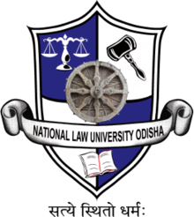

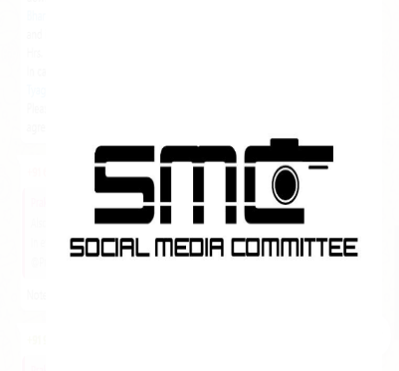

About the Organizers
The National Law University Odisha (NLUO) is a vibrant addition to India’s national law universities. Within the short span, NLUO has made its mark as a university engaged in teaching and research in law.

About the Video/Making Competition
National Law University Odisha is the state coordinator for Odisha for the 70th Constitutional Day-Yearlong Celebration and as a part of the yearlong celebration is organizing Kartavya- 1st NLUO-SMC State Level Video Making Competition on the theme of Fundamental Duties.

Eligibility
The Competition is open for all Undergraduates and Post Graduate students [hereinafter collectively referred to as “Participants”] from any recognized University/Colleges across the state of Odisha.

The Themes of the Short Film/Video
The Short Film/ Video must adhere to at least one of the following Fundamental Duties:
- Respecting the National Flag and the National Anthem;
- Promoting harmony and the spirit of common brotherhood amongst all the people of India transcending religious, linguistic and regional or sectional diversities;
- Renouncing practices derogatory to the dignity of women;
- Value and Preserve the rich heritage of our composite culture;
- Protecting and Improving the natural environment including forests, lakes, rivers and wild life;
- Having compassion for living creatures;
- Safeguarding public property and to abjure violence;
- Providing opportunities for education to his child or, as the case may be, ward between the age of six and fourteen years by the parents and guardians.

Prizes
The meritorious participants would be awarded cash prize as follows:
Winner | Rs. 7000/-
Runners-Up | Rs. 4500/-
2nd Runners-Up | Rs. 2500/-

Certificate of Excellence would be awarded to the top 3 teams- Winners, Runners Up and the 2nd Runners Up.
Certificate of Merit would be awarded to the teams who bagged the spot of 4th 5th and 6th Spot in the competition.

General Guidelines for The Competition
- The Video/Short Films must be strictly based on the theme(s) as has been specified above. The participants may choose to make a Video/Short Films on the multiple themes as has been mentioned above.
- The participants have to mention the theme(s) they have chosen in the registration form [Annexure A] which has to be submitted at the time of registration.
- The Participants can make a video/short film in any of the following languages:
- Odia
- Hindi
- English
- The duration of the Video/Short Film should not be less than three minutes and should not exceed ten minutes.
- The Video/Short Film should be creative, original and carry a message for the society.
- It is encouraged, though not mandatory, in cases where the language is in Odia or Hindi, to provide subtitles.
For detailed guidelines please refer to the rule book.
Link to the Rule Book:
https://www.nluo.ac.in/wp-content/uploads/2020/01/rulebook.pdf

How to Register
The Eligible Participant can register themselves for the competition by mailing a scanned copy of the duly filled form [Registration & Undertaking Form] along with scanned copy of their valid Identity Card(s) issued by their respective college/university [attached in the same mail] on or before 11:59 PM, 14th March, 2020 at smc@nluo.ac.in.
The subject of the mail should be ‘Registration| Video Making Competition.’
Link to the Registration Form
https://www.nluo.ac.in/wp-content/uploads/2020/01/registration-and-undertaking-form.pdf

How to Submission
The Eligible Participant who have successfully registered themselves are to upload their video/short film in Google Drive of their respective G-Mail Account. Post uploading, the participants have to create a ‘link’ which is sharable with the organizers. The participants are then required to give access to the organizer’s G-mail account [smc@nluo.ac.in] to have access to their video/short film.
The participants can submit their video/short film by mailing the link of the Google Drive [as mentioned above] on or before 11:59 PM, 4th April, 2020 at smc@nluo.ac.in.
Note: A detailed step-by-step submission procedure guide with pictorial assistance will be sent to the participants post their registration, for their kind assistance.
The subject of the mail should be ‘Submission | Name of the Video’. For eg. ‘Submission | The National Flag’ in case the name of the short film is The National Flag.

Important Dates
The important dates for the event are as follows:
Release of Notification | 26.01.2020
Last date of registration | 14.03.2020
Online Submission of Video/Short-Film | 04.04.2020
Declaration of Results in the Website of the University | 18.04.2020

Judging Criteria
Entries will be judged by experts on the basis of its originality, creativity and its overall cinematography. It must be one which imbibes in itself and cherishes the idea and respect for the fundamental duties.

Anti-Plagrism Policy
The Short Film/Video must be original and unpublished work of the participant(s). Any video/short film which is found to be copied/plagrised from an existing video/concept shall be disqualified.

Patron(s)
Prof. Dr. Shri Krishna Deva Rao
Patron-in-chief
[Hon’ble Vice Chancellor, National Law University Odisha]

Prof. Dr. Yogesh Pratap Singh
Patron
[Hon’ble Registrar, National Law University Odisha & Patron]

Dr. Owais Hasan Khan
[Hon’ble Faculty Advisor, Social Media Committee, National Law University Odisha]

Contact Us
In case of any queries/clarification, please feel free to reach us out at smc@nluo.ac.in with the subject of the mail- ‘Queries | Video Making Competition’
You can also contact the below mentioned:
Members-Social Media Committee
Rohit +91-8763927132
Shivanjali Bhalerao +91-9406545560
Suprabh Garg +91-6290379583
Prakhar Mishra- +91-9827541515
Ketan-Dev +91 -8168196897

Attachments
- Rule Book.
- Brochure.
- Registration and Undertaking Form.

