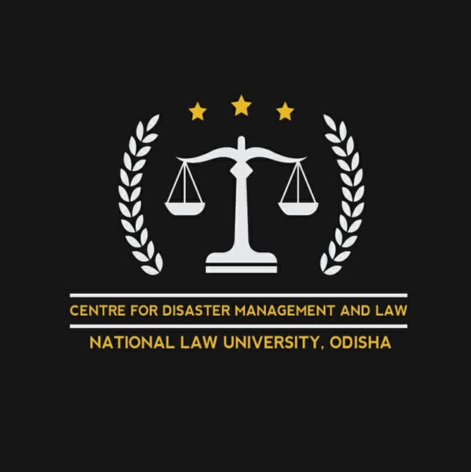
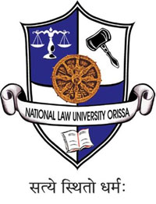

centre for disaster management and law

PRESENTS

1st article writing competition on Legal Aspects of Coronavirus Pandemic

about the centre

The Centre for Disaster Management and Law has been set up with an objective to promote vivid research in the field of Disaster Management. It is emerging globally as a full-fledged academic discipline. In the backdrop of its evolution from the practitioner’s domain, its boundaries have been permeable. However, as a field of research, it demands specialisation to meet with the dynamic challenges posed by not only conventionally categorised disasters but new ones not viewed traditionally as disasters.
As India is a country vulnerable to disaster, comprehensive research on disaster management is quintessential to minimise its adverse impact on the growth of the country. The legal framework related to Disaster Management remains a grey shaded area with a lot of ambiguities prevalent. Rehabilitation, systematic reconstruction and sustainable recovery post-disaster are an arena which requires persistent activism. The centre suggests a holistic legal resolution to deal with the integral aspects of preparedness, response and recovery. The mission of the Centre is to cater to the advancement of knowledge in disaster management, to respond to the sectoral needs and promote positive practices.

about the competition

There are seldom times when the survivability of humanity is tested and the current situation is one of those. The recent outbreak of Covid-19 has to put test people’s patience, resilience and determination to survive against the unseen enemy. One of the ways in which such pandemic can be prevented is through the implementation of different kinds of laws addressing a variety of issues like the supply of essential commodities, ban against public gathering, implementation of section 144 and varied other issues. The idea of the competition is to make analyse the different action taken by the government in such drastic times and whether such action is being taken under the ambit of law or not.

themes and topics

The centre invites articles on the theme of “Legal Aspects of Coronavirus Pandemic”. Some of the topics under the theme are as follows:
- Public Health and Human rights
- Evaluation of Epidemic Diseases Act, 1897
- The legality of Quarantine powers
- Assessment of Emergency Health Powers
- Is Coronavirus pandemic an Act of God?
- Fake news and Covid-19
- Prisons - Parole - Pandemic
- Legal issues between employers and employees during epidemic/ pandemic
- Legal implications of a PHIEC (Public Health Emergency of International Concern) by WHO
- Justification of imposing Article 144 in various parts of the country
- The course of Legal Development: Spanish Flu 1920 to Covid-19.
- Legal issues of Academic institutions' closures
- Medical Law and coronavirus
The above topics are only suggestive in nature and any article dealing with any other topic related to the theme shall be due consideration.

submission details and guidelines

All the articles should strictly adhere to the guidelines. Any article found not following the same shall be outrightly rejected. The guidelines are as follows:
- The title of the article should be appropriate.
- The article must be within 2000 words excluding footnotes.
- Plagiarism up to 15% is allowed.
- Full names of both author and co-author along with designation and contact number(s) must be given.
- Method of citation must be Oscola.
- The body of the paper shall be in Times New Roman, font size 12, 1.5 line spacing. Footnotes should be in Times New Roman, size 10 single line spacing.
- A margin of 4 centimetres shall be left on all sides of the paper.
- The paper shall be in MS Word Format.
- Co-authorship is allowed not more than 2 people.
- The copyright of the article shall lie with the centre.
- The results shall be declared on 30 May 2020.
- All the entries shall be sent to cdml@nluo.ac.in.

There will be no registration fee for the competition. The last date of submission is 30th April 11:59 PM. Any articles received after the deadline shall not be given any consideration.

who can participate

- Academicians, Researchers and Ph.D./Doctoral Scholars from the field law.
- Students including those who are pursuing Post Graduation.
- Advocates, NGOs and Think Tank.
- Government officers and employees of Government undertaking
- Representatives of Regulatory Bodies.

prizes

- Top 10 articles shall be published in the blog of the Centre.

- Every participant shall be given participation certificate provided articles follow the necessary guidelines.

contact details

For any further details feel free to contact the undersigned:
Megha Sadhu | Sagnik Sarkar | Mukesh Kumar
Faculty Advisor | Convenor | Co-Convenor
9777008438/7978106100 | 7044091480/ 9348024929 | 8077806022

